Municipal Separate Storm Sewer System
NPDES Permit No. DC0000221

Prepared by:
District Department of the Environment
Tommy Wells, Acting Director

Prepared by:
District Department of the Environment

Prepared by:
District Department of the Environment

2014 MS4 Annual Report Addendum

Photo by Living Classrooms

Table of Contents
List of Tables ii
List of Figures iii
1 Introduction 1
1.1 Background 1
2 Interim Monitoring 2
2.1 Wet Weather Discharge Monitoring 2
2.2 Storm Event Data 4
2.3 Sample Type, Collection, and Analysis 8
2.4 Monitoring Results 9
A Data Field Sheet A-1
B Trash Trap Design B-2
C Sewershed Maps C-9

List of Tables
Table 1 Monitoring Station Information 2
Table 2 Rain Events Sampled 5
Table 3 Estimates of Wet Weather Flow (in gallons) of all Events Sampled at Each Station in 2014 8
Table 4 2014 Trash Monitoring Results 10
Table 5 Trash Loading Rates 11
Table 6 2014 Trash Composition 14

List of Figures
Figure 1 2014 Average Trash Loading Rate in Pounds 12
Figure 2 2014 Average Trash Loading Rate in Items of Trash 12
Figure 3 2014 Trash Composition 13
Figure 4 Walter Reed Trash Trap B-3
Figure 5 Battery Kemble Trash Trap B-4
Figure 6 Oxon Run Trash Trap B-5
Figure 7 Benning Road Trash Trap B-6
Figure 8 McDonald's Trash Trap B-7
Figure 9 New York Avenue BMP Trash Trap B-8
Figure 10 Walter Reed Monitoring Site Sewershed Land Use Map C-9
Figure 11 Battery Kemble Monitoring Site Sewershed Land Use Map C-10
Figure 12 Oxon Run Monitoring Site Sewershed Land Use Map C-11
Figure 13 Benning Road Monitoring Site Sewershed Land Use Map C-12
Figure 14 McDonald's Monitoring Site Sewershed Land Use Map C-13
Figure 15 New York Avenue BMP Monitoring Site Sewershed Map C-15

DISTRICT OF COLUMBIA
NATIONAL POLLUTANT DISCHARGE ELIMINATION SYSTEM
MUNICIPAL SEPARATE STORM SEWER SYSTEM DISCHARGE PERMIT

Introduction
The Government of the District of Columbia (the District) submits this Addendum to the 2014 Annual Report. This report documents trash monitoring activities required to fulfill the requirements of the District’s National Pollutant Discharge Elimination System (NPDES) Municipal Separate Storm Sewer System (MS4) Permit No. DC0000221, reissued on October 7, 2011 and modified November 9, 2012.

Background
The District’s MS4 permit requires the District to monitor trash loads discharged from DC MS4 outfalls. The monitoring data must be reported annually to U.S. EPA Region III, as required by Section 5.2.1 of the MS4 Permit. Six MS4 outfalls were monitored three times each during wet weather. All sampling events had to be separated from the last rainfall event by at least 72 hours and meet minimum precipitation requirements. Three monitoring sites were chosen from the monitoring sites listed in the DC MS4 permit because they were feasible to monitor for trash. Another three sites were chosen collaboratively with and approved by the EPA.
The 2014 trash monitoring was completed just after the start of calendar year 2015, but not in time to summarize and report on data collected for the 2014 MS4 Annual Report. Numerous issues caused the delay in sampling. First, the National Park Service took several months to issue permits to sample on their property in 2013. This review and permitting process was partially delayed by the Fall 2013 Federal Government shutdown. The permitting delay required that some of the FY13 sampling be conducted in 2014 which in turn pushed back the 2014 sampling.

Second, unfamiliarity with challenging site conditions at some of the sampling sites led to further delays in sampling. The sampling team learned that large flow conditions at several of the sites, specifically Walter Reed and Oxon Run, can be quite damaging to trash traps. Both sites drain large sewersheds, which can produce significant flows during severe storms. Several traps were harmed during these storms and another was damaged by a fallen tree. The repair and rebuilding of the traps could not always be completed before the next qualifying rain event. As a result, the sampling team missed several qualifying storm events and was forced to avoid very large storm events, further restricting their ability to collect samples on time.

Third, sampling was delayed by seasonal weather effects including heavy snow and too frequent or too light rain events. Heavy snow fall during January, February, and March 2014 produced few qualifying rain events and freezing conditions along the mainstem of the Anacostia during this period made sampling conditions at the Benning Road station impossible. Further, during May 2014, it rained too frequently to achieve the 72 hour separation between storms as required under the 40 CFR. In contrast, during July, rain events below the required sampling threshold, often occurred the day before a qualifying event, effectively spoiling sampling conditions.

Interim Monitoring
In FY 2014 sampling is preceded under the interim sampling provisions. The District is providing a summary the 2014 monitoring data and analysis for quantification of trash loads. This report contains descriptions of the monitoring sites, descriptions of the monitored precipitation events, explanation of the sampling methodology, and the data and analysis obtained from the samples at each site.

Wet Weather Discharge Monitoring
Table 1 provides details on each sampling site and Appendix 3 contains a land use map for each trash monitoring location.
Table 1 Monitoring Station Information

Watershed | Site | Station | Land Use | Acres | Sample Date
Rock Creek | WR | Walter Reed  (Ft Stevens Rd & 16th St, NW) | Mixed density residential | 23 | 02/03/2014, 06/25/2014, 08/31/2014
Potomac | BK | Battery Kemble  (Garfield St & 49th St, NW) | Low density residential | 11 | 02/03/2014, 04/15/2014, 06/25/2014
 | OR | Oxon Run  (Mississippi Ave & 15th St, SE) | Residential 46%, Public Land 45%, Commercial 5%, Utilities 4% | 43 | 10/21/2014, 11/23/2014, 01/03/2015
Anacostia | BR | Benning Road  (Benning Rd & Anacostia Ave, NE) | Commercial | 12 | 09/13/2014, 11/05/2014, 12/16/2014
 | McD | McDonald’s  (Minnesota Ave & Burroughs Ave, NE) | Residential 65%, Commercial 23%, Industrial 12%, | 7.4 | 04/15/2014, 06/03/2014, 10/21/2014
 | NYA | New York Ave BMP (New York Ave & South Dakota Ave, NE) | Transportation right of way | 1.5 | 10/21/2014, 11/23/2014, 01/03/2015

Walter Reed (Ft Stevens Rd NW & 16th Street NW)
This sampling site and its sewershed are located within the Piedmont physiographic province of the Rock Creek watershed. The drainage area is mostly residential. Land near 16th Street is high density residential. Medium density residential covers the rest of the area except for small pockets of low and medium-low density residential. An elementary school adds one small patch of public/quasi-public institutional land use to the sewershed. Pedestrian and vehicle traffic are common in the neighborhood. Well-used bus lines run along 16th and 14th Street. Tree cover in the area is moderate, but most trees are mature street trees. Rock Creek Park bordering 16th Street contributes a lot of tree debris.
Battery Kemble (Garfield Street NW & 49th Street NW)
This sampling site and its sewershed are located within the Piedmont physiographic province of the Potomac River watershed. This area is entirely low density residential. Tree cover is dense with many mature trees. Battery Kemble Park, which borders the sewershed, is a popular recreation area. People park along 49th Street to access the park. Some trash on the street is from people with dogs and children going to the park. During the monitoring period, a construction site was located just on the outside of the sewershed, and construction vehicles access the site via 49th Street. The site may have contributed some litter debris during the sampling period. Traffic is mostly light vehicle traffic with some pedestrians accessing the park.
Oxon Run (Mississippi Avenue SE & 15th Street SE)
This sampling site and its sewershed are located within the Coastal Plain physiographic province of the Potomac River watershed. The major land uses are local and federal public (all elementary schools) and residential. The residential is mostly medium density with some low medium density residential and one small lot of low density residential. A few small patches of zoned commercial are scattered around the sewershed, with one large patch of mixed use that is all commercial (i.e. grocery store and strip mall) in the sewershed. The area has moderate to dense tree cover with many mature trees. In addition to vehicle traffic, the community has heavy foot traffic and well-used Metro bus routes.
Benning Road (Benning Road NE & Anacostia Avenue NE)
This sampling site and its sewershed are located within the Coastal Plain physiographic province of the Anacostia River watershed. The Benning Road sewershed is primarily commercial land use. The one patch of low-density residential land use within the sewershed is an empty lot with a concrete pad and a few trees. A small social services business is located in the corner lot of indeterminate land use. Tree cover is extremely sparse. Traffic includes vehicles, bicycles, buses, and pedestrians.
McDonald’s (Minnesota Avenue NE & Nannie Helen Burroughs Avenue NE)
This sampling site and its sewershed are located within the Coastal Plain physiographic province of the Anacostia River watershed. The industrial land use consists of a major beer and liquor distribution center. Commercial land use along Nannie Helen Burroughs Avenue is mostly fast food and gas stations. One small patch of institutional land use is a church. The rest of the land is low density residential. Traffic in the area is primarily vehicular, with some pedestrian traffic. Tree cover is sparse with some mature trees in the residential area and young street trees along Nannie Helen Burroughs Avenue.

New York Avenue BMP (New York Avenue NE & South Dakota Avenue NE)
This sampling site and its sewershed are located within the Coastal Plain physiographic province of the Anacostia River watershed. This small sewershed is technically zoned commercial, but is entirely used for transportation right-of-way. It drains a small portion of the New York Avenue eastbound lanes and the exit ramp to South Dakota Avenue. Tree cover in the sewershed itself is sparse, but leaves blow into the area from adjacent dense mature tree stands. Traffic is exclusively vehicular.

Storm Event Data
To meet EPA standards for the DC MS4 permit, monitored events had to meet three criteria per Title 40 of the United States Code of Federal Regulations:
- Events for sites shall be equal to or larger than 0.1 inches of precipitation.
- All events sampled must be separated from the last precipitation event by 72 hours.
- Where feasible, the depth of rain and the duration of the event should not vary by more than 50 percent from the average depth and duration (to ensure that the storm would be ‘representative’, i.e. typical of the area in terms of intensity, depth and duration).

Monitoring conducted for the development of the Anacostia trash TMDL in the coastal plain showed that at least 0.25 inches of rainfall is necessary to move trash through the District’s MS4. Therefore, only samples from storms at least 0.25 inches in magnitude were monitored at stations found within the coastal plain. However, under the direction of DDOE, who gained approval from EPA, samples collected at Piedmont stations were only collected from storms at least 0.10 inches in magnitude. This was due to greater slopes found in the Piedmont province that could affect flow velocity and movement of trash through the MS4.
In 2014, snow fell in January, February, and March, producing few qualifying rain events. In May, it rained too frequently to achieve 72 hours separation between storms. Potential qualifying events in July were often spoiled by a rain event less than the required sampling threshold occurring the day before. Sampled spring and summer rain events were a mix of moderate thunderstorms and light-to-moderate rains with occasional brief heavy periods. In autumn and winter, most sampled rain events were light or very light rains with occasional spots of moderate intensity rainfall.
When possible, rainfall data was taken from the National Weather Service station at Reagan National Airport. Weather data reported from weather stations hosted on Weather Underground (wunderground.com) were used when National did not provide a reasonable rainfall estimate for highly localized rain events at a monitoring site. The H Street Corridor-NoMa KDCWASHI27 Weather Underground station was used for a localized storm that missed National Airport on June 3, 2014. The H Street Corridor-NoMa station was the closest station to the McDonald’s monitoring site that was in the path of the storm. The Capitol Hill KDCWASHI44 Weather Underground station was used for a localized storm that missed National Airport on September 13, 2014. The Capitol Hill station was the closest station to the Benning Road monitoring site

Table 2 Rain Events Sampled

Date | Precipitation  (inches) | Duration  (hours) | Peak Intensity | Days from Previous Rain | Sites Sampled
02/03/14 | 1.48 | 13 | 0.22 | 5 | WR, BK
04/15/14 | 1.53 | 21 | 0.64 | 7 | BK, McD
06/03/14 | 0.87* | 2* | 0.87 | 5 | McD
06/25/14 | 0.45 | 1 | 0.69 | 3 | WR, BK
08/31/14 | 0.27 | 3 | 0.14 | 8 | WR
09/13/14 | 0.27** | 1.5** | 0.19 | 7 | BR
10/21/14 | 1.09 | 24 | 0.24 | 6 | OR, McD, NYA
11/05/14 | 0.27 | 8 | 0.11 | 7 | BR
11/23/14 | 0.31 | 5 | 0.16 | 6 | OR, NYA
12/16/14 | 0.40 | 4 | 0.29 | 7 | BR
01/03/15 | 0.54 | 24 | 0.14 | 5 | OR, NYA
Precipitation amount, duration, and days from previous rain taken from National Weather Service Washington Reagan National Airport KDCA weather station
Peak intensities from H Street Corridor-NoMa KDCWASHI27 Weather Underground station
* Event data taken from H Street Corridor-NoMa KDCWASHI27 Weather Underground station
** Event data taken from Capitol Hill KDCWASHI44 Weather Underground station

that was in the path of the storm. The National Weather Service station at Reagan National Airport does not collect rainfall intensity data, so peak intensity data was obtained from the H Street Corridor-NoMa KDCWASHI27 Weather Underground station a centrally located weather station that collects precipitation rate data.
Narrative Description of Sampled Storms

February 3, 2014
A sample was collected from the Walter Reed and Battery Kemble sites. This light to moderate rain dropped 1.48 inches of rain in 9 hours. The peak rainfall intensity was 0.22 inches per hour. Snow briefly mixed with the rain toward the end of the event, but all snow melted on contact. The last measurable rain occurred 5 days before this event.

April 15, 2014
A sample was collected from the Battery Kemble and McDonald’s sites. The rain event had 1.53 inches of rain in 21 hours. This storm had intermittent light to moderate rainfall, and then peaked during a brief heavy period with an intensity of 0.64 inches per hour. The last measurable rain occurred 7 days before this event.

June 3, 2014
A sample was collected from the McDonald’s site. This rain event was a localized heavy thunderstorm with a peak rainfall intensity of at least 0.87 inches per hour. The storm missed National Airport entirely, but at the McDonald’s site the deluge was strong enough to move heavy debris down the drain, including 2.5 pound chunks of concrete. According to the H Street Corridor-NoMa Weather Underground station, 0.87 inches of rain fell in 2 hours. The last measurable rain occurred 5 days before this event.

June 25, 2014
A sample was collected from the Walter Reed and Battery Kemble sites. This heavy but brief thunderstorm with a peak rainfall intensity of 0.69 inches per hour dropped 0.45 inches of rain in 1 hour. The last measurable rain occurred 3 days before this event.

August 31, 2014
A sample was collected from the Walter Reed Site. This rain event was a pair of light thunderstorms separated by a period of lighter rain. The peak rainfall intensity was 0.14 inches per hour. In 3 hours, a total of 0.27 inches of rain fell. The last measurable rain occurred 8 days before this event.

September 13, 2014
A sample was collected from the Benning Road site. This brief, light to moderate rain had a peak rainfall intensity of 0.19 inches per hour with localized pockets of slightly higher intensity. One such area of higher intensity was near the Benning Road trap. According to the Capitol Hill Weather Underground station near the trap, 0.27 inches of rain fell in 1.5 hours. The last measurable rain occurred 7 days before this event.

October 21, 2014
A sample was collected from the Oxon Run, McDonald’s, and New York Avenue sites. This 24-hour rain event began the evening of October 21 and ran through October 22, collecting 1.09 inches of rain. A few cells of moderate intensity rain occurred in some areas, but most of the rain event was very light rain. The peak rainfall intensity was 0.24 inches per hour at the H Street Corridor-NoMa Weather Underground station. The slightly higher intensity rain cell that hit that weather station bypassed the McDonald’s and New York Avenue sites, so they likely experienced much lower peak intensities. The last measurable rain occurred 6 days before this event.

November 5, 2014
A sample was collected from the Benning Road site. During this very light rain event, 0.27 inches of rain fell in 8 hours. The peak rainfall intensity was 0.11 inches per hour. The last measurable rain occurred 7 days before this event.

November 23, 2014
A sample was collected from the Oxon Run and New York Avenue sites. A light rain delivered 0.31 inches of rain in 5 hours. The peak rainfall intensity was 0.16 inches per hour. The last measurable rain occurred 6 days before this event.

December 16, 2014
A sample was collected from the Benning Road site. This rain event started as a moderate rain with a peak rainfall intensity of 0.29 inches per hour. After the first 2.5 hours, the rain tapered off into a very light rain/mist. In total, 0.40 inches of rain fell in 4 hours. The last measurable rain occurred 7 days before this event.

January 3, 2015
A sample was collected from the Oxon Run and New York Avenue sites. This rain event was intermittent light rain with brief periods of slightly heavier light rain, accumulating only 0.54 inches of rain in 24 hours. The peak rainfall intensity was 0.14 inches per hour. The last measurable rain occurred 5 days before this event.

Using the modified version of the simple method, the flow for each event sampled at each station in 2014 was computed. The equation below describes the calculation:

$$R=\frac{P x P_{j} x R_{vc}}{12} ×A$$
Where:
R = Runoff volume, typically expressed in acre-feet
P = Precipitation, typically expressed in inches
P_{j} = Precipitation correction factor, typically 0.9
R_{vc} = Composite runoff coefficient
A = Area of the catchment, typically expressed in acres

Runoff coefficients were recently developed by DDOE for the District’s consolidated TMDL implementation plan. They were developed for drainage areas for each TMDL water body. The coefficient that corresponds to each monitoring station was used in the calculation. Table 3 below summarizes the calculations.

Table 3 Estimates of Wet Weather Flow (in gallons) of all Events Sampled at Each Station in 2014

Site | Date | Precipitation | Runoff Coefficient | Acreage | Runoff Volume (gallons)
Walter Reed | 2/3/2014 | 1.48 | 0.58 | 23 | 482,260.112
 | 6/25/2014 | 0.45 |  |  | 146,633.142
 | 8/31/2014 | 0.27 |  |  | 87.979.885
Battery Kemble | 2/3/2014 | 1.48 | 0.45 | 11 | 178,892.433
 | 4/15/2014 | 1.53 |  |  | 185,083.611
 | 6/25/2014 | 0.45 |  |  | 54,417.188
McDonald's | 4/15/2014 | 1.53 | 0.55 | 7.4 | 152,172.616
 | 6/3/2014 | 0.87* |  |  | 86,676.480
 | 10/21/2014 | 1.09 |  |  | 108,508.525
Benning Rd | 9/13/2014 | 0.27** | 0.53 | 12 | 42,034.834
 | 11/5/2014 | 0.27 |  |  | 42,034.834
 | 12/16/2014 | 0.4 |  |  | 62,237.623
Oxon Run | 10/21/2014 | 1.09 | 0.54 | 43 | 618,466.01
 | 11/23/2014 | 0.31 |  |  | 175,959.771
 | 1/3/2015 | 0.54 |  |  | 306,300.341
New York Ave | 10/21/2014 | 1.09 | 0.53 | 1.5 | 21,180.343
 | 11/23/2014 | 0.31 |  |  | 5,865.326
 | 1/3/2015 | 0.54 |  |  | 10,427.246
Precipitation amount taken from National Weather Service Washington Reagan National Airport KDCA weather station
* Event data taken from H Street Corridor-NoMa KDCWASHI27 Weather Underground station
** Event data taken from Capitol Hill KDCWASHI44 Weather Underground station

Sample Type, Collection, and Analysis
Outfalls were monitored using removable trash traps. Detailed descriptions of the traps used at each outfall are included in the appendix. In general, each trap consisted of a frame that fit over the outfall, and a box or sock of one-inch metal poultry netting that collected the trash and natural debris exiting the pipe. These designs also facilitated continuous flow and drainage of stormwater. When an acceptable rain event was predicted, traps were deployed well before the rain began. Following the end of an event, traps, and any material contained within the trap, were retrieved. Trap contents were transferred to labeled plastic trash bags for transport. The trap contents were taken to a residence in Washington, DC (the same place samples were processed during the data collection for the TMDL). Bagged samples were set on a sloped concrete pad, and small slits were cut in the bottom of the bags to allow water to drain away.

The samples were processed within 72 hours of collection before appreciable degradation of any organic matter. The trap contents were hand-sorted to separate trash from natural debris. The natural fraction was weighed and properly discarded. The trash fraction was further sorted into its individual components and quantified using the categories used for the Anacostia River trash TMDL and shown on the data sheet in the appendix. Then the total trash fraction was weighed and properly discarded.

Monitoring Results
Table 4 details the results of total trash collected in pounds from each 2014 sampling event. The relationship between the amount of trash and the amount of rain was investigated. The amount of trash per basin was normalized to trash per acre to allow comparisons between the different drainage areas. Both the weight and the number of items per acre for each storm are divided by the rainfall amount for that storm. The loading rates vary widely between basins with a loading rate from the McDonald’s sewershed of 0.0004 pounds per inch of rain per acre during a very low intensity rain, and the high-traffic commercial Benning Road sewershed with a rate of 3.5 pounds per inch per acre, Table 5. Even within a given land use, the variation in loading rates between storms is usually at least a factor of two. This is not unexpected for the type of data being analyzed. The same analysis, applied to rainfall intensity instead of total rainfall amount, did not provide any less variability.

Table 4 2014 Trash Monitoring Results

Station | Date | Rain Amount (inches) | Trash Weight (pounds)
Walter Reed  (Rock Creek) | 02/03/2014 | 1.48 | 4.563
 | 06/25/2014 | 0.45 | 3.250
 | 08/31/2014 | 0.27 | 3.625
Battery Kemble  (Potomac) | 02/03/2014 | 1.48 | 0.250
 | 04/15/2014 | 1.53 | 0.813
 | 06/25/2014 | 0.45 | 0.438
Oxon Run  (Potomac) | 10/21/2014 | 1.09 | 2.500
 | 11/23/2014 | 0.31 | 0.750
 | 01/03/2015 | 0.54 | 1.563
Benning Road  (Anacostia) | 09/13/2014 | 0.27 | 11.500
 | 11/05/2014 | 0.27 | 2.563
 | 12/16/2014 | 0.40 | 5.188
McDonald’s  (Anacostia) | 04/15/2014 | 1.53 | 16.438
 | 06/03/2014 | 0.87 | 14.313
 | 10/21/2014 | 1.09 | 0.003
New York Ave BMP  (Anacostia) | 10/21/2014 | 1.09 | 0.438
 | 11/23/2014 | 0.31 | 0.069
 | 01/03/2015 | 0.54 | 0.438

Table 5 Trash Loading Rates

Station | Inches of Rainfall | Pounds per Inch of Rain per Acre | Items per Inch of Rain per Acre
Walter Reed | 1.48 | 0.134 | 7
 | 0.45 | 0.314 | 22
 | 0.27 | 0.584 | 27
Battery Kemble | 1.48 | 0.015 | 0.2
 | 1.53 | 0.048 | 1
 | 0.45 | 0.088 | 2
Oxon Run | 1.09 | 0.053 | 5
 | 0.31 | 0.056 | 7
 | 0.54 | 0.067 | 8
Benning Road | 0.27 | 3.549 | 229
 | 0.27 | 0.791 | 33
 | 0.40 | 1.081 | 106
McDonald’s | 1.53 | 1.452 | 50
 | 0.87 | 2.223 | 63
 | 1.09 | 0.00037 | 0.2
New York Ave | 1.09 | 0.268 | 30
 | 0.31 | 0.148 | 24
 | 0.54 | 0.541 | 48

The average value of three data points per station is of little statistical value with the extreme variation present, but it provides an interesting comparison of the loading rates from the different sewersheds. Figure 1 shows the relative average loading on the basis of pounds of trash per inch of rain per acre of sewershed.
Figure 2 shows the relative average loading on the basis of items of trash per inch of rain per acre of sewershed. Again, these averages may not be meaningful given the small number of samples.
Figure 1 2014 Average Trash Loading Rate in Pounds

Figure 2 2014 Average Trash Loading Rate in Items of Trash

A total of 3,769 items of trash were collected during sampling. The number of items in major categories is shown in Figure 3. Table 6 breaks this information down even further. As in all previous studies, the food wrappers were the most abundant item encountered. Bottles and various beverage containers were not a dominant fraction by number of items, but they are highly visible and occupy a large volume of the trash samples. Paper and plastic bags were a slightly smaller portion of the trash than in previous studies.
Expanded polystyrene foam was aggregated into one number that included fragments and pieces of cups and takeout containers, whole cups and plates, packing material, and miscellaneous foam pieces, but excluded whole Styrofoam clamshells, which were counted in the take-out category.

Figure 3 2014 Trash Composition

Table 6 2014 Trash Composition

Trash Category | Number of Items | Percent of Total | Category Includes
Food Wrappers | 938 | 24.9
Paper | 494 | 13.1 | Napkins, newspaper, adverts & signs, miscellaneous paper
Miscellaneous Plastic | 414 | 11.0
Cigarette | 388 | 10.3 | Smoking related stuff
Lids & Straws | 357 | 9.5
Take-out | 245 | 6.5 | Take-out packaging, condiments, utensils, Styrofoam clamshells
Bottles & Cans | 212 | 5.6 | All bottles, cans, and drink packs
Styrofoam | 210 | 5.6 | Cups, plates, packaging and chunks but not whole takeout clamshells
Other | 166 | 4.4
Debris | 120 | 3.2
Drugs & Toiletries | 101 | 2.7
Paper & Plastic Cups | 71 | 1.9 | Paper and plastic drink cups
Bags | 53 | 1.4 | Paper and plastic bags

Data Field Sheet
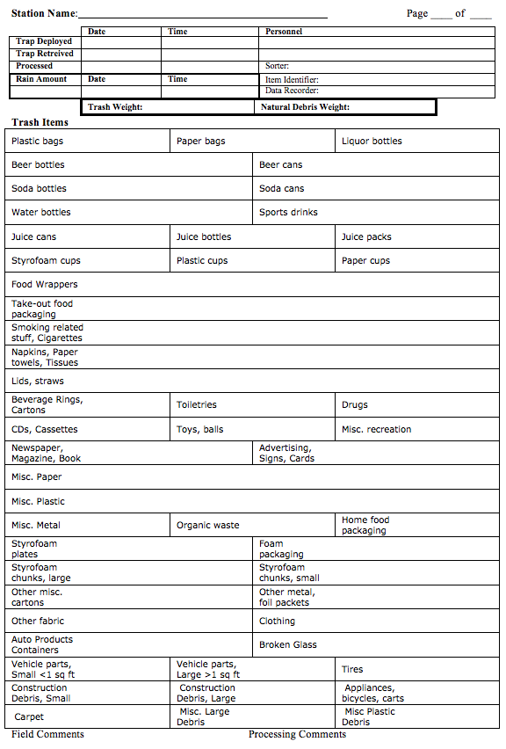

Trash Trap Design
The trash traps are designed to cause little to no interference with the outfall’s structure and functioning while straining out all the trash from storm water effluent. During heavy flows, the traps break away from the outfall before water can backup and cause flooding up the pipe. Cable ties with a tensile strength of no more than 75 lbs. are used to secure metal poultry netting to a trap frame, which enables the mesh to break away from the frame so more water can escape. The ropes and attachment points securing the traps are also designed to allow high water pressure during heavy flows to detach the traps from the outfall relatively easily. While each trap and location is different, traps generally broke away from the outfall at intensities greater than one inch per hour. If the trap is subject to lateral forces due to installation in the stream channel, then upstream rainfall and flow velocity of the stream begin to affect the trap integrity. The ropes used to secure the traps to the stakes had a break-strength of 120 lbs. or 550 lbs. and the generally accepted reduction from knots is 35%. No attachments are made to the outfall structure itself. Traps are held in place with ropes tied or clipped to heavy-duty stakes or posts driven into the streambed or bank. To service the traps, the attachments are untied or unclipped from the stakes and the trap gently pushed/pulled away from the outfall.

Box Style Trash Trap
A rigid metal box frame is covered with metal poultry netting. The frame is pushed flush against the outfall and tied in place to stakes in the streambed or bank. Box traps are built large enough to allow doors over outfalls to swing open unimpeded. In the event of heavy flow, the force of the water on the box pulls the box free of the stakes and pushes the trap away from the outfall or tears the mesh away from the frame.

Sock Style Trash Trap
A metal hoop is slipped over the protruding outfall pipe. A long metal poultry netting bag is attached to the hoop, allowing a large surface area for water to escape the sock as trash and debris accumulates at the toe of the bag. The hoop is tied to stakes in the streambed or bank, not attached directly to the outfall. In the event of heavy flow, the force on the bag snaps the ropes or pulls out the stakes so the hoop slips off the outfall or the bag breaks away from the metal hoop.

Trash Traps at Each Monitoring Station

Walter Reed
Walter Reed site has a protruding pipe so a sock style trap is used. A metal hoop made from ¾ inch metal hanger strap is bent to fit the irregular shape of the broken outfall mouth. The hoop is slipped partially over the pipe. Three ropes run to stakes imbedded in the ground. One stake is driven into the ground between the broken pieces of the outfall apron to keep the bottom from kicking off. When the trap is full, it is too heavy to be lifted up and dumped out. The sock is built in three sections so it can be emptied in increments. A rope cinch was originally added to pull the trap closed if it tore off the outfall. However, experience demonstrated that the trash naturally migrated to the toe of the trap due to stream flow and the outfall effluent flow. The cinch was never needed to keep the trash in the trap.

Figure 4 Walter Reed Trash Trap

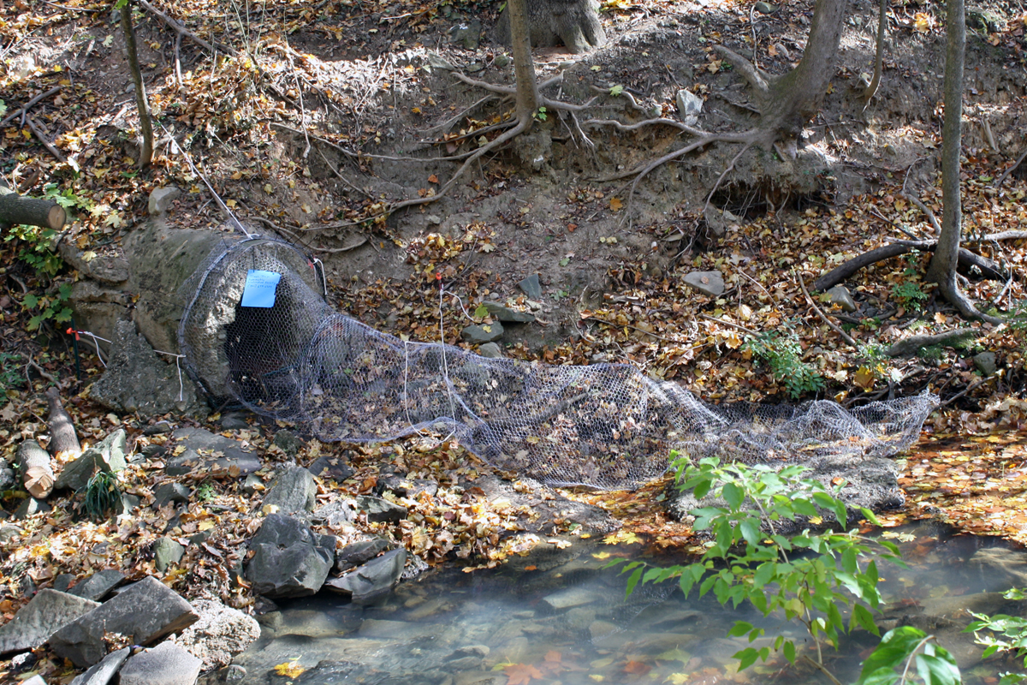

Battery Kemble
The Battery Kemble site required a box style trap. The box frame was constructed from salvaged hollow aluminum frame and aluminum pipe. The frame was slightly bent at the bottom front to follow the curve of the broken outfall apron. Two stakes on the bank held the top of the trap flush with the outfall. Two stakes in the streambed kept the bottom of the trap from pushing backward. To empty the trap, the contents were shaken out the front into a wide, shallow tub.

Figure 5 Battery Kemble Trash Trap

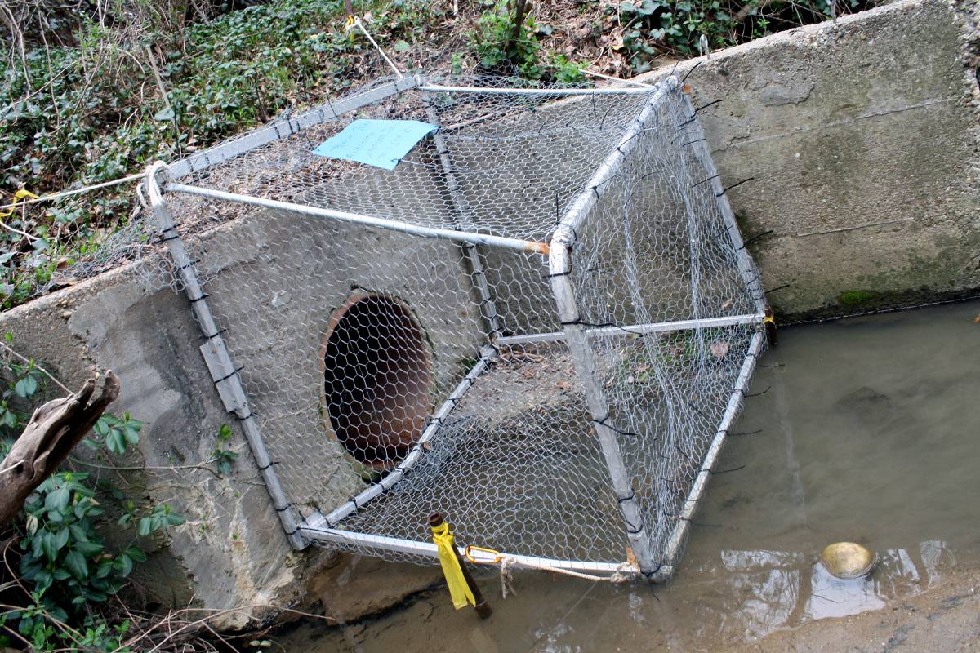

Oxon Run
The Oxon Run trap had to be designed and built to accommodate the 6’ tall swing gate. Rocks embedded in the outfall apron did not allow the entire trap to sit flush with the ground. The front section of the trap lies flat on the apron, allowing the swing gate to move freely. The back section of the trap is elevated roughly 12 inches on platforms over the rocks. Trash and debris initially accumulate in the front part only. As flow increases, the water level in the trap rises until it is high enough to spill onto the elevated back section of the trap. Floatable trash and natural debris are then washed into the elevated section by the high water. Heavier debris and sediment usually stay trapped in the non-elevated front section. The size of the trap necessitated that it be disassembled and packed flat for transport to and from the site. The trap was originally made of thin lumber, but it broke too easily so the sampling team replaced broken sections with thicker lumber. Poultry netting is stapled to the wood. The staples pull out when the stormwater exerts excessive force against the netting. The bottom front panel is wedged between the first row of apron rocks and the outfall face. The top of the trap is pulled flush against the outfall face by two ropes that run to stakes behind the outfall wall. The trap is disassembled and the sample removed by hand or shaken onto a tarp.

Figure 6 Oxon Run Trash Trap

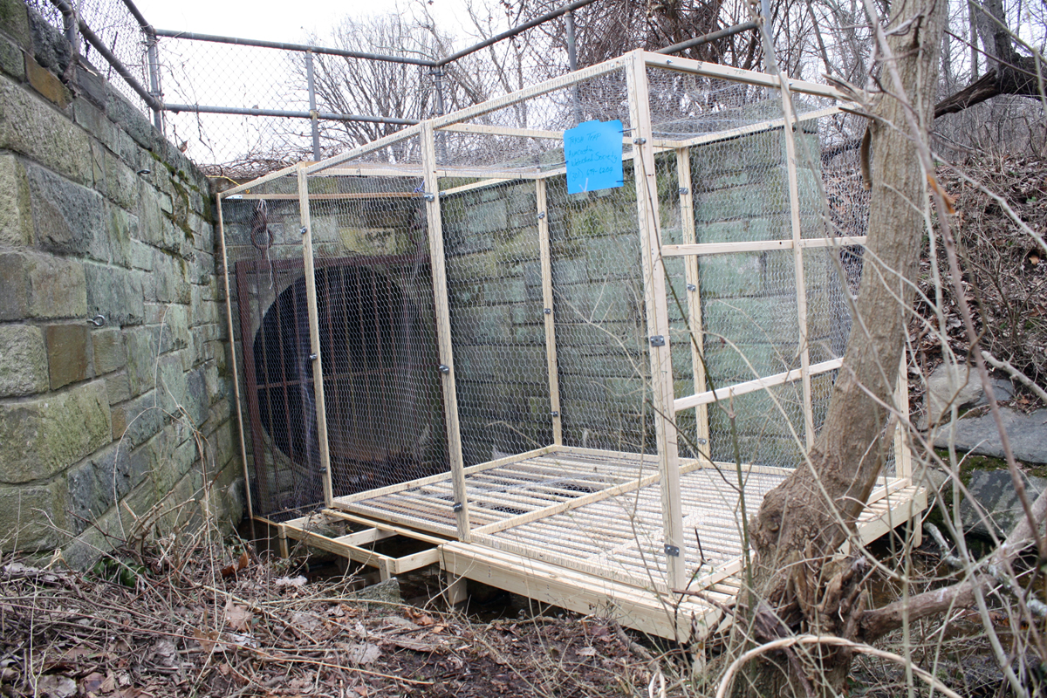

Benning Road
This outfall is flush with the seawall so it required a box trap. The box frame is made from salvaged aluminum frame and aluminum pipe. A sock attached to the back of the box provides more trap volume. The top of the trap is tied to two stakes behind the seawall. The bottom is held tight to the seawall by ropes that run up tall posts driven into the riverbed. This outfall is on the tidal Anacostia River so it can only be serviced during low tide. Trash is removed from the trap with a long handled net. Once the trap is mostly empty, it is pulled up on shore and the last bits of sample are shaken out into a wide shallow tub.

Figure 7 Benning Road Trash Trap

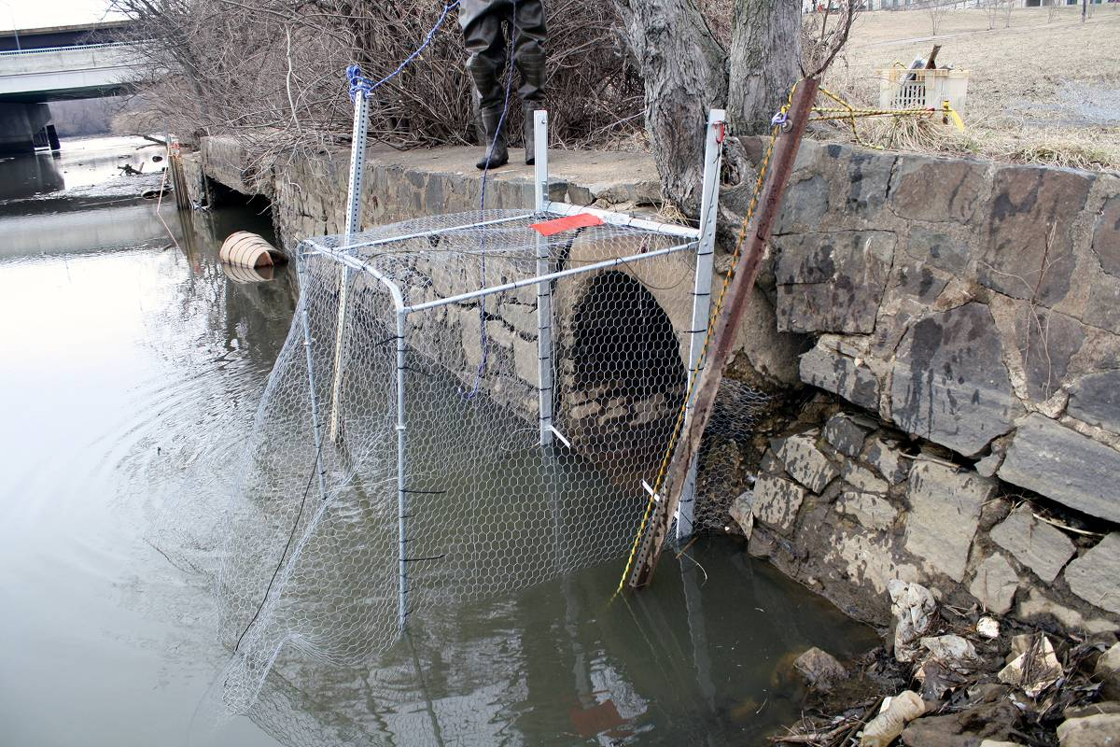

McDonald’s
This protruding pipe requires a simple sock trap. A hoop is slipped over the pipe and held in place by ropes running to stakes embedded in the bank. The poultry netting sock is held out of the main stream flow by another rope running to a stake on the bank. The trap is emptied by tipping the trap upside down over a wide, shallow tub.

Figure 8 McDonald's Trash Trap

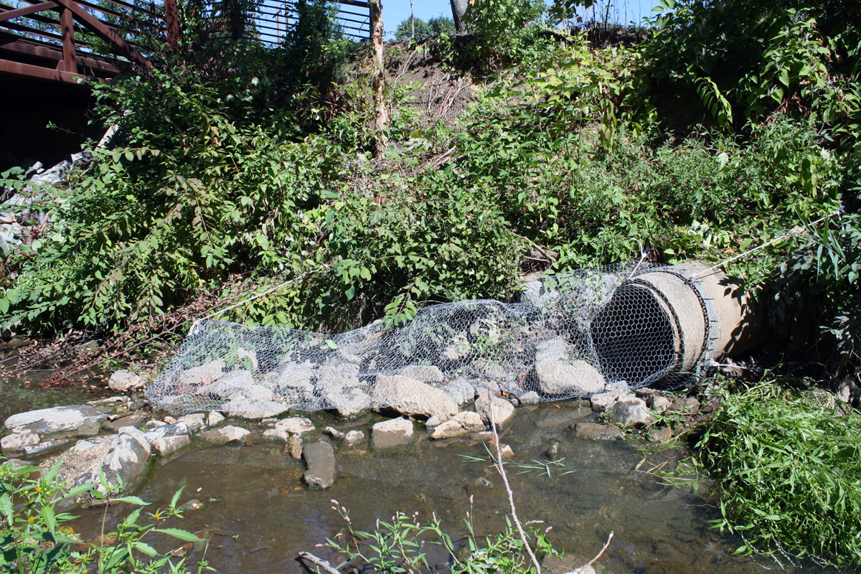

New York Avenue BMP
A metal hoop is pulled flush against the outfall face with three stakes driven into the bank The trap is slightly elevated by salvaged metal ladders underneath (not visible in the picture) to allow water room to drain through the bottom of the trap. The toe of the trap is a rectangular metal frame, which allows more room at the toe for trash to accumulate. The trap is emptied by shaking it into a wide, shallow tub.

Figure 9 New York Avenue BMP Trash Trap

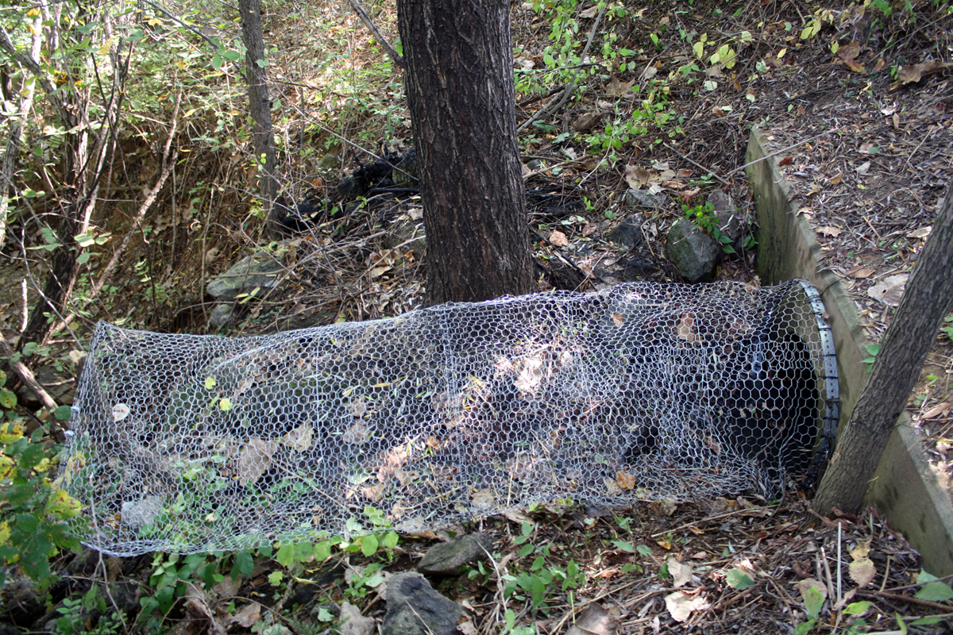

Sewershed Maps
Figure 10 Walter Reed Monitoring Site Sewershed Land Use Map
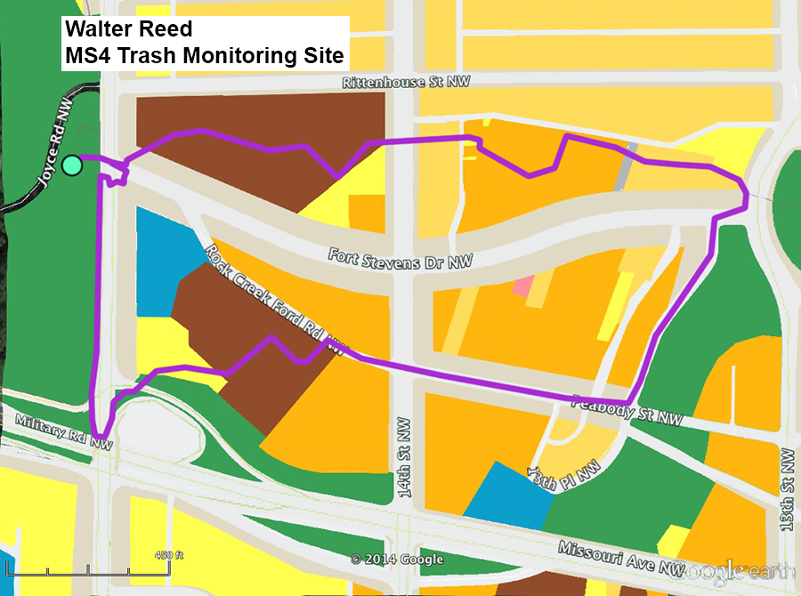
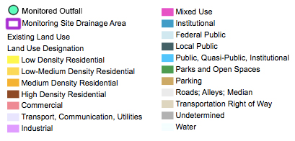

Figure 11 Battery Kemble Monitoring Site Sewershed Land Use Map

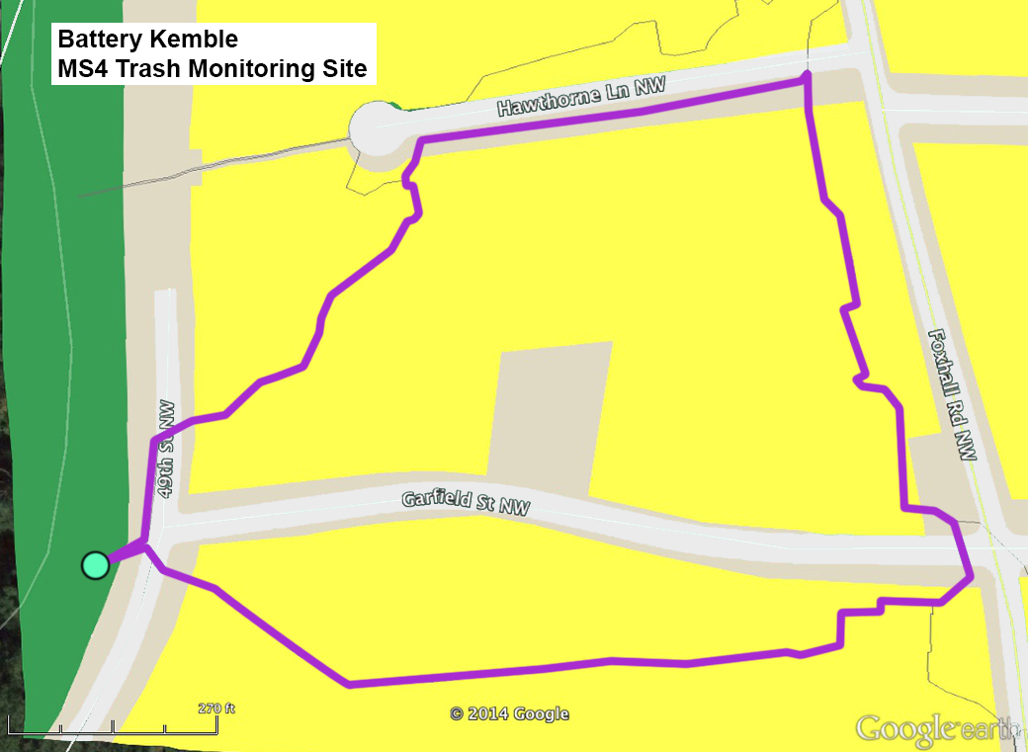

Figure 12 Oxon Run Monitoring Site Sewershed Land Use Map

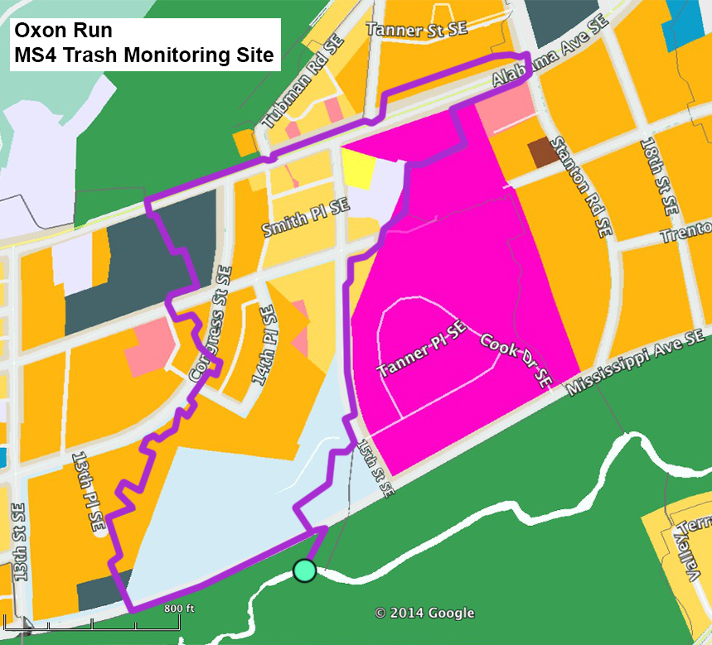

Figure 13 Benning Road Monitoring Site Sewershed Land Use Map
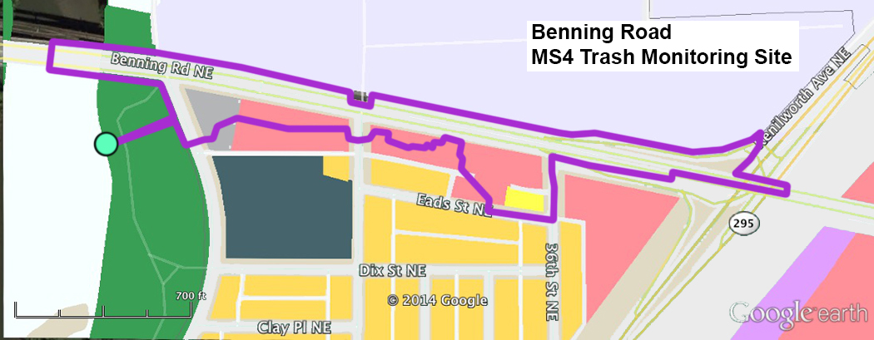

Figure 14 McDonald's Monitoring Site Sewershed Land Use Map
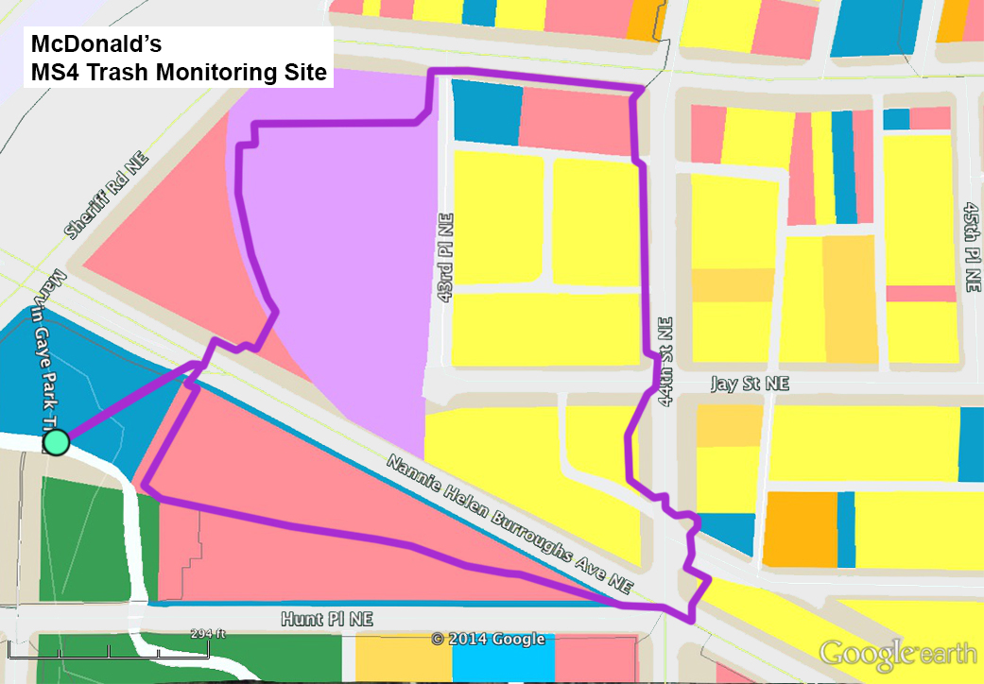

Figure 15 New York Avenue BMP Monitoring Site Sewershed Map
