Sustainable Energy Utility Advisory Board (SEUAB) Meeting
Tuesday, April 18, 2023
10:00 AM – 12:00 PM

Call to Order
Chair Bicky Corman called the meeting to order at 10:02 AM, April 18, 2023. Chair Bicky Corman called a quorum of the Sustainable Energy Utility Advisory Board (SEUAB or Board) at 10:03 AM. This was a Microsoft Teams video conference call meeting.

Roll Call/Instructions
Roll call was taken at 10:04 AM and the following people were in attendance:

Board Members
Name | In Attendance? | FY 2023  Special Meetings  Attendance Record | FY 2023  Sub Committee Meeting  Attendance Record | FY 2023 Regular Meetings  Attendance Record
Bicky Corman - Board Chair (Mayor’s Designee) | Yes | 5/5 | 1/1 | 5/6
Marshall Duer-Balkind – Vice Chair (Councilmember Cheh) | Yes | 5/5 | 1/1 | 6/6
Sandra Mattavous-Frye (or OPC proxy) | Yes | 5/5 | 1/1 | 6/6
Danielle Gurkin (PSC) | Yes | 4/5 | 0/1 | 6/6
Pending - James Pittman (Electric Company) | Yes | 5/5 | 1/1 | 6/6
Eric Jones (Building Management) | Yes | 5/5 | 1/1 | 6/6
Nina Dodge (Environment) | Yes | 4/5 | 0/1 | 6/6
Jamal Lewis (Low-Income Community) | Yes | 5/5 | 0/1 | 5/6
Vacant (Economic Development) | N/A | N/A | N/A | N/A
Sasha Srivastava (Renewable Energy) | Yes | 5/5 | 1/1 | 6/6
Vacant (Building Construction) | N/A | N/A | N/A | N/A
Vacant (Council Chairperson Mendelson) | N/A | N/A | N/A | N/A
Manny Geraldo (Gas Utility) | Yes | 0/5 | 0/1 | 2/6

Other Attendees: Sarah Kogel-Smucker (OPC), Ernest Jolly (DCSEU), Angela Johnson (DCSEU), Patti Boyd (DCSEU), Ben Burdick (DCSEU), Rebecca Foster (VEIC), Lou Hutchinson (VEIC), Dave Epley (DOEE), Dr. Lance Loncke (DOEE), Dr. Nick Burger (DOEE), Hussain Karim (DOEE), Brittany Whited (DOEE), Portia Hurtt (WGL), Crystal McDonald (DCSEU), John Richards (WGL)

Approval of Agenda
- Vice Chair Marshall Duer-Balkind proposed adjusting the agenda to allow more time for WGL EEDR discussion.
- Chair Bicky Corman moved to approve the updated agenda and was seconded by Vice Chair Marshall Duer-Balkind. All were in favor, and none were opposed.

Approval of March Minutes
- Chair Bicky Corman moved to approve the agenda and was seconded by Vice Chair Marshall Duer-Balkind. All were in favor, and none were opposed.

FY23 Q1 DCSEU Performance
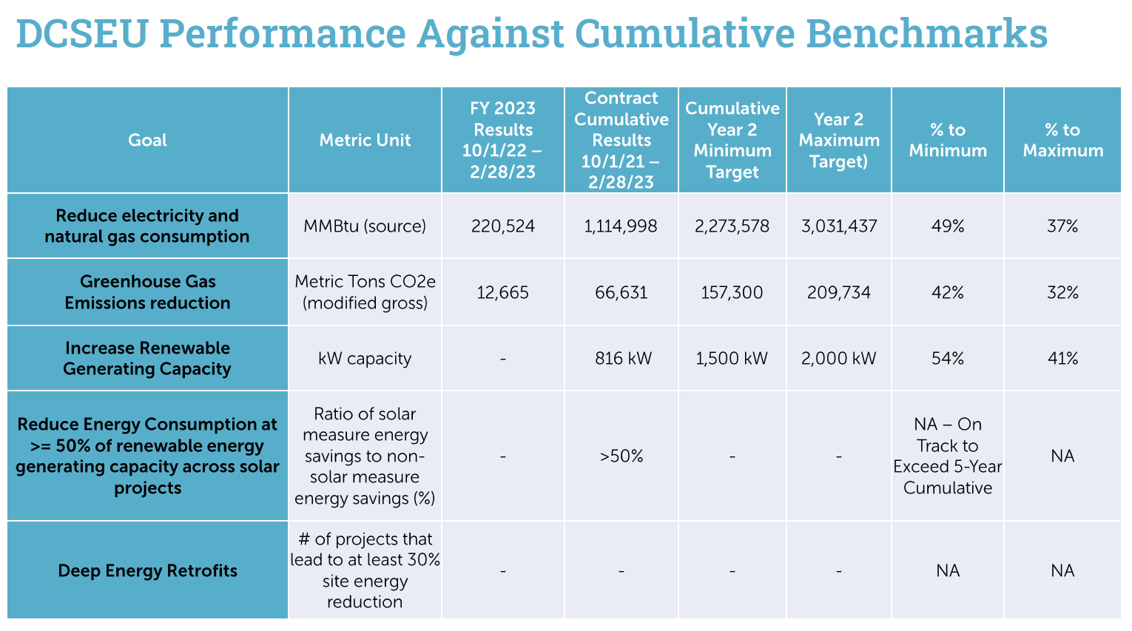

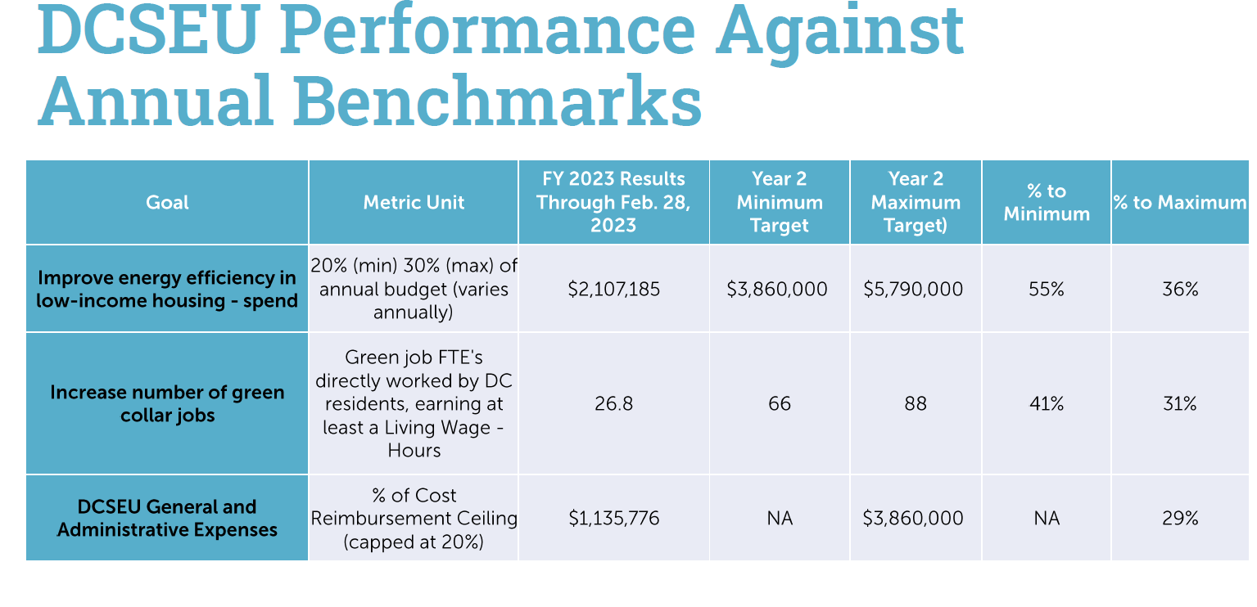
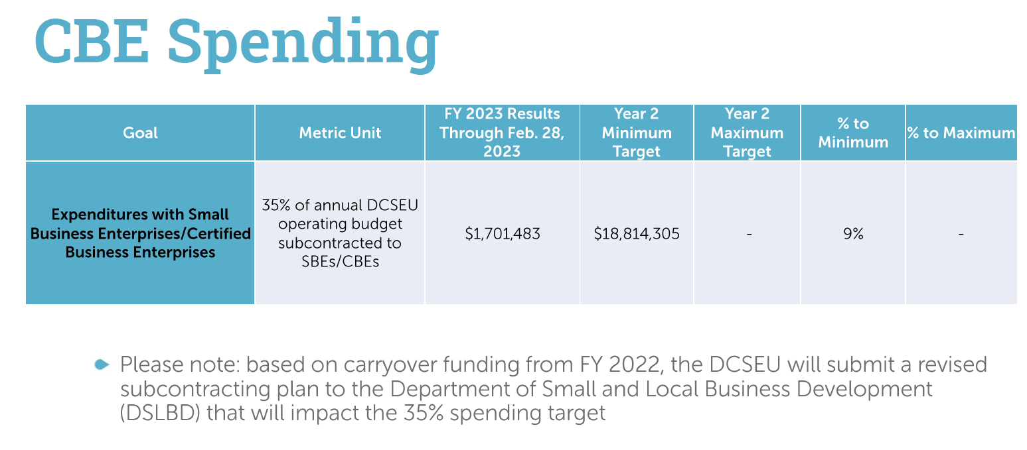
- Chair Bicky Corman asked what DCSEU’s revised plan for DSLBD would include.
- Ben Burdick (DCSEU) shared that DCSEU is resubmitting a subcontracting plan to DSLBD based on DCSEU’s new budget (increased).
- Chair Bicky Corman inquired whether the deep retrofit benchmark spending was different from the Affordable Housing Retrofit Accelerator (AHRA).
- Ben Burdick (DCSEU) explained that the deep retrofit benchmark is based on SETF funding, and AHRA is ARPA funding, not included in that deep retrofit benchmark.
- Chair Bicky Corman asked if the Building Energy Performance Standards (BEPS) were to be pushed back (as proposed in the Budget Support Act), would that affect DCSEU’s work?
- Ernest Jolly (DCSEU) shared there will be some implications but those are to be determined.
- Vice Chair Marshall Duer-Balkind mentioned that the other outcomes would be potential impacts on AHRA funding.
- Vice Chair Marshall Duer-Balkind inquired whether DCSEU analyzed the expected impact of funding for AHRA.
- Ernest Jolly (DCSEU) shared that DCSEU is hopeful additional funding will come in through IRA.
- Dr. Lance Loncke (DOEE) clarified that DCSEU FY24 funding will not be impacted by the Budget Support Act. Dr. Loncke mentioned that AHRA funding has always been on a temporary basis, however, the team is hopeful any unspent FY23 dollars can be carried over into FY24.
- Vice Chair Marshall Duer-Balkind highlighted that many AHRA projects take years to complete, so it would be challenging for the FY23 budget to be spent. Although FY23 carryover isn’t technically FY24 budget, the carryover will significantly impact the FY24 budget.
- Dr. Lance Loncke (DOEE) mentioned that the team would have a better idea of FY23 carryover in August or September.
- Dave Epley (DOEE) summarized that FY24 AHRA funding would be rollover funding.
- Vice Chair Marshall Duer-Balkind shared that many stakeholders were concerned with this question because the rollover money determines whether the DCSEU has assurance on funding to fully achieve its goals.
- Dave Epley (DOEE) confirmed that the uncertainty of FY24 rollover funding impacts the nature of AHRA implementation and this not only affects DCSEU but also building owners and contractors.
- Nina Dodge shared that regardless of the BEPS budget and delays on implementation, there are a significant number of building owners that are moving forward with BEPS and have compiled pathway plans. Nina asked if the DCSEU was involved with these buildings.
- Ernest Jolly (DCSEU) shared that BEPS and AHRA will be covered later in the presentation.
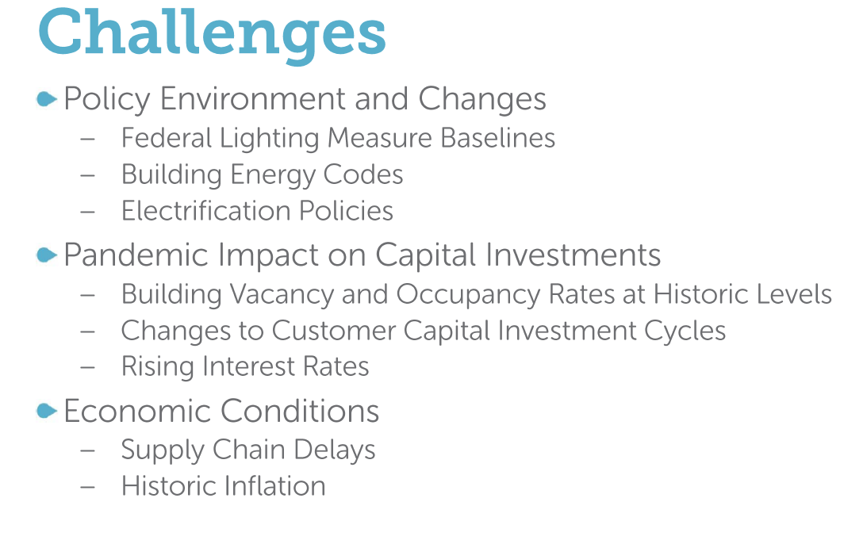
- Chair Bicky Corman recognized that many challenges have been unprecedented and unexpected, but some have been expected and asked if DCSEU could share its plan for anticipating some of the policy challenges and changes.
- Ernest Jolly (DCSEU) shared that DCSEU plans to lay out a timeline and impact of the challenges and will share the impact with the Board.
- Chair Bicky Corman asked if DCSEU could provide a timeline on the different instances (challenge with supply chain, building codes, etc.).
- Ernest Jolly (DCSEU) committed to providing this information by June 1.
- Sarah Kogel-Smucker (OPC) highlighted that some of the challenges shared, such as the supply chain delay, may be easing. She asked if the DCSEU examined where the supply chain/market is now versus where it was a year or two ago.
- Ernest Jolly (DCSEU) shared that his team is seeing less of a supply chain issue in the building envelope products (insulation, window enhancements, windows) and more delay in heat pumps and HVAC equipment. He explained that DCSEU is working closely with building owners and DOEE to keep track of projects affected by the supply chain.
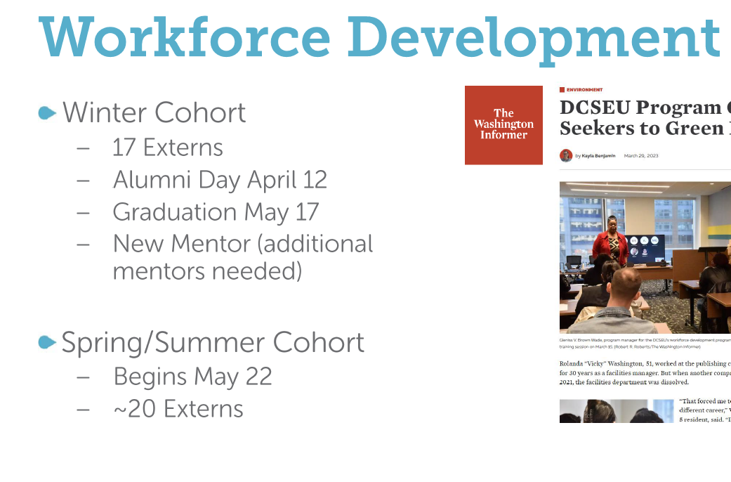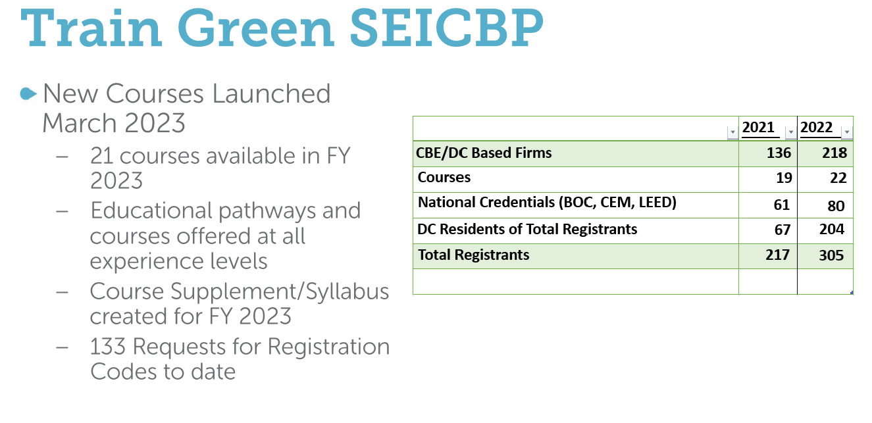
- Jamal Lewis asked what the average length of the courses is and how long it takes for someone to complete them.
- Crystal McDonald (DCSEU, Director of Account Management and Workforce Development, cmcdonald1@dcseu.com) shared that the shortest course is two days with the longest course being 12 weeks. She also mentioned that several courses are on demand and can be accessed at any time.
- Jamal Lewis inquired whether DCSEU tracked how people heard about the train green program.
- Crystal McDonald (DCSEU) noted that the team does not necessarily track this information, but DCSEU works with DOEE, DSLBD, and CBE’s to help spread the word.
- Nina Dodge asked if all train green mentors had to be from CBEs?
- Crystal McDonald (DCSEU) mentioned that mentors and hosts for the workforce development extern program do not have to be a CBE (thought that would be preferred)
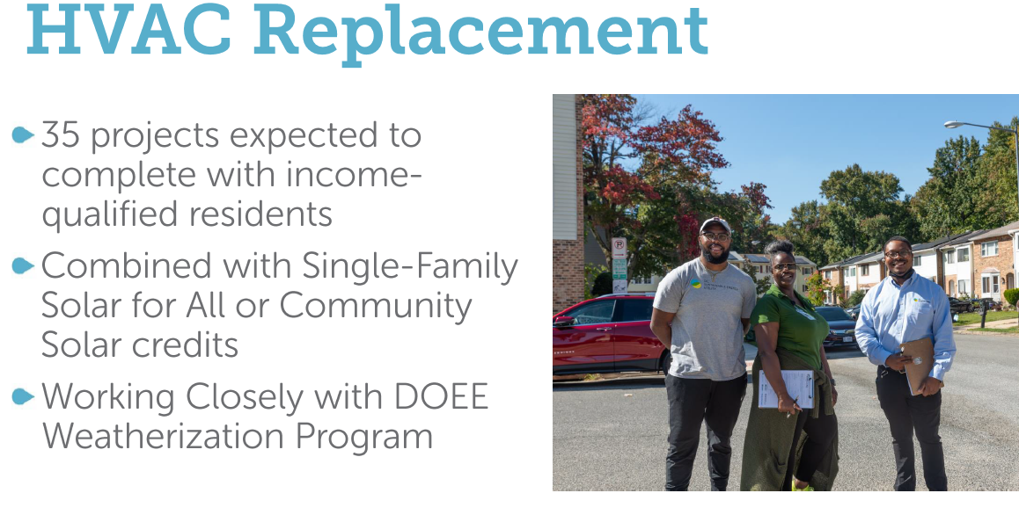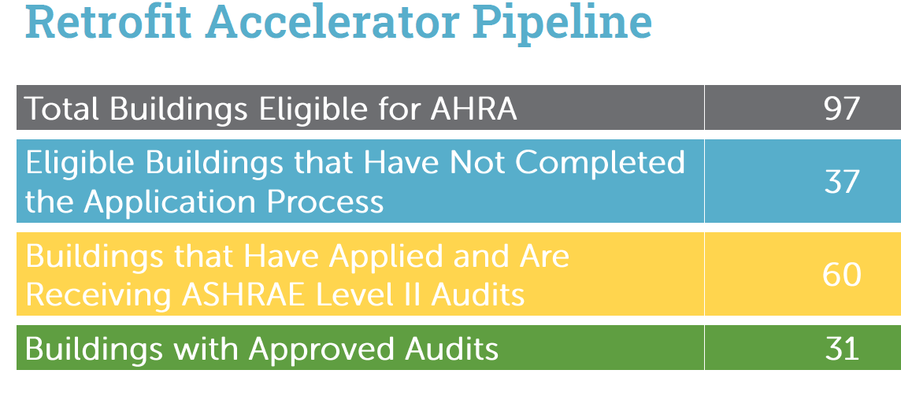
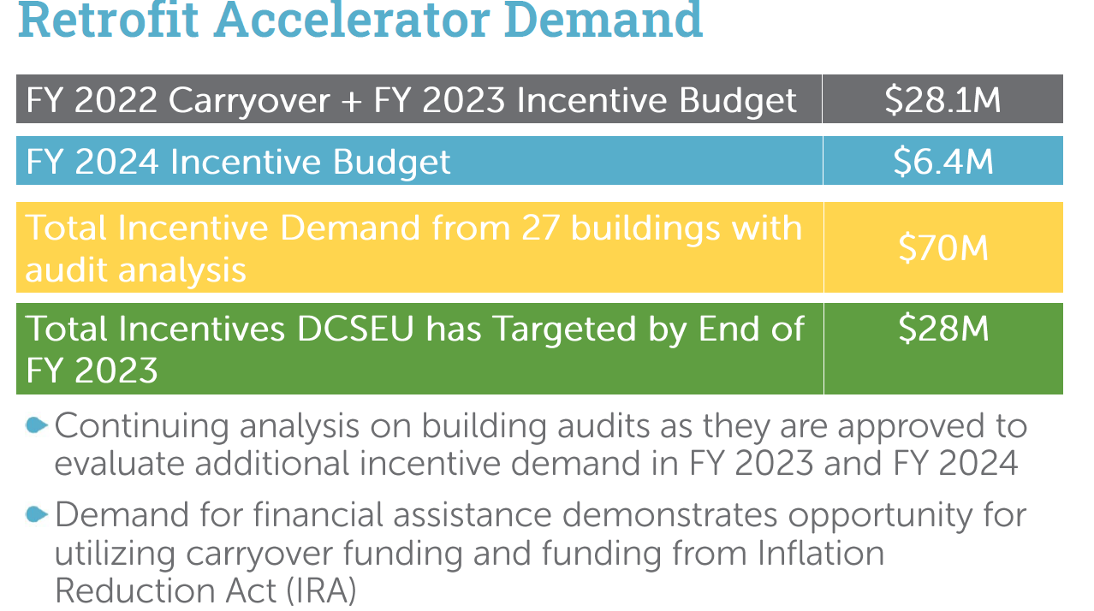
- Chair Bicky Corman Bicky asked if DCSEU was tracking the savings over time.
- Ben Burdick (DCSEU) confirmed the DCSEU plans to continue to track savings and these buildings as measures are completed.
- Jamal Lewis asked if the HVAC replacement program was replacing gas equipment to electric.
- Ben Burdick (DCSEU) confirmed.
- Jamal Lewis inquired about the heat pump supply chain and whether DCSEU had a pump supplier.
- Ben Burdick (DCSEU) shared that DCSEU works with two subcontractors on the HVAC replacement program and those organizations work through their own supply channels.
- Jamal Lewis asked if the amount of money that is demanded is based on projects that are currently in the pipeline.
- Ben Burdick (DCSEU) confirmed.
- Dave Epley (DOEE) shared that the 70 million (for the 27 buildings) is what is needed, not necessarily the funding available.
- Vice Chair Marshall Duer-Balkind highlighted the gap between the funding available (28 million) versus the amount needed (70 million) and asked how DCSEU planned to close that funding gap.
- Ben Burdick (DCSEU) mentioned that the 28 million includes what the team believes it can procure and install by the end of the fiscal year, September 30.
- Nina Dodge asked
  - Do all AHRA buildings fall under BEPS?
  - Could DCSEU provide an update on how the program is being advertised and how many buildings are in the que? Nina shared that this information could be followed up on.
- Dave Epley (DOEE) shared that when AHRA was designed and DOEE applied for American Rescue Plan Act (ARPA), DOEE worked from a list of 140 affordable housing projects that did not meet BEPS, 40 of those properties were public housing, which left 100 buildings to target through AHRA. He clarified that none of the AHRA buildings are government owned.
- Nina Dodge inquired whether all AHRA buildings were multifamily.
- Dave Epley (DOEE) confirmed.
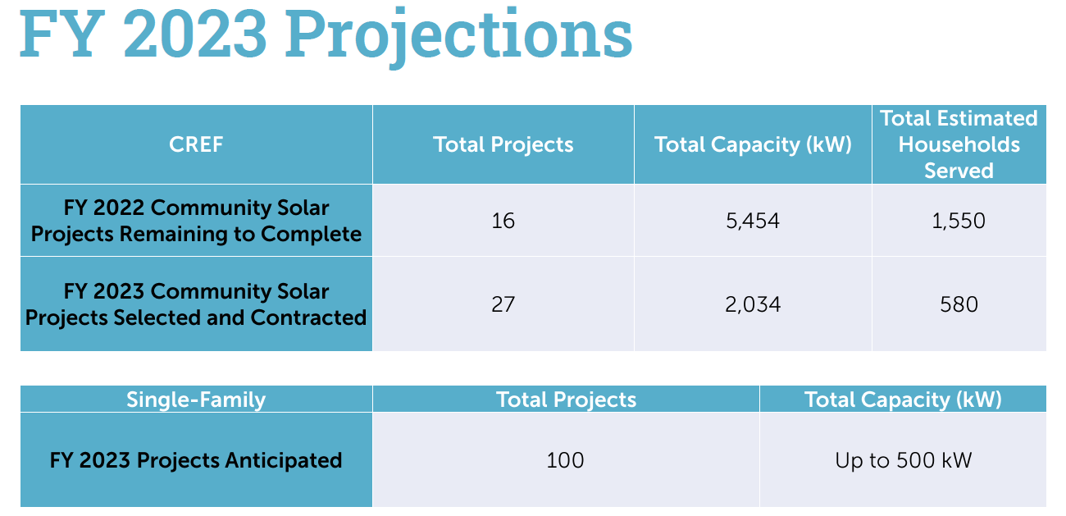
- Sasha Srivastava inquired why the project number went up in FY23, but the total capacity had gone down and whether DCSEU had reasoning on the difference between FY22 and FY23.
- Ben Burdick (DCSEU) shared the DCSEU team would follow up.
- Nina Dodge asked if AHRA project are also Solar for All served buildings.
- Ben Burdick (DCSEU) mentioned that AHRA buildings do not necessarily participate in Solar for All, however the Solar for All account management team is actively working with AHRA team to determine overlap.

FC1160 WGL EEDR Programs – Board Letter
- Vice Chair Marshall Duer-Balkind asked if the DCSEU team agreed with the Board’s draft letter.
- Ernest Jolly (DCSEU) confirmed that they agreed with the Boards position.
- Sarah Kogel-Smucker (OPC) inquired if the intention of WGLs programs is that WGL will fund smart thermostats and workforce development.
- Ernest Jolly (DCSEU) explained that WGL would provide supplemental funding to the already existing smart thermostat and workforce development program.
- Sarah Kogel-Smucker (OPC) asked if WGL would get a rate on return on what it charges to its customers (for the two proposed programs)?
- Sarah Kogel-Smucker (OPC) highlighted that it would be more expensive to pay for the programs via WGL (due to its 9.25% rate on return), than via current channels (via SETF funding).
- Vice Chair Marshall Duer-Balkind emphasized Sarah’s comments by stating WGL’s route would be more expensive to customers.
- Jamal Lewis mentioned that WGL’s workforce plan includes training on both electric and gas equipment and asked if there was room to adjust (given the DCSEU is no longer incentivizing gas).
- Ernest Jolly (DCSEU) shared that DCSEU’s workforce development covers all topics from the energy sector.
- Vice Chair Marshall Duer-Balkind shared that knowing about gas equipment helps the workforce speak more effectively to the nuances of gas and make the case more effectively with customers (than someone who only understands the electric side).
- John Richards (WGL) shared that the table on page 4 needed to be revised and he would get back to the Board on revised numbers.
- John Richards (WGL) mentioned upcoming dates:
  - April 25, 2023: requesting DOEE/DCSEU/DCSEUAB feedback/letter
    - DCSEUAB welcome to file on a timeline that works best for the Board
  - April 28, 2023: WGL submitting final proposal to PSC
- Nina Dodge inquired whether the greenhouse gas study findings were going to be included in WGL’s filings.
- John Richards (WGL) confirmed the filing will include the greenhouse gas study findings.
- Chair Bicky Corman asked if WGL would be putting in the investments as a regulatory asset and addressing in the next rate case.
- John Richards (WGL) shared he assumed so but would need to clarify.
- Chair Bicky Corman mentioned that it would cost less for DCSEU to provide the smart thermostats via SETF, that it would for WGL to provide the program.
- John Richards (WGL) clarified that there are two different programs being proposed:
  - DCSEU thermostats – WGL plans to augment DCSEU - $100 per thermostat incentive to customers.
  - Pepco marketplace - $100 incentive. An online marketplace administrative burdens are lower because through a website.
- John Richards (WGL) shared that given the proposed programs are non-gas equipment programs, WGL hopes to have the District’s support. John recognized the concern regarding the rate of return.
- Jamal Lewis asked if WGL had ever offered standalone building envelope programs?
- John Richards (WGL) noted that he was not aware of any standalone programs, however if WGL was approached by the PSC to implement a program without gas equipment, and if it could be implemented cost effectively, WGL would be open to it.
- Board members determined that a special meeting would be scheduled within the next week to finalize and vote on the WGL EEDR letter.

Board Action Items
- Approval of Meeting Agenda
- Approval of March Minutes

Future Agenda Items
- Special Board meeting to vote on WGL EEDR letter
- DCSEU FY23 Q2 Performance
- Approval of April Meeting Minutes
- Tracking bills and legislation

Adjournment
- Vice Chair Marshall Duer-Balkind adjourned the meeting at 12:05 PM.

Acronyms used during this meeting
- AHRA - Affordable Housing Retrofit Accelerator
- BEPS - Building Energy Performance Standards
- CAEA - Clean Affordable Energy Act
- CEDC Act – Clean Energy DC Act
- DCSEU - District of Columbia Sustainability Energy Utility
- DOEE - Department of Energy and Environment
- EEDR – Energy Efficiency and Demand Response
- OPC - Office of the People’s Counsel
- PHI – Pepco Holdings
- PSC - Public Service Commission
- WGL – Washington Gas Light
Minutes prepared by Jennifer Johnston, DOEE

