Sustainable Energy Utility Advisory Board (SEUAB) Meeting
Tuesday, January 9, 2024
10:00 AM – 12:00 PM

Call to Order
Vice Chair Dr. Larry Martin called the meeting to order at 10:06 AM, January 9, 2024. Dr. Martin called a quorum of the Sustainable Energy Utility Advisory Board (SEUAB or Board) at 10:05 AM. This was a Microsoft Teams video conference call meeting.

Roll Call/Instructions
Roll call was taken at 10:03 AM and the following people were in attendance:

Board Members
Name | In Attendance? | FY 2024 Special Meetings  Attendance Record | FY 2024 Regular Meetings  Attendance Record
Pending - Board Chair (Mayor’s Designee) | N/A | N/A | N/A
Mansi Talwar (Councilmember Allen) | Yes | 1/1 | 3/4
Sandra Mattavous-Frye (or OPC proxy) | Yes | 1/1 | 3/4
Danielle Gurkin (PSC) | Yes | 0/1 | 2/4
Pending - (Electric Company) | N/A | N/A | N/A
Eric Jones (Building Management) | Yes | 0/1 | 4/4
Nina Dodge (Environment) | Yes | 1/1 | 4/4
Jamal Lewis (Low-Income Community) | Yes | 1/1 | 4/4
Jaleel Shujath (Economic Development) | Yes | 1/1 | 4/4
Sasha Srivastava (Renewable Energy) | Yes | 1/1 | 4/4
Giuls Kunkel (Building Construction) | Yes | 1/1 | 2/4
Dr. Larry Martin – Vice Chair (Council Chairperson Mendelson) | Yes | 1/1 | 4/4
Pending – (Gas Utility) | N/A | N/A | N/A

Other Attendees: Patti Boyd (DCSEU), Angela Johnson (DCSEU), Ben Burdick (DCSEU), Crystal McDonald (DCSEU), Jahmai Sharp (DCSEU), Tamara Christopher (DCSEU), Solome Girme (DCSEU) Rebecca Foster (VEIC), Jennifer Johnston (DOEE), Dr. Lance Loncke (DOEE), Hussain Karim (DOEE), Dr. Yohannes Mariam (OPC), Kintéshia Scott (OPC), Portia Hurtt (WGL), Lamont Akins (Pepco), Nicholas Weil (BEGA)

Approval of Agenda
- Vice Chair Dr. Larry Martin moved to approve the agenda and was seconded by Jamal Lewis. All were in favor, and none were opposed.

Approval of December Minutes
- Vice Chair Dr. Larry Martin moved to approve the December meeting minutes and was seconded by Mansi Talwar. All were in favor, none were opposed.

Workforce Development
- Crystal McDonald (DCSEU) presented on DCSEU’s workforce development and Train Green Sustainable Energy Infrastructure Capacity Building and Pipeline Program (Train Green SEICBP):
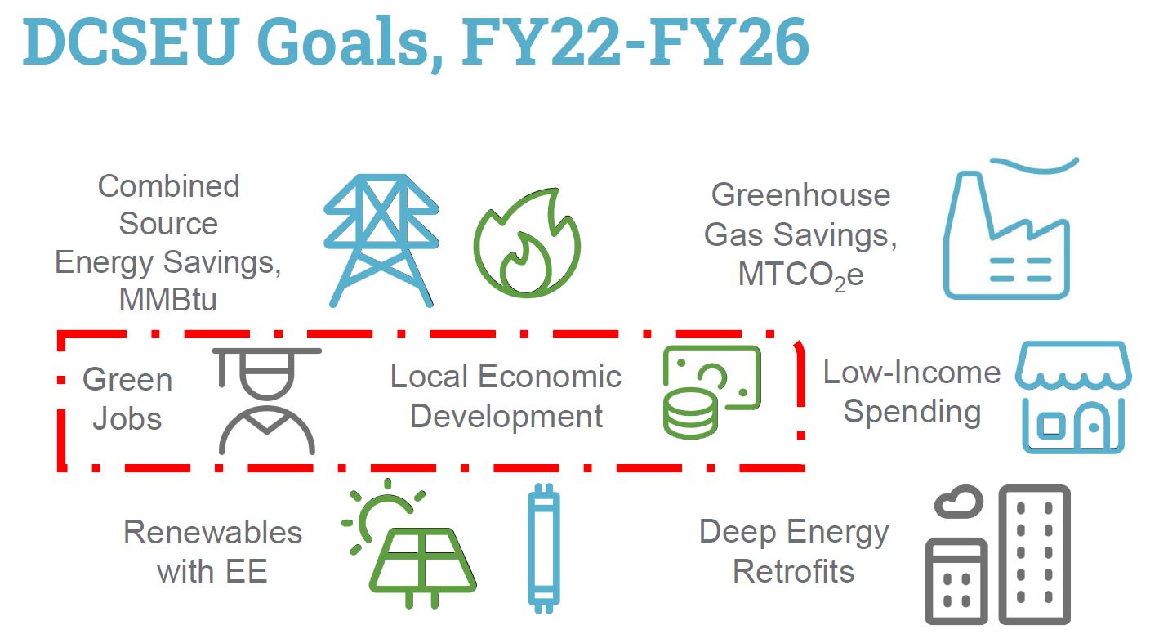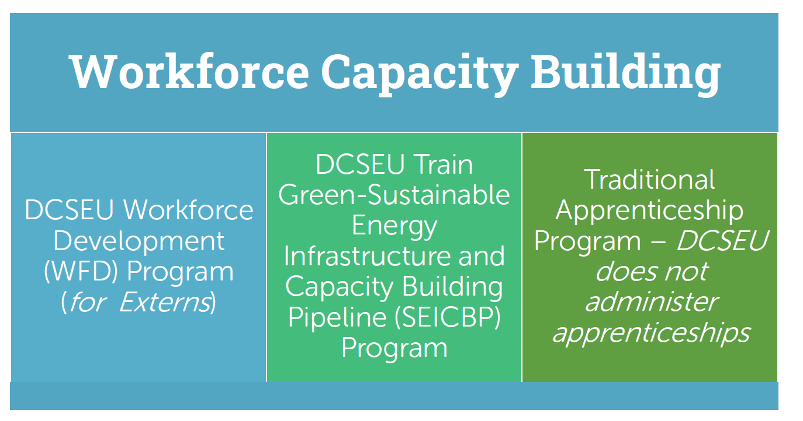
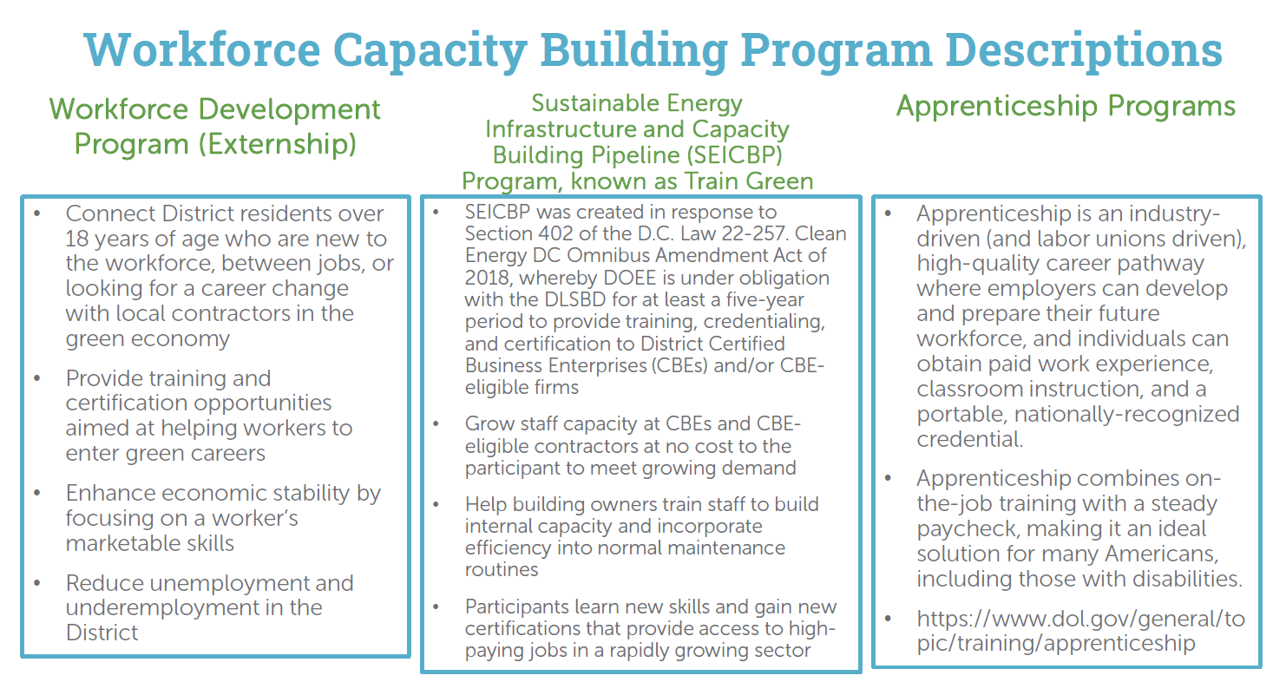
- Gleniss Brown Wade (DCSEU) provided an overview of DCSEU’s workforce development impact:
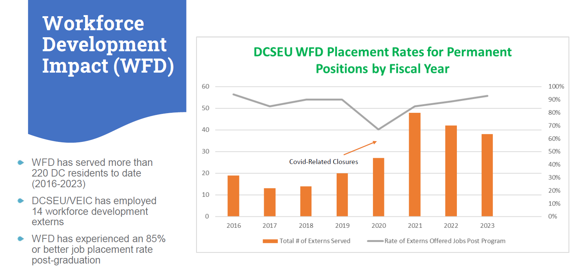
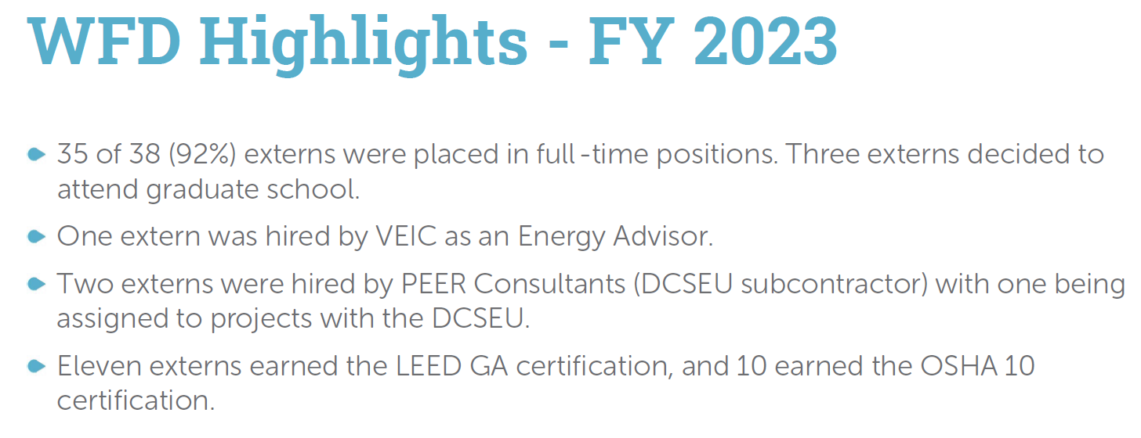
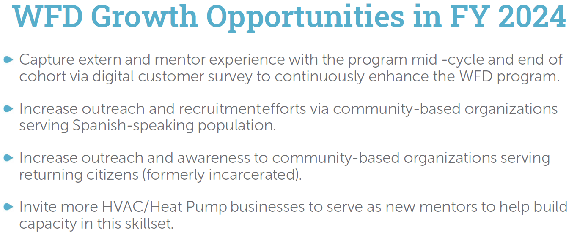
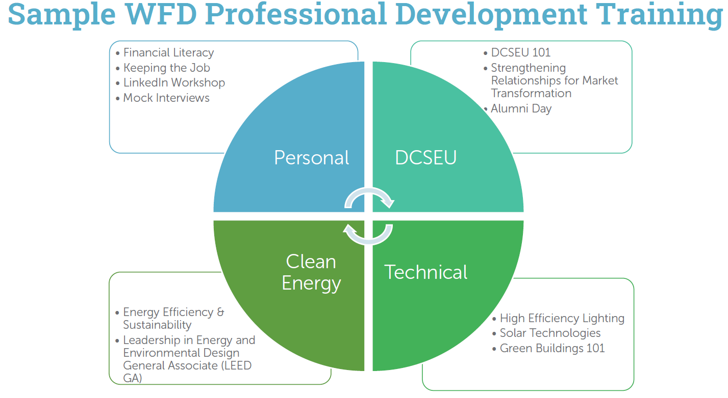
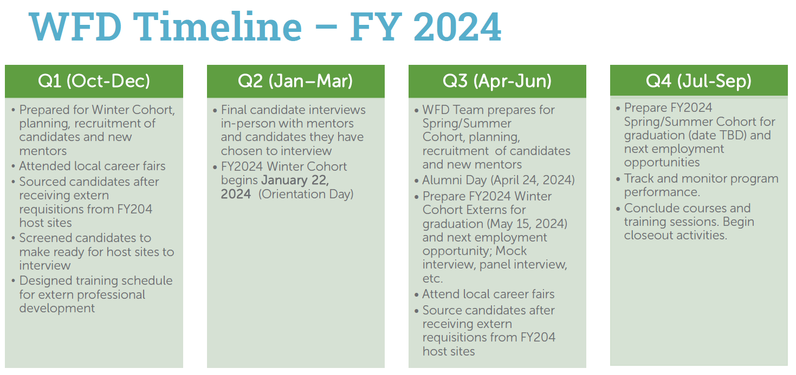
- Crystal McDonald (DCSEU) shared that on Wednesday mornings the externs have professional development training with DCSEU staff on energy efficiency and sustainability. Crystal extended an invitation to the Board.
- Mark Bryan (DCSEU) presented on DCSEU’s Train Green SEICBP:
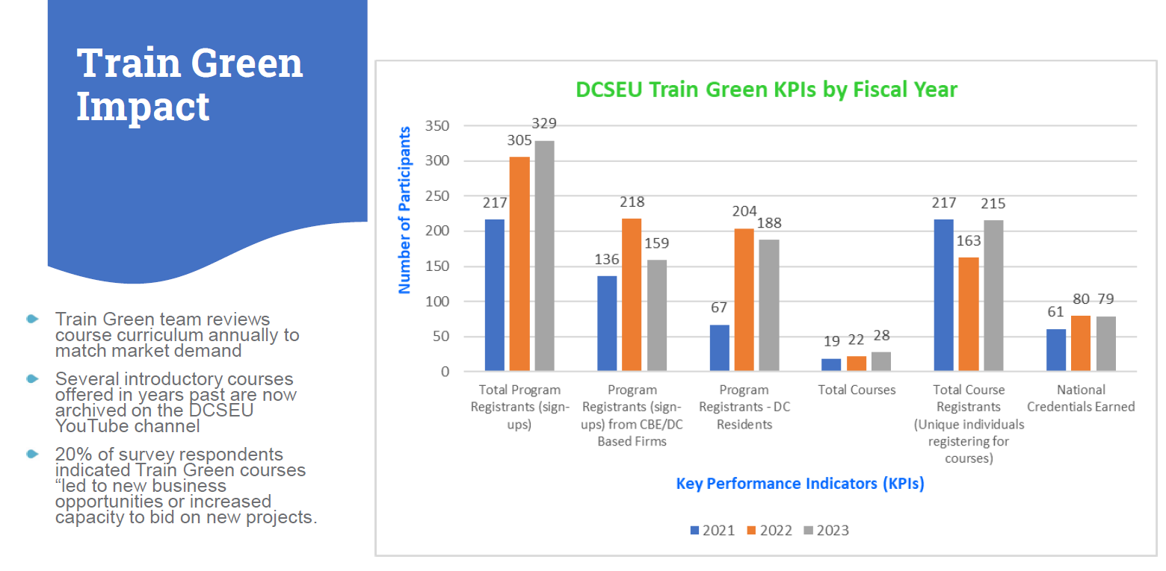
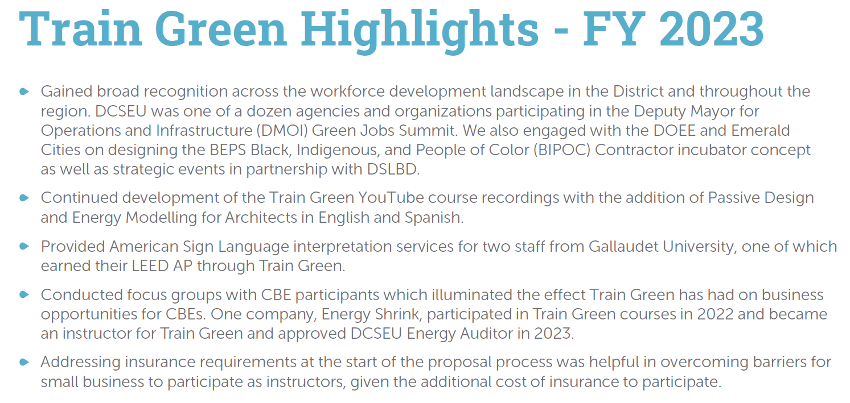
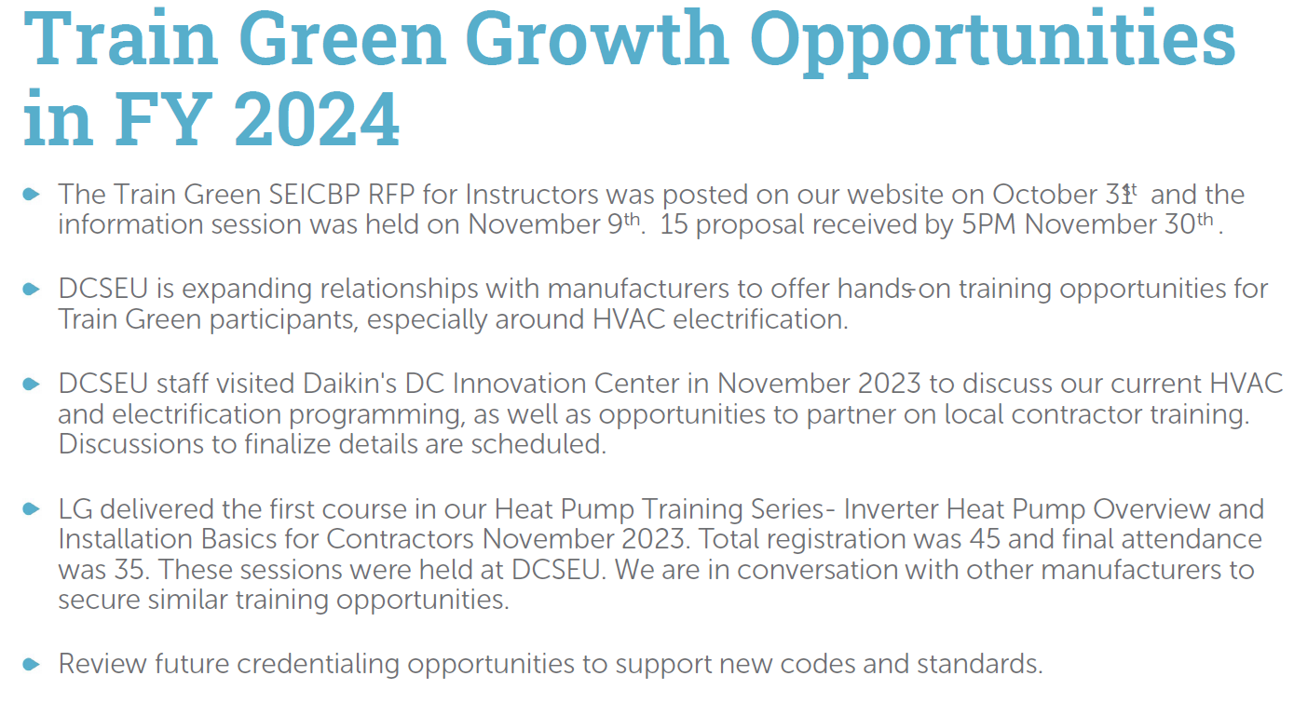
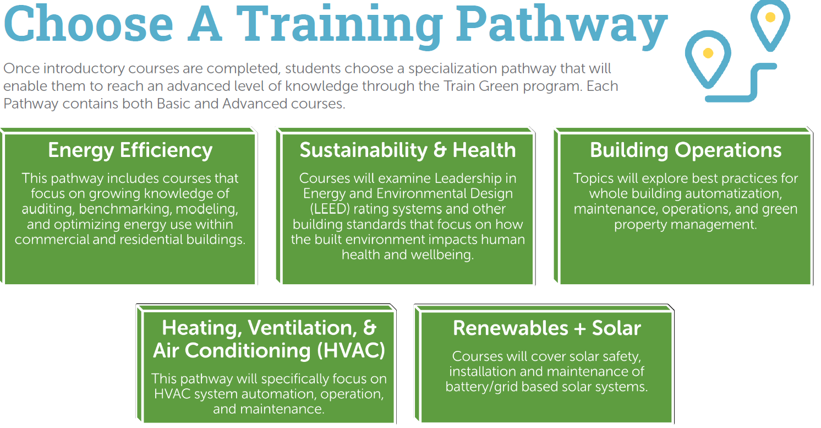
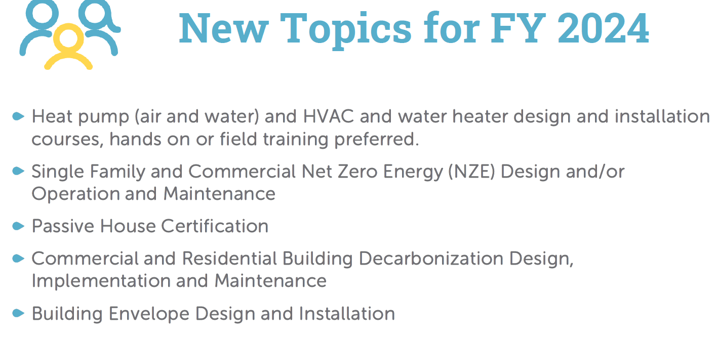
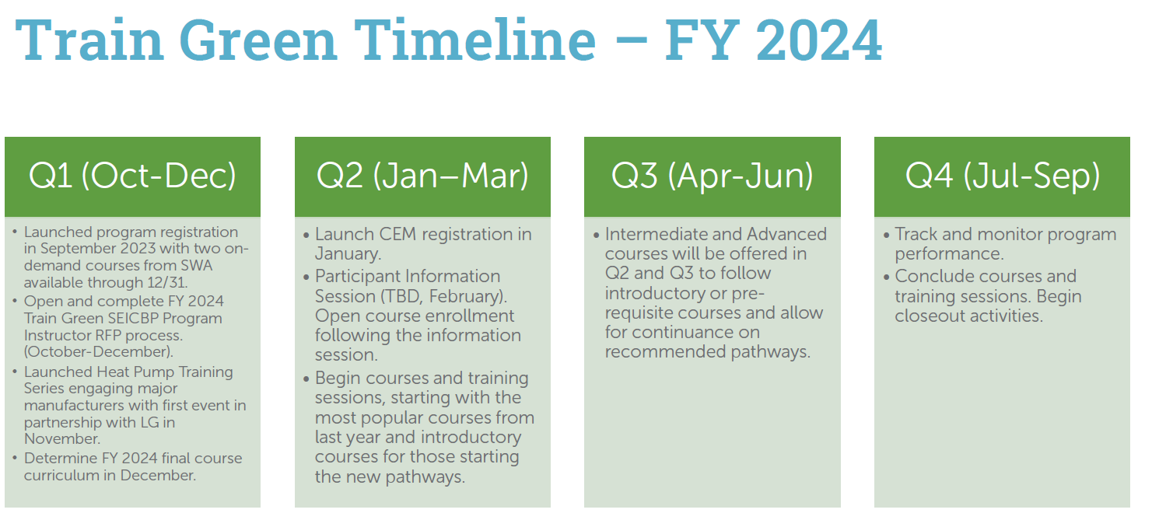

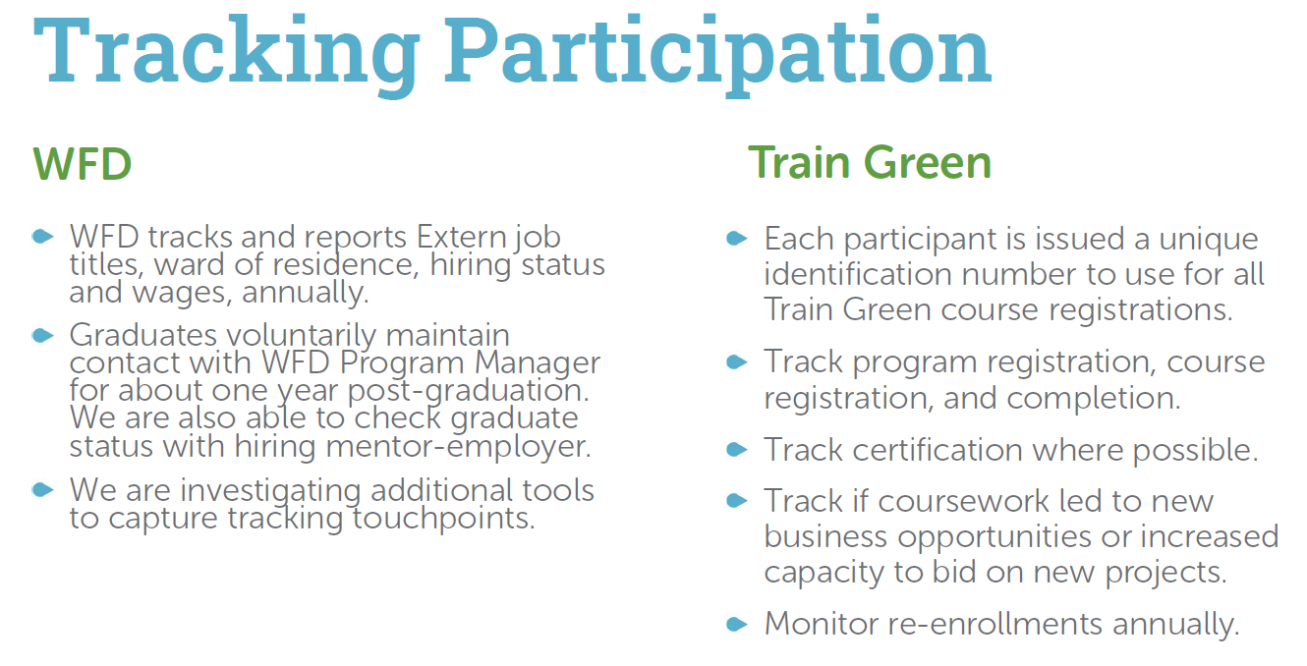
- Jamal Lewis asked if the DCSEU tracked how long registrants had been in the field before applying for SEICBP training opportunities.
- Crystal McDonald (DCSEU) shared that DCSEU does not track participants work experience.
- Mark Bryan (DCSEU) mentioned that DCSEU does ask participants their basic level of experience (introductory, etc.).
- Eric Jones asked:
  - How does the DCSEU coordinate with the other workforce development groups in the District?
  - How is the DCSEU ensuring efforts are being tracked?
  - Does the DCSEU have any interaction with the Workforce Investment Council?
    - If not, what work can be done to ensure more collaboration moving forward?
- Crystal McDonald (DCSEU) highlighted the DCSEU’s coordination with the other workforce development programs (outlined below). Crystal mentioned that the DCSEU team has been in touch with Department of Employment Services and the DC infrastructure Academy. Crystal also shared that she planned to meet with Drew Hubbard (Workforce Investment Council).
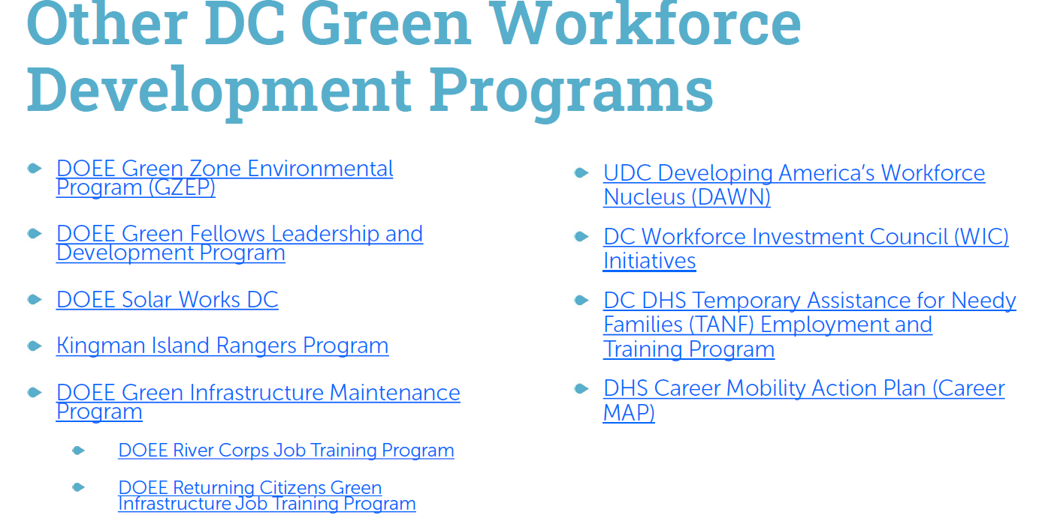
- Director Ernest Jolly (DCSEU) shared that the DCSEU also participated on a panel with the Deputy Mayor of Operations and Infrastructure on workforce development which focused on coordinating with other programs.
- Jaleel Shujath thanked the DCSEU workforce team for their work and asked:
  - How is the DCSEU getting the word out about its workforce development opportunities?
- Crystal McDonald (DCSEU) shared that the DCSEU promotes its workforce development opportunities through multiple channels such as its trade ally newsletter, coordinating with DC Department of Small & Local Business Development (DSLBD), and working with its commercial and industrial partners.
- Jaleel Shujath asked:
  - Is the DCSEU coordinating with University of DC’s (UDC’s) apprenticeship and workforce development program?
- Crystal McDonald (DCSEU) mentioned that the DCSEU is not working with UDC in a formal capacity.
- Jaleel Shujath asked:
  - Is DOEE tracking the green workforce development across the different programs?
- Dr. Lance Loncke (DOEE) shared that DOEE was not tracking this information.
- Nina Dodge asked:
  - Is the DCSEU coordinating with unions and if so, what unions have parallel programs?
- Crystal McDonald (DCSEU) highlighted that the DCSEU does not have direct coordination with unions.
- Mark Bryan (DCSEU) mentioned the 602 steamfitters’ union in Maryland, though there is not direct overlap between 602 work and DCSEU’s workforce development opportunities.
- Eric Jones shared that 80% of the local construction industry is not union-based.
- Crystal McDonald (DCSEU) offered to follow-up with Jaleel and Eric and would reach out to them directly.
- Vice Chair Dr. Larry Martin proposed the Board form a subcommittee to continue the conversation on workforce development and report findings/suggestions back to the larger group. Dr. Martin inquired who would be interested in participating.
- Jaleel Shujath and Eric Jones volunteered to participate on the workforce development subcommittee.
- Nina Dodge shared that one union dealing with utilities in the DMV highlighted that the
work supporting decarbonization and electrification pay less than those positions working with gas pipelines.

DERs Follow Up Discussion
- Vice Chair Dr. Larry Martin shared the following slide deck:
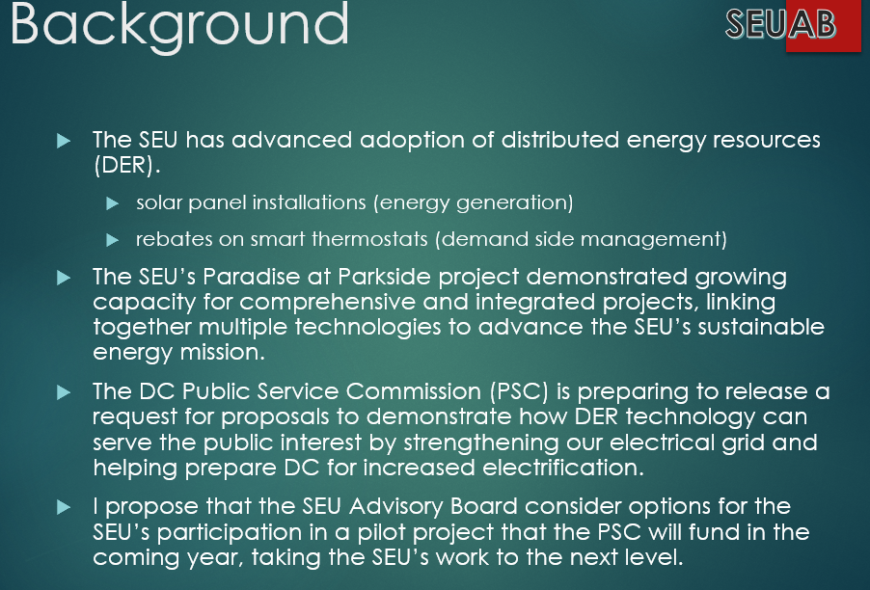
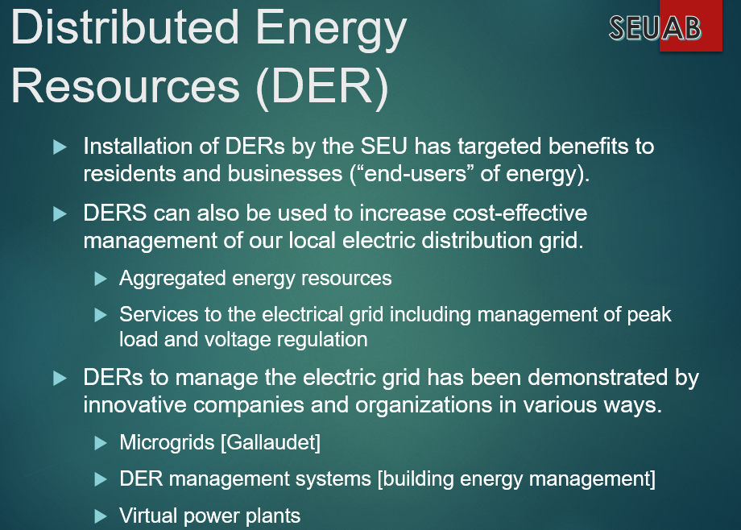
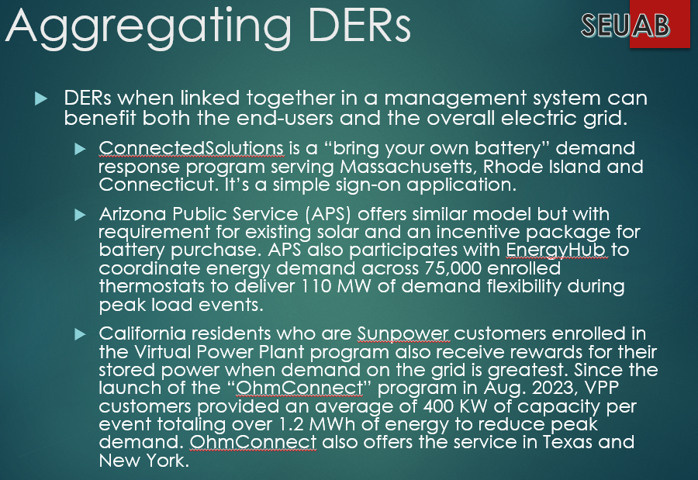
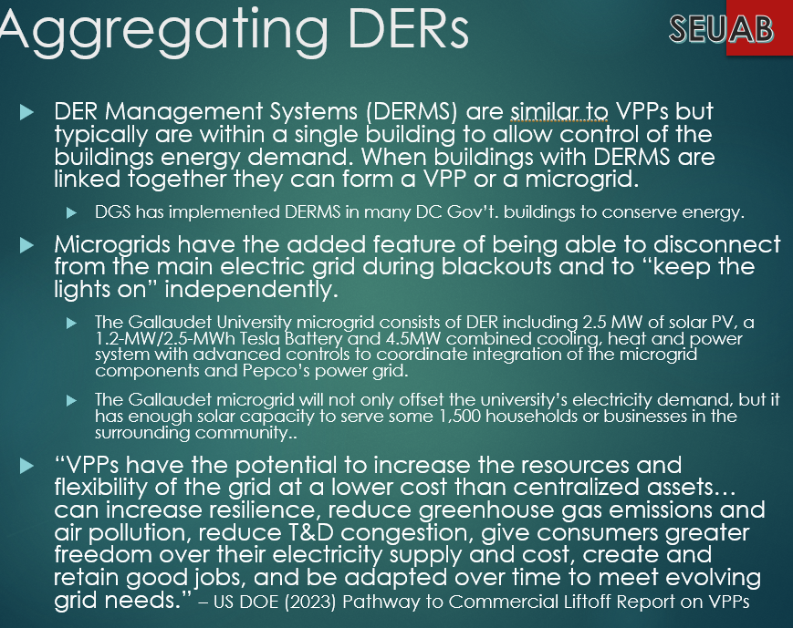
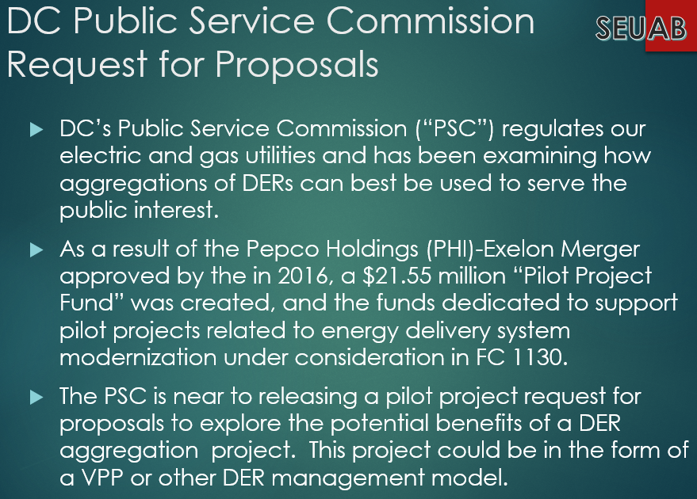
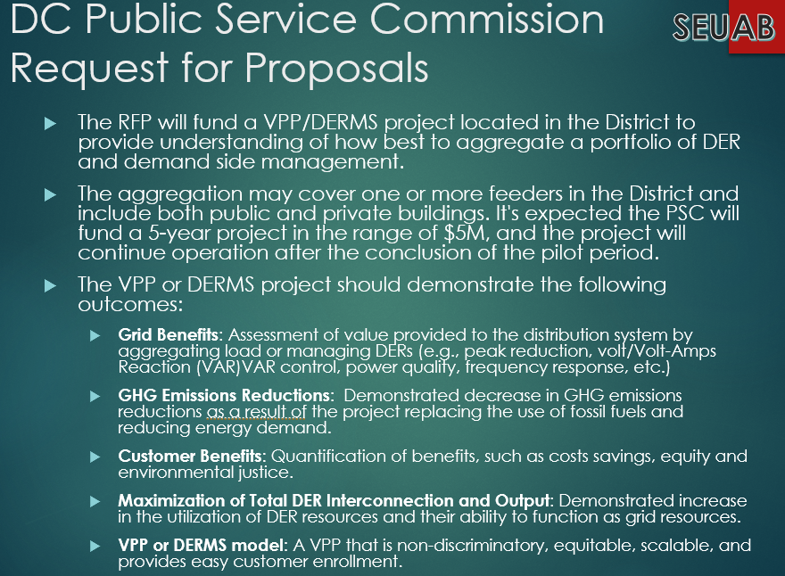
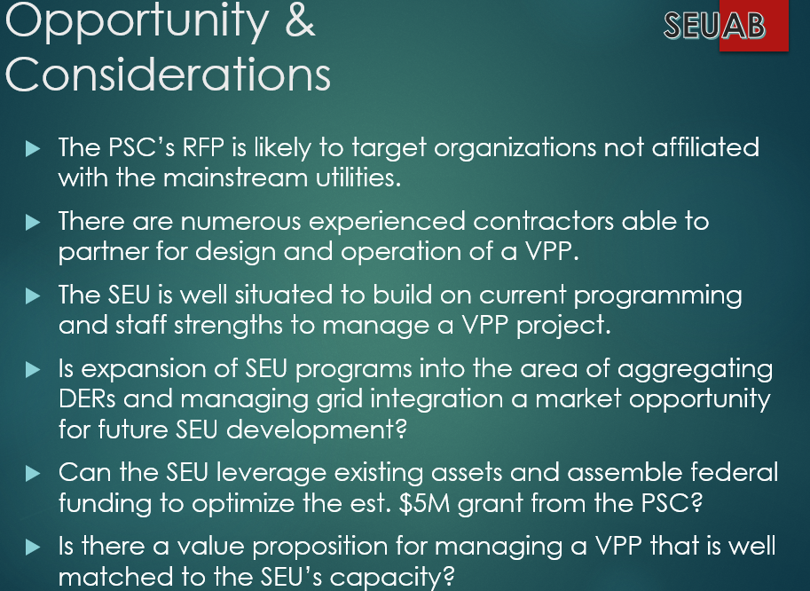
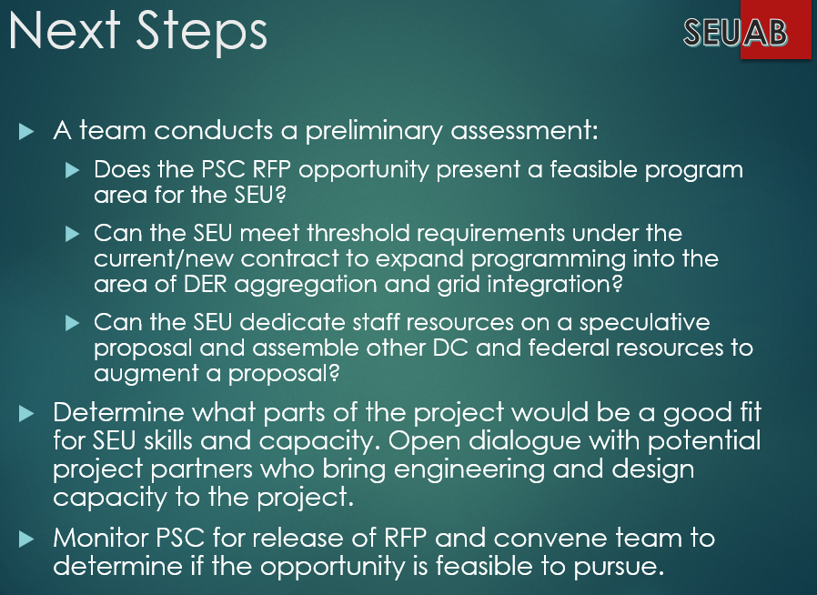
- Mansi Talwar shared that she liked the idea of exploring this opportunity. She highlighted that if the DCSEU wanted to participate in a virtual power plant (VPP), it would need to have a partnership with the system owner and a company like Skilled Grids (similar to the microgrid project at Gallaudet University). She also mentioned that the $5 million grant would not cover the cost of the project, so the DCSEU would need Federal funding and financial support from partners.
- Guils Kunkel asked Vice Chair Dr. Larry Martin whether he envisioned a commercial sector or a single family/multifamily residential customer for the pilot? Guils also asked if the examples provided in the slide deck (Arizona and California) were focused in more urban environments or spread across the state?
- Nina Dodge shared that with the $5 million budget, the project would have to be a small-scale pilot and that DCSEU should build off current projects to use in a potential proposal.
- Jamal Lewis asked Vice Chair Dr. Larry Martin what the eligibility criteria was for organizations applying for this pilot?
- Vice Chair Dr. Larry Martin shared that based on the early RFP draft, the utilities or any entity with a utility contract were excluded. Dr. Martin mentioned that the examples shared were in an urban environment, however DER models range from centralized to de-centralized. For example, there was one project that coupled solar power with batteries. The complex installed batteries all over the property and the system was self-contained (most likely exporting as much power as the system imported). In Arizona, the Arizona Public Service (APS) operates a bring your own thermostat program where the EnergyHub coordinates energy demand across 75,000 enrolled thermostats to deliver 110 MW of demand flexibility during peak load events.
- Vice Chair Dr. Larry Martin mentioned the DCSEU would focus on something specific for the pilot project given the funding constraints. Dr. Martin highlighted the potential opportunity to couple PSC funding with the Inflation Reduction Act and grants coming out of the U.S. Department of Energy (U.S. DOE).
- Jamal Lewis asked the DCSEU team what the next steps were in considering a proposal for the VPP/ Distributed energy resource management systems (DERMS) project?
- Director Ernest Jolly shared the DCSEU team would first need to connect with DOEE to determine if the VPP/DERMS RFP aligns with DCSEU’s contract obligations.
- Nina Dodge asked the DCSEU team what technical assistance would be needed to explore the VPP/DERMS space and offered the Board as a resource to connect staff with national subject matter experts.
- Vice Chair Dr. Larry Martin echoed Nina’s comment and shared the Rocky Mountain Institute (RMI) and U.S. DOE have resources available in the VPP/DERMS space. Dr. Martin suggested a subcommittee be created if DCSEU and DOEE determine the RFP is a good fit for the DCSEU.
- Nina Dodge suggested the Board continue to explore VPP/DERMS even if the DCSEU does not pursue the RFP. Nina highlighted the need to decrease load on the grid and that learning more about VPP/DERMS could be an educational opportunity.

Legislative
- Hussain Karim (DOEE) highlighted several PSC cases:
  - FC 1156: Pepco applied for a second multiyear rate plan. OPC and the District government will file direct testimony on 1/12/24.
  - PSC held abeyance (has not authorized) WGL's request for an extension of PROJECTPipes 2 (PP2) for another year. In this request, WGL also asked for $57 million to expand through December 2024 (3-year PP2 plan was originally from January 1, 2021, to December 31, 2023, for a total amount of $150 million in December 2020).
  - PSC approved WGL’s request for a $24 million rate increase.
- Hussain Karim (DOEE) mentioned PROJECTPipes is different from other proceedings because WGL can recover its expenditures almost immediately without having to wait to file another rate application. Hussain also shared there was no update on WGL’s incentive program comment period.

New Business
- Jennifer Johnston shared the following upcoming events:
  - Festival Center Open House
    - Where: Festival Center, 1640 Columbia Road NW Washington, DC 20009
    - When: Thursday, January 11 from 9am-11am
    - More information: https://festivalcenter.org/event/openhouse/
  - Bicky's Celebration of Service (I will share a meeting invite shortly)
    - Where: Logan Tavern, 1423 P St NW, Washington, DC 20005
    - When: Thursday, January 18 from 5:30pm-7pm
- Jennifer also shared information on DOEE’s Sustainability Awards:
  - Application period opens: January 2, 2024
  - Application period closes: January 30, 2024
  - To view the online application form and learn more about the awards, go to: District Sustainability Awards | doee (dc.gov)
  - What are the awards?
    - The District Sustainability Awards highlight businesses, individuals, and organizations that are working towards a more sustainable DC. Awardees’ projects and programs support the Mayor’s Sustainable DC Plan, which aims to make the District the nation’s greenest, healthiest, most sustainable city; it encompasses equity, governance, education, built environment, climate, economy, energy, food, nature, transportation, waste, and water.

Board Action Items
- Approval of Meeting Agenda
- Approval of December Minutes
- Approval to form a subcommittee on workforce development

Future Agenda Items
- Approval of January Meeting Minutes
- Contract Modifications
- Working Group Update: FC1130
- DOEE/DCSEU Oversight hearing
- Legislative Updates
- New Business

Adjournment
- Vice Chair Dr. Larry Martin adjourned the meeting at 11:53 AM.

Acronyms used during this meeting
- AHRA - Affordable Housing Retrofit Accelerator
- ATO - Authorization to Operate
- BSA - Bill Stabilization Adjustment
- CAEA - Clean and Affordable Energy Act of 2008
- CBE - Certified Business Enterprise
- CEM - Certified Energy Manager
- CREF - Clean Renewable Energy Facility
- DCSEU - District of Columbia Sustainability Energy Utility
- DERMS - Distributed Energy Resource Management Systems
- DOB – Department of Buildings
- DOEE - Department of Energy and Environment
- DSLBD - DC Department of Small & Local Business Development
- EEDR – Energy Efficiency and Demand Response
- kW - kilowatt
- MOTA – Mayor's Office of Talent and Appointments
- OPC - Office of the People’s Counsel
- PP2 - PROJECTPipes 2
- PSC - Public Service Commission
- SBCT - Societal Benefit Cost Test
- SEICBP - Sustainable Energy Infrastructure Capacity Building and Pipeline Program
- SETF - Sustainable Energy Trust Fund
- TAG - Technical Advisory Groups
- VPP - Virtual Power Plant
- WGL – Washington Gas Light
Minutes prepared by Jennifer Johnston, DOEE

