Sustainable Energy Utility Advisory Board (SEUAB) Meeting
Tuesday, November 14, 2023
10:00 AM – 12:00 PM

Call to Order
Chair Bicky Corman called the meeting to order at 10:07 AM, November 14, 2023. Chair Bicky Corman called a quorum of the Sustainable Energy Utility Advisory Board (SEUAB or Board) at 10:08 AM. This was a Microsoft Teams video conference call meeting.

Roll Call/Instructions
Roll call was taken at 10:08 AM and the following people were in attendance:

Board Members
Name | In Attendance? | FY 2024 Special Meetings  Attendance Record | FY 2024 Regular Meetings  Attendance Record
Bicky Corman - Board Chair (Mayor’s Designee) | Yes | 1/1 | 2/2
Mansi Talwar (Councilmember Allen) | Yes | 1/1 | 1/1
Sandra Mattavous-Frye (or OPC proxy) | No | 1/1 | 1/1
Danielle Gurkin (PSC) | No | 0/0 | 1/1
Pending - (Electric Company) | N/A | N/A | N/A
Eric Jones (Building Management) | Yes | 0/0 | 2/2
Nina Dodge (Environment) | Yes | 1/1 | 2/2
Jamal Lewis (Low-Income Community) | No | 1/1 | 1/1
Jaleel Shujath (Economic Development) | Yes | 1/1 | 2/2
Sasha Srivastava (Renewable Energy) | Yes | 1/1 | 2/2
Giuls Kunkel (Building Construction) | No | 1/1 | 0/0
Dr. Larry Martin – Vice Chair (Council Chairperson Mendelson) | Yes | 1/1 | 2/2
Pending – (Gas Utility) | N/A | N/A | N/A

Other Attendees: Ernest Jolly (DCSEU), Patti Boyd (DCSEU), Angela Johnson (DCSEU), Ben Burdick (DCSEU), Crystal McDonald (DCSEU), Jahmai Sharp (DCSEU), Rebecca Foster (VEIC), Hussain Karim (DOEE), Dr. Lance Loncke (DOEE), Jennifer Johnston (DOEE), Dave Epley (DOEE), Lamont Akins (Pepco), Poetri Deal (Pepco)

Approval of Agenda
- Chair Bicky Corman moved to approve the agenda and was seconded by Eric Jones. All were in favor, and none were opposed.

Approval of October and November Minutes
- Nina Dodge moved to approve the October and November meeting minutes and was seconded by Vice Chair Dr. Larry Martin. All were in favor, none were opposed.

Board’s FY22 Annual Report
- The Board incorporated minor edits to the annual report.
- Eric Jones moved to approve the Board’s FY22 annual report and was seconded by Eric Jones. All were in favor, and none were opposed.

DCSEU’s FY23 Preliminary Results
- Ben Burdick (DCSEU) presented on DCSEU’s FY23 preliminary results:
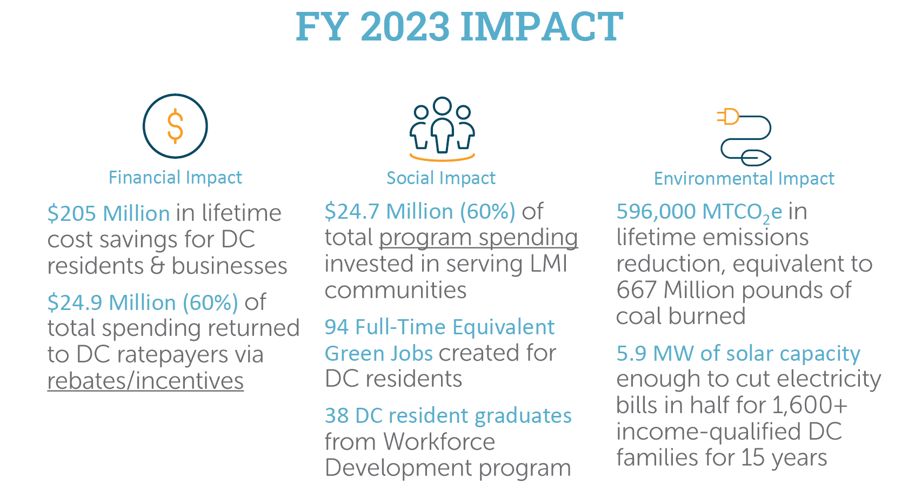
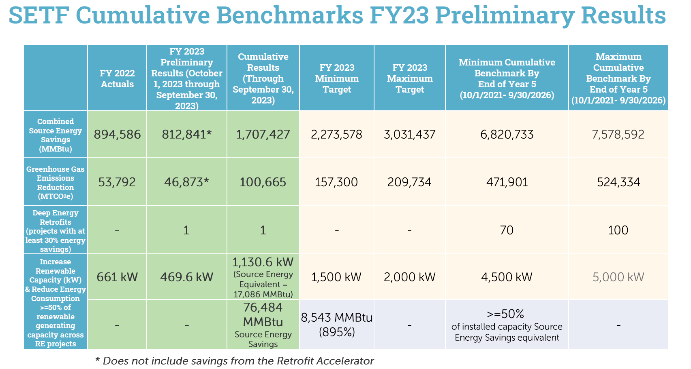
- Nina Dodge asked if the deep energy retrofit benchmark had an income requirement.
- Ben Burdick (DCSEU) shared that the deep energy retrofit benchmark included any building above 50,000 square feet.
- Nina Dodge asked if the DCSEU could explain Source Energy Equivalent.
- Patti Boyd (DCSEU) provided an example:
  - If a renewable energy system generates 500-kilowatt (kW) hours a year, this benchmark says that the DCSEU needs to find energy savings of half of that 500 kW hours a year.
- Chair Bicky Corman asked if the DCSEU deployed 1,130.6 kW then 50% of that energy would need to be saved through energy efficiency measures.
- Patti Boyd (DCSEU) explained:
  - The 1,130.6 kW is converted to Source Energy Equivalent (via PVWatts calculator) of 17,086 MMBtu, so the DCSEU would need to meet 50% of 17,086 MMBtu (8,543 MMBtu) in energy efficiency savings.
- Chair Bicky Corman highlighted that DCSEU is behind the year 2 benchmark.
- Patti Boyd (DCSEU) shared the DCSEU is confident it will meet the year 5 renewable energy benchmark.
- Mansi Talwar inquired whether the renewable energy benchmark only included projects that were authorized to operate (ATO) by Pepco and if the DCSEU was on the second year of the contract period in FY23.
- Ben Burdick (DCSEU) confirmed all projects counted toward this benchmark have been ATO’d and that FY23 is the second year of the contract cycle.
- Nina Dodge highlighted the importance of the DCSEU educating the public and the Board of these benchmarks.
- Director Ernest Jolly (DCSEU) offered to provide a workshop on DCSEU’s contract benchmarks so the Board is able to articulate the DCSEU’s goals.
- Chair Bicky Corman inquired whether Pepco and/or Washington Gas would have similar metrics for its utility energy efficiency and demand response (EEDR) programs.
- Director Ernest Jolly (DCSEU) mentioned that the Public Service Commission (PSC) ultimately decides the metrics for the utility EEDR programs, however the DCSEU tries to be a leader in this space to provide guidance to the PSC.
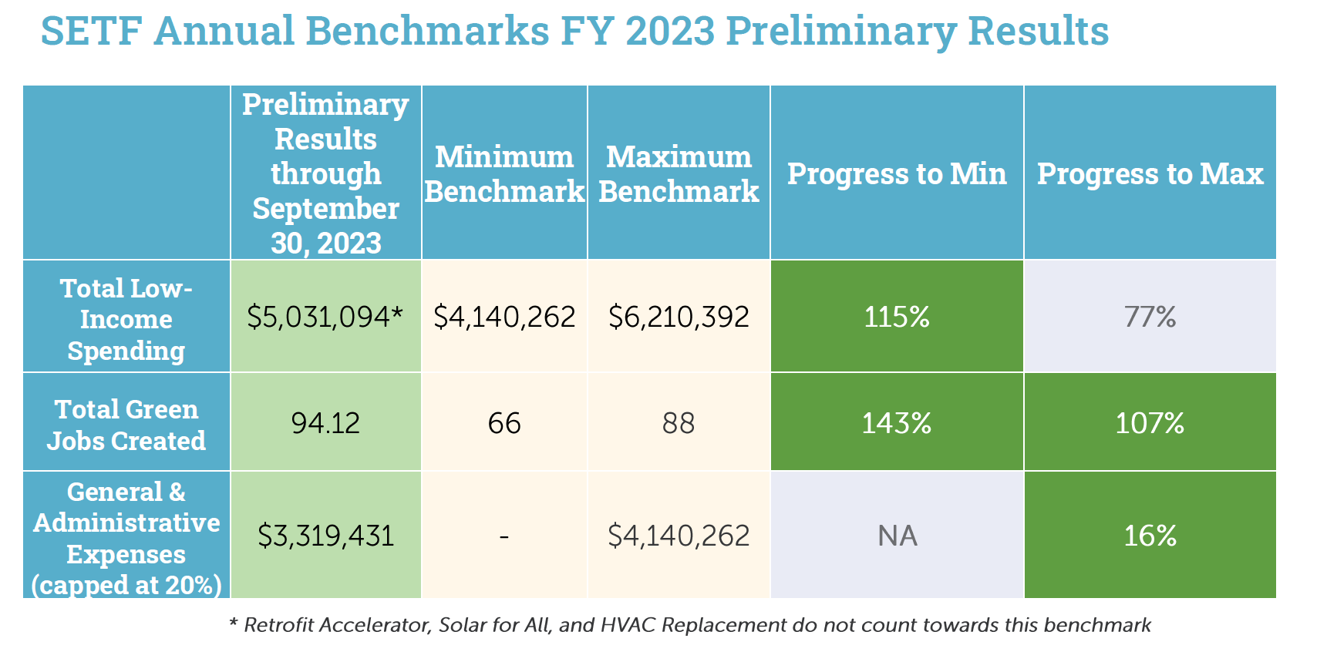
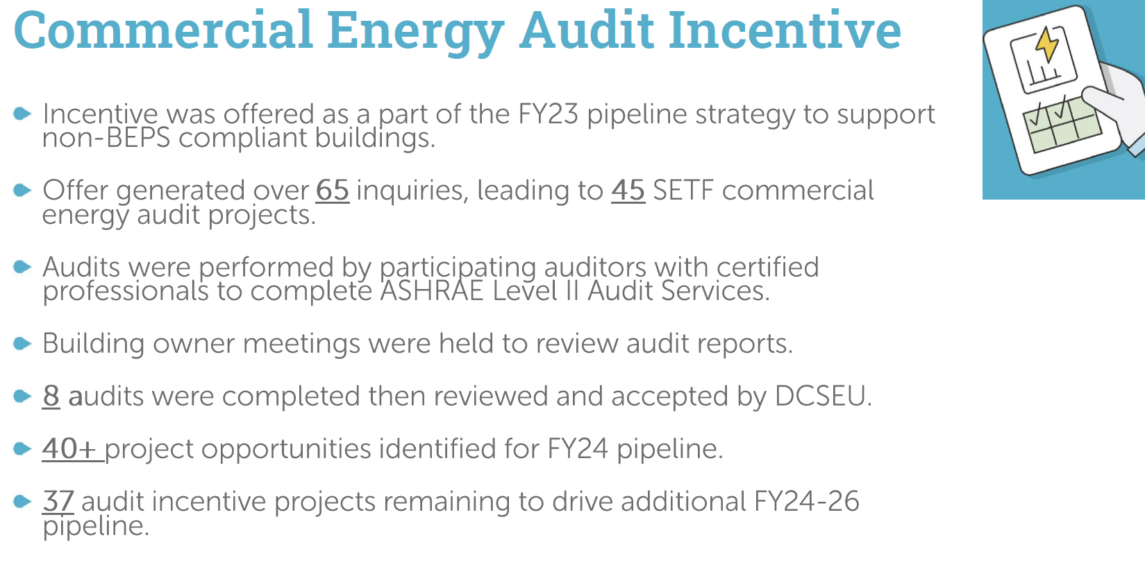
- Chair Bicky Corman asked Eric Jones how apartment and office building owners view the commercial energy audit incentive.
- Eric Jones mentioned that some building owners view DCSEU’s offerings as assistance, while others view it as somewhat of a burden because (in the building owners’ opinion) there are still underlining costs associated with this offering. From the user’s standpoint, directives are given to building owners without considering or asking for their opinion/recommendation. Eric provided an example:
  - While making a building more environmentally friendly is a positive, due to the time frame, the property must sit empty for contractors to do the energy efficiency and upgrade work. The property owner is being penalized for having their space vacant.
- Mansi Talwar added that George Washington University conducted several energy audits pre-pandemic with the intension of implementing energy efficiency measures however due to inflation, the measures have not saved the school any money.
- Director Ernest Jolly offered to meet with Eric and Mansi to better understand the building owner’s perspective and learn how the DCSEU can provide more effective incentives packages.
- Director Ernest Jolly also highlighted the challenges with not being able to finance projects via a typical capital project model.
- Dr. Lance Loncke (DOEE) clarified that due to government financing, the DCSEU cannot finance projects on a capital project model. The Sustainable Energy Trust Fund (SETF) is collected monthly so money cannot be promised to the DCSEU given the uncertainty of SETF monies collected.
- Vice Chair Dr. Larry Martin shared that the DCSEU could explore financing opportunities from the DC Green Bank and explore more creative ways to finance commercial projects.
- Mansi Talwar commented that due to utility escalation, many buildings have seen significant increase in energy bills. Mansi highlighted that with the Bill Stabilization Adjustment (BSA), GWU felt penalized for investing in energy efficiency. Mansi mentioned that if the utility rates keep escalating, then the motivation for building owners may be hindered.
- Dr. Lance Loncke (DOEE) clarified that Pepco needs a certain level of revenue to be able to maintain grid distribution.
- Hussain Karim (DOEE) shared that the BSA is part of Pepco’s rates, which means it's just a distribution piece and he was surprised to hear GWU’s rate went up so much.
- Mansi Talwar shared that if GWU’s energy bills were increasing then other building owners may be affected and dissuaded from investing in energy efficiency measures.
- Eric Jones mentioned that Pepco will continue to make a profit because commercial property owners will continue to pay a higher rate, also with the need for heavy-ups, prices will continue to rise.
- Nina Dodge shared that DC must not be the only place experiencing this challenge with incorporating the Building Energy Performance Standards (BEPS) and balancing increasing electric costs. Nina suggested meeting with the Institute for Market Transformation (IMT) to understand how other jurisdictions are adjusting to this challenge.
- Eric Jones cautioned to reaching out to IMT for guidance because IMT may not be the most transparent since IMT played a key role in establishing BEPS.
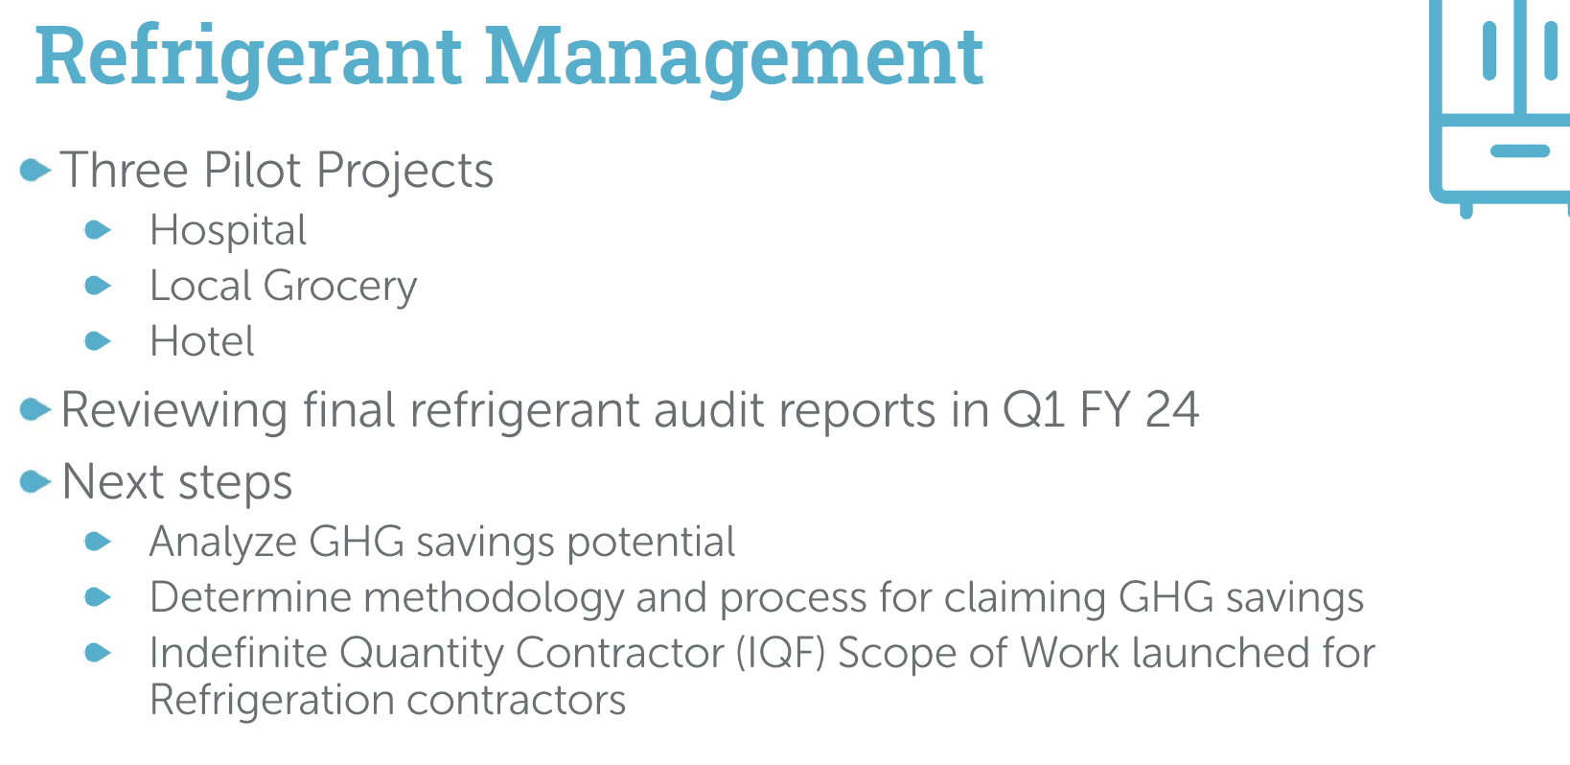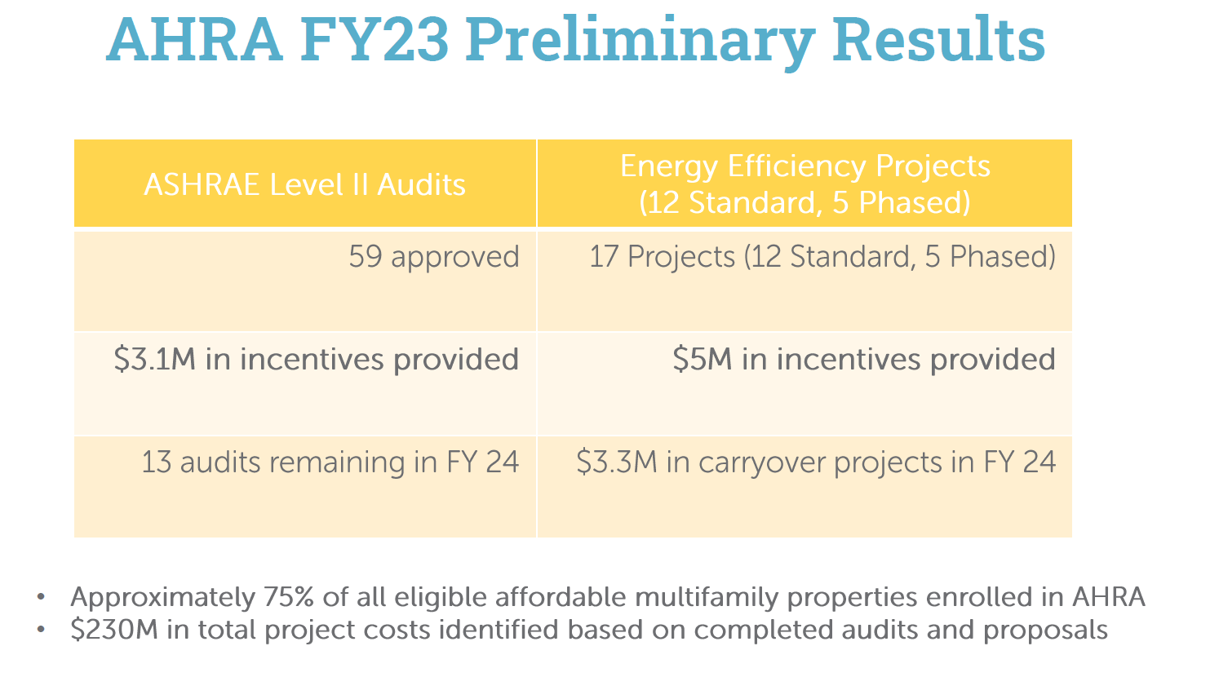
- Chair Bicky Corman asked if 75% of all eligible affordable multifamily properties were enrolled in the Affordable Housing Retrofit Accelerator (ARHA), then has DCSEU fixed the challenges it had faced in the past?
- Ben Burdick (DCSEU) shared that implementing AHRA has been challenging (being the first of its kind in the country) however that DCSEU has found a way to accelerate AHRA in FY23.
- Chair Bicky Corman clarified that the FY23 preliminary benchmarks did not include AHRA savings.
- Ben Burdick (DCSEU) confirmed that FY23 preliminary numbers did not include savings from AHRA, however the DCSEU plans to include AHRA savings in the final FY23 benchmark tracking.
- Vice Chair Dr. Larry Martin inquired about the implications of the budget being constrained to the government’s fiscal year versus a capital budget.
- Ben Burdick (DCSEU) mentioned that traditional energy efficiency projects like lighting or switching out equipment that a building already has (such as heat pumps) can typically be completed within a fiscal year, however for larger electrification projects (such as switching from a central heating system moving to a Variable Refrigerant Flow (VRF) system) is a multi-year project. The major renovations are a big commitment for building owners and property managers to undertake.
- Director Ernest Jolly added that some projects require disruption of tenants to get the work done, and that is a big deal for those buildings with lower occupancy rates concerned with cash flow.
- Dr. Lance Loncke (DOEE) shared that Board members who have relationships and contacts with affordable buildings should implore them to take advantage of AHRA. A big question the team has is why are building owners still not taking full advantage of AHRA, even though the DCSEU is covering all the costs.
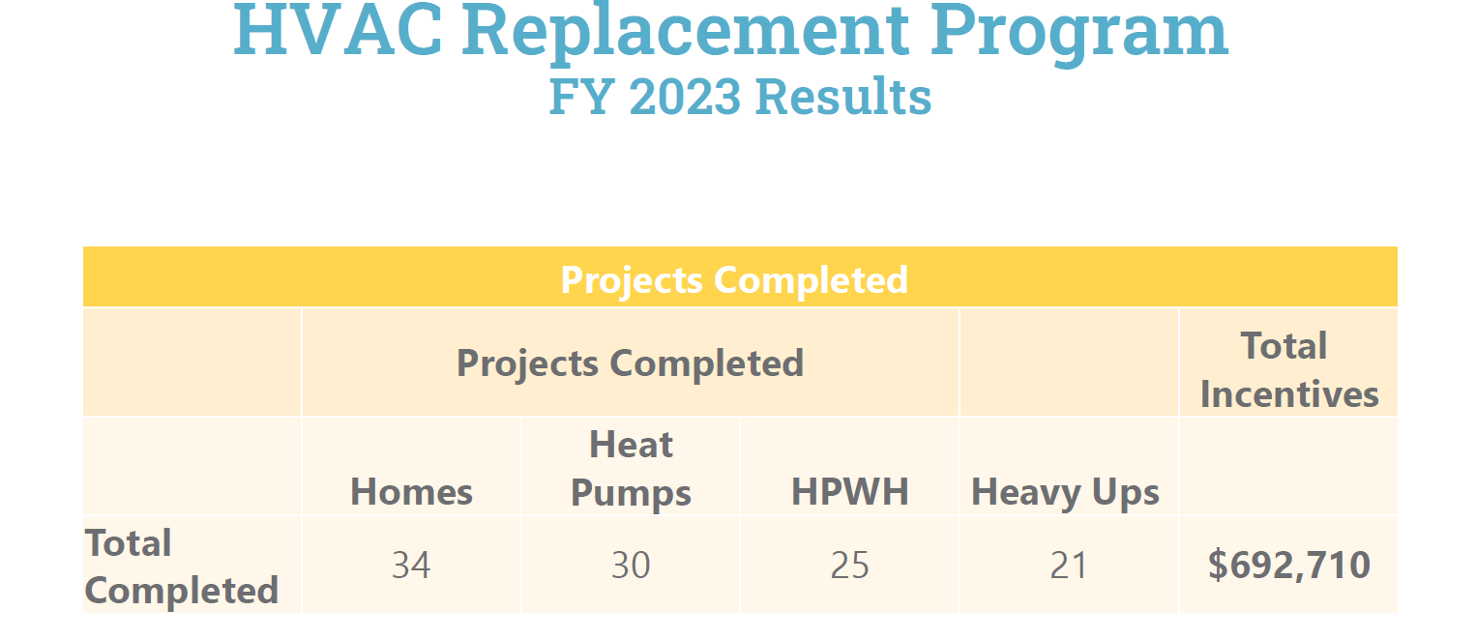
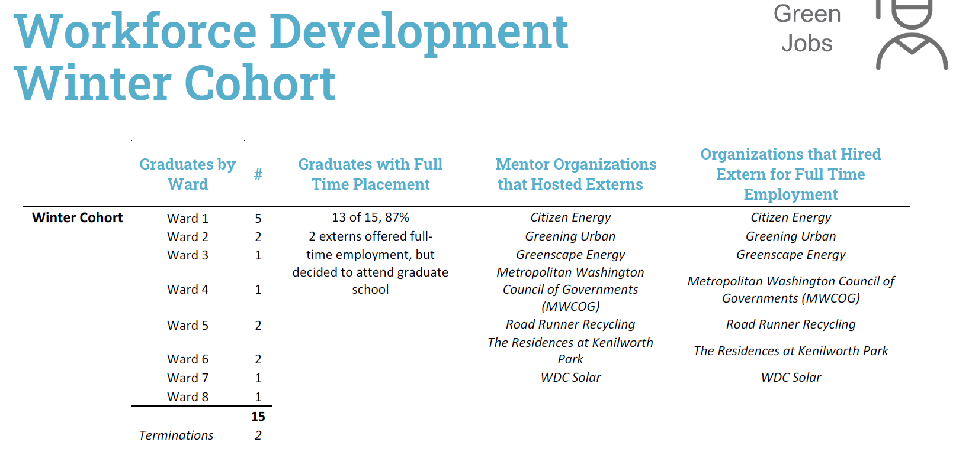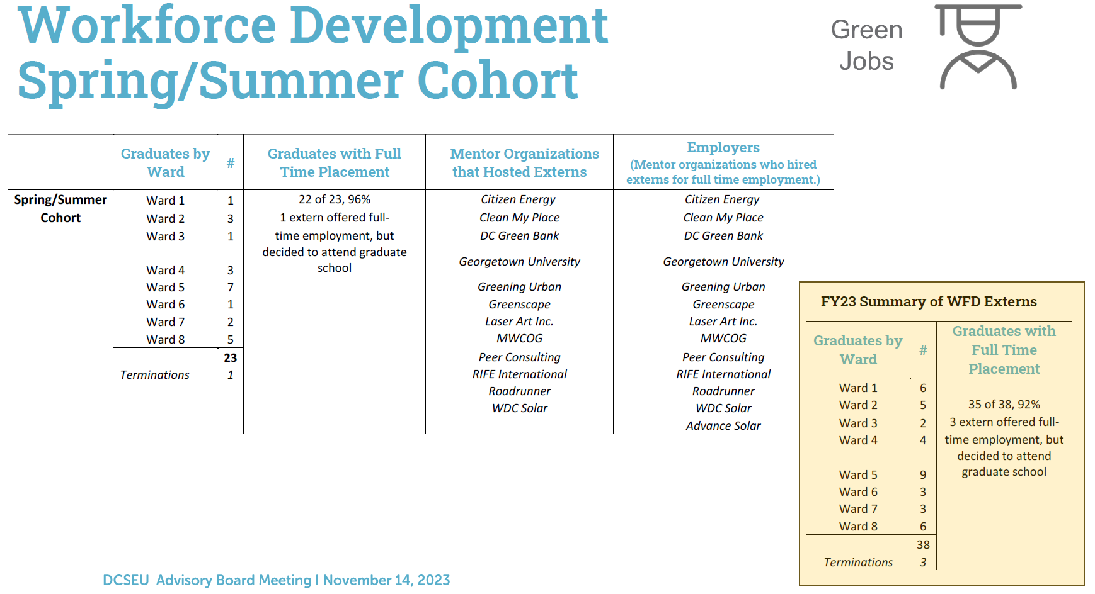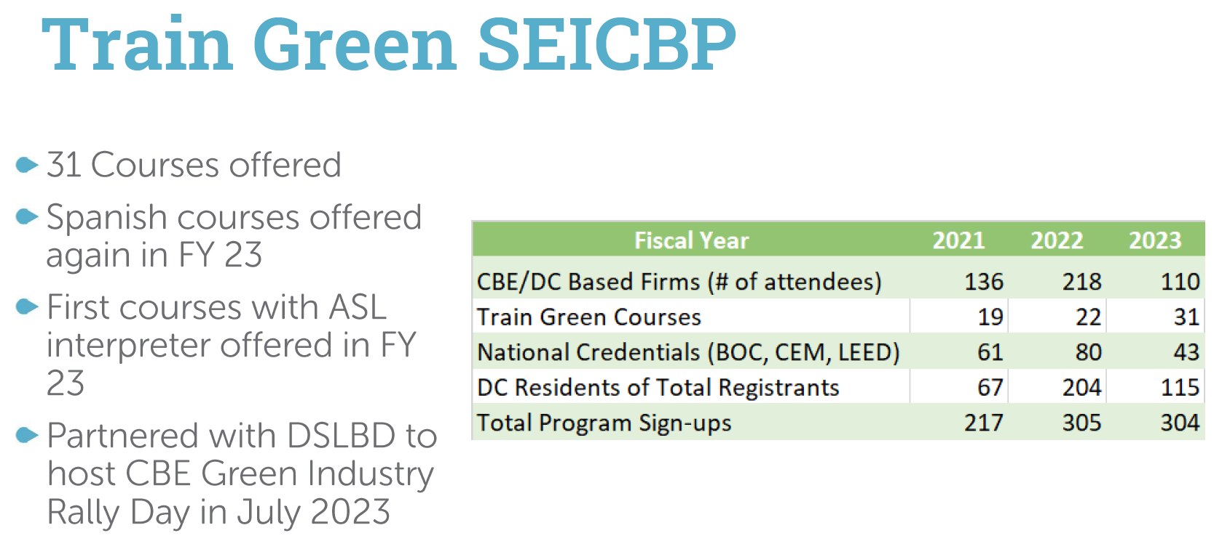
- Eric Jones asked:
  - Can you give us a better idea of who you partner with as far as training providers?
  - How many participants are entering good paying positions such as apprenticeships or pre-apprenticeships?
  - Do you have any stats on how many groups are participating?
- Crystal McDonald shared that the DCSEU has a list of about 30 courses and elicits instructors who can provide either a certificate of completion or a nationally recognized credential to do the work, especially the work here in the district. For example, the Certified Energy Manager (CEM) course is available where participants receive the CEM certificate upon completion of the course and passing of the exam. Providers are selected based on an RFP process.
We just issued our RFP for this season.
- Ben Burdick (DCSEU) shared that he would follow-up regarding Eric’s last two questions.
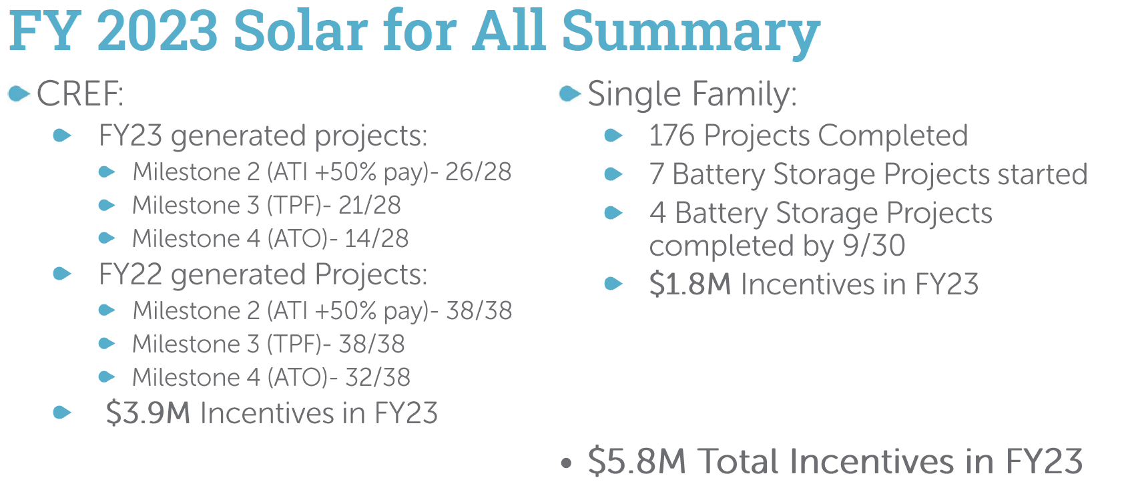

Legislative Updates
- Hussain Karim (DOEE) provided the following legislative updates:
  - FC1176: Pepco's application for approval to increase rates through the implementation of a Multiyear Rate Plan (“MYP”), also referred to as the “Climate Ready Pathway,” for its electric distribution service
    - The Apartment & Office Building Association of Metropolitan Washington (AOBA) motioned for enlargement of time however PSC did not approve the motion. OPC appealed PSC’s order to the Court of Appeals, and we will keep an eye out for what happens next.
  - FC1130: In the Matter of the Investigation into Modernizing the Energy Delivery System for Increased Sustainability
    - Synapse Energy Economics, Inc.'s Study on the Value of Distributed Energy Resources (“VDER”) is available for comment.
- Chair Bicky Corman shared that this would be her last meeting as a Chair and would be stepping down from her Board position. Chair Corman thanked Board members for their participation and enthusiasm for the Board.
- Board members thanked Chair Corman for her service and highlighted the great loss it is for the team to lose her as Chairperson.

Future Agenda Items
- Approval of November Meeting Minutes
- Discussion on DCSEU Contract Modifications
- Discussion of OPC’s memo on societal benefit cost test
- DCSEU Contract Overview
- FC1130 - Discussion of Board providing comments on Synapse Energy Economics, Inc.'s Study on the Value of Distributed Energy Resources (“VDER”)

Adjournment
- Chair Bicky Corman adjourned the meeting at 12:58 PM.

Acronyms used during this meeting
- AHRA - Affordable Housing Retrofit Accelerator
- ATO - Authorization to Operate
- BSA - Bill Stabilization Adjustment
- CAEA - Clean and Affordable Energy Act of 2008
- CEM - Certified Energy Manager
- CREF - Clean Renewable Energy Facility
- DCSEU - District of Columbia Sustainability Energy Utility
- DOB – Department of Buildings
- DOEE - Department of Energy and Environment
- EEDR – Energy Efficiency and Demand Response
- IMT – Institute for Market Transformation
- kW - kilowatt
- MOTA – Mayor's Office of Talent and Appointments
- OPC - Office of the People’s Counsel
- PSC - Public Service Commission
- SBCT - Societal Benefit Cost Test
- SETF - Sustainable Energy Trust Fund
- TAG - Technical Advisory Groups
- VRF - Variable Refrigerant Flow
- WGL – Washington Gas Light
Minutes prepared by Jennifer Johnston, DOEE

