Clyde Thompson
District Resident
Winner of the 2019 District Sustainability Award
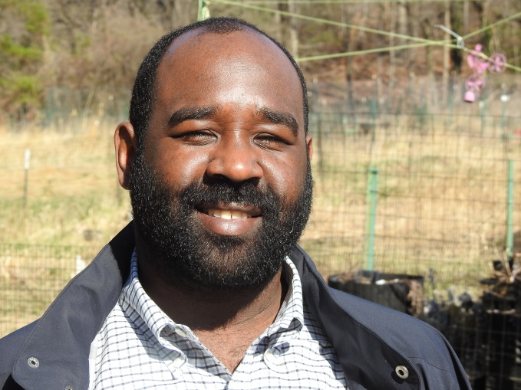
Mr. Thompson has worked diligently to improve the lives of Ward 7 residents and make the community more environmentally sustainable. He was a leader on the Far Northwest Equity Advisory Group that made implementation recommendations for Clean Energy DC and Climate Ready DC, and participates in the 100% Renewable and Equitable Cities project that DOEE helps coordinate. Mr. Thompson also led a campaign to clean up an abandoned community garden in Benning Terrace Public Housing and he volunteers regularly on neighborhood and park clean-up events.

