Cushman & Wakefield
Winner of the 2018 District Sustainability Award

Cushman & Wakefield has completed a plethora of environmental projects in 2017 worldwide, many of which are right here in Washington, DC. In fact, Cushman & Wakefield has completed seven LEED projects in Washington, D.C., five of which achieved LEED Platinum, the highest level of recognition for the rating system.
At 1800 Massachusetts Avenue NW, Cushman & Wakefield partnered with the building owner and tenant, Service Employees International Union (SEIU), to implement sustainability policies and practices for exterior hardscape and maintenance, water efficiency, purchasing, waste management, integrated pest management, and green cleaning.
As part of the LEED process, the Cushman & Wakefield property team also conducted an ASHRAE Level II energy audit. The audit identified several low/no cost and capital cost energy conservation measures. Cushman & Wakefield, in partnership with SEIU, implemented 100% of the low/no cost measures and expects to see an energy savings of 59,233.14 kWh, which is the equivalent greenhouse gas emissions savings of preventing 44,421 lbs. of coal from being burned.
In addition, 1800 Massachusetts Avenue, NW, has a green roof that is populated with only native plant species that do not require irrigation. Cushman & Wakefield ensures that the green roof is maintained and that the native species thrive to promote more biodiversity in the Washington, D.C. region and to provide habitat for the local insect and bird populations.
Cushman & Wakefield also achieved LEED Platinum certification at 1111 19th Street NW. In addition to implementing sustainable policies and pursuing an energy audit, Cushman & Wakefield upgraded the water fixtures in the building in order to conserve more water. Thanks to the low flow faucets, toilets and showers installed, 1111 19th Street was able to save 33.07% of their water consumption as compared to the LEED baseline.
In addition, Cushman & Wakefield conducted a waste stream audit to identify more ways to reduce the amount of waste entering local landfills. The waste was broken up by tenant and then analyzed to determine the total waste generated, what percent of the trash was actually recyclable, and the total weight of what was recycled. The property management team is now able to address specific concerns and formulate approaches to increase waste diversion at the building. Currently, the tenants at the building divert just under 40% of the total waste leaving the building to recycling facilities. Armed with the detailed diversion information broken down by tenant, Cushman & Wakefield hopes to increase the diversion rate to be above 50% in the coming year.
Cushman & Wakefield recognizes our responsibility to employees, clients, and the communities within which we operate, both present and future. We are committed to securing a better, more sustainable future, and continually seek to live what we preach by developing and implementing sustainable practices and innovation every day and in every location.
The LEED green building rating system is the industry standard for sustainability best practices. Cushman & Wakefield offers a free proprietary LEED training program to all employees globally. We believe that LEED accreditation gives our employees a solid foundation of green building principles and helps transform the way we think about our built environment. The Cushman & Wakefield LEED Training Program is not only a great professional development tool, but also an opportunity for all employees to engage in the green building movement. Currently, Cushman & Wakefield has 232 LEED Accredited Professionals and 245 LEED Green Associates.
As part of our commitment to achieving measurable results across the triple bottom line of People, Planet and Profit, we manage LEED projects for both buildings managed by Cushman & Wakefield as well as for buildings managed by other companies. In the past few years, Cushman & Wakefield has managed more than 28 million square feet of LEED project work. Our proven approach of education and engagement has produced successful LEED projects, from small single-tenant office buildings to 1,000,000-plus square-foot office buildings and mixed-use projects in a wide array of markets. These projects have resulted in substantial energy, water, and waste savings across the country.
In the U.S., our strategy is to ensure that all of our managed properties and facilities benchmark and reduce energy usage even if they don’t pursue LEED certification. As such, Cushman & Wakefield maintains a centralized ENERGY STAR Portfolio Manager account in which we have benchmarked more than 1,000 buildings and strive to add all new assignments. Through continuous assessment on individual, market, and national levels, we identify and develop tools and resources to ensure all buildings abide by a single energy management policy.
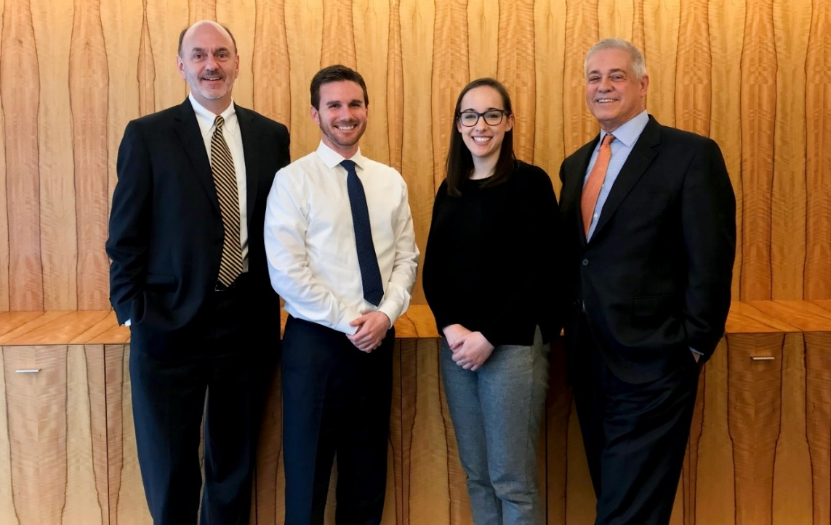
Left to Right (Tom Updike, Eric Tilden, Emily Paciolla, and Bill Grillo)

More specifically in the East Region of the United States, energy management and reduction is written into our principles of engineering, which are required to be implemented by all building engineers.
For five consecutive years, Cushman & Wakefield has been named an ENERGY STAR Partner of the Year Sustained Excellence for our continued leadership in protecting our environment through superior energy efficiency achievements. In Washington, D.C. we have 18,433,032 square feet benchmarked in ENERGY STAR with an average ENERGY STAR score of 80. So far in 2017, five buildings have been ENERGY STAR certified and over 45 will be eligible by the end of the year.
Our energy management strategy aims to communicate with, engage with, and educate brokers, property managers, owners and asset managers, tenants, building engineers, vendors, and the general public on ways they can contribute to energy reduction. It includes:
- Providing benchmarking support
- Developing informational resources and proprietary training programs
- Collaborating with the EPA
- Sharing case studies
- Releasing a national energy performance report
- Designating market champions
- Holding annual engineering summits
In addition, we recognize the importance of encouraging our employees to implement strategies to run buildings more efficiently. Recognizing achievements by managed properties incentivizes high performance and encourages continued improvement. Internally, regional property management leadership recognizes building teams that have demonstrated superior performance on an annual basis.
Cushman & Wakefield is also committed to report and reduce its carbon footprint through the Carbon Disclosure Project. We completed the report in 2015, 2016 and are currently working on the report for 2017.
To address the impact that materials have on the environment, Cushman & Wakefield has embarked on a procurement transformation to help improve our overall sustainability, quality, and value. We have completed an assessment of our current state across policies, process, people, and tools, and partners with a leading procurement consultancy to overlay industry best practices. The firm now has a defined roadmap and list of initiatives which we will execute over the next year to ensure continual improvement in all aspects of procurement.
Cushman & Wakefield participates in community events around the world. The Washington, D.C. office is no different. Cushman & Wakefield is an official sponsor of The Race for Hope, a fun and inspiring 5K in our nation’s capital focused on joining forces in the fight against brain tumors. It is one of the largest fundraisers in the country, with the proceeds supporting the National Brain Tumor Society and ABC (Accelerate Brain Cancer Cure). In 2017, Cushman & Wakefield raised $139,073 and assisted with planning and volunteering at the event.
Also in Washington, D.C., Cushman & Wakefield participates in the annual Boys and Girls Club of Greater Washington Thanksgiving Event. Cushman & Wakefield assists with planning, provides volunteers for the event on the day of, provides food donations, and donates funds to the Boys and Girls Clubs of Greater Washington. In 2016, Cushman & Wakefield raised $3,910 in addition to the time and food donated at the event. Cushman & Wakefield also participates in a variety of other smaller events throughout the year in the Washington, D.C. area including drives to collect donations of school supplies, fundraising drives for local charities, and more.

Cushman & Wakefield is committed to making a positive impact in both our corporate operations and business services. We launched a comprehensive Global Corporate Responsibility Program in 2015, in order to ensure Cushman & Wakefield remains a market leader in sustainable management practices as a firm and for our clients. Our public Environmental Commitment, gives structure to the firm’s sustainability goals and outlines how we will integrate environmental, social, and governance (ESG) priorities into our corporate operations. We have prioritized the following impact areas; energy and resource management, corporate occupancy, green leasing and sustainable site selection, procurement, client services, employee training, corporate responsibility and reporting, and legal and regulatory compliance.
Cushman & Wakefield Employees
