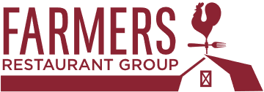

Farmers Restaurant Group
Winner of the 2019 People’s Choice Award

www.farmersrestaurantgroup.com

In 2018, Farmers Restaurant Group launched Our Last Straw, a campaign turned non-profit working to eliminate single-use plastic straws across the DMV. Leading the charge for change, Farmers Restaurant Group has already built a coalition of over 200 restaurants, bars, cafes, hotels, and event venues across the DC metropolitan region to join their mission: Eliminate single-use plastic straws.

