Gensler
Winner of the 2019 District Sustainability Award
https://www.gensler.com/
Gensler is a leader in DC green architecture and a strong example of sustainable building to other firms. Gensler professionals have worked on 94 sustainable projects in DC, including the first U.S. office building to use under-floor air distribution, and later the first retail rollout prototype, data center and car dealership to earn LEED certifications. Gensler’s Impact by Design 2018 is their third annual publication assessing firm-wide resilience and sustainability.
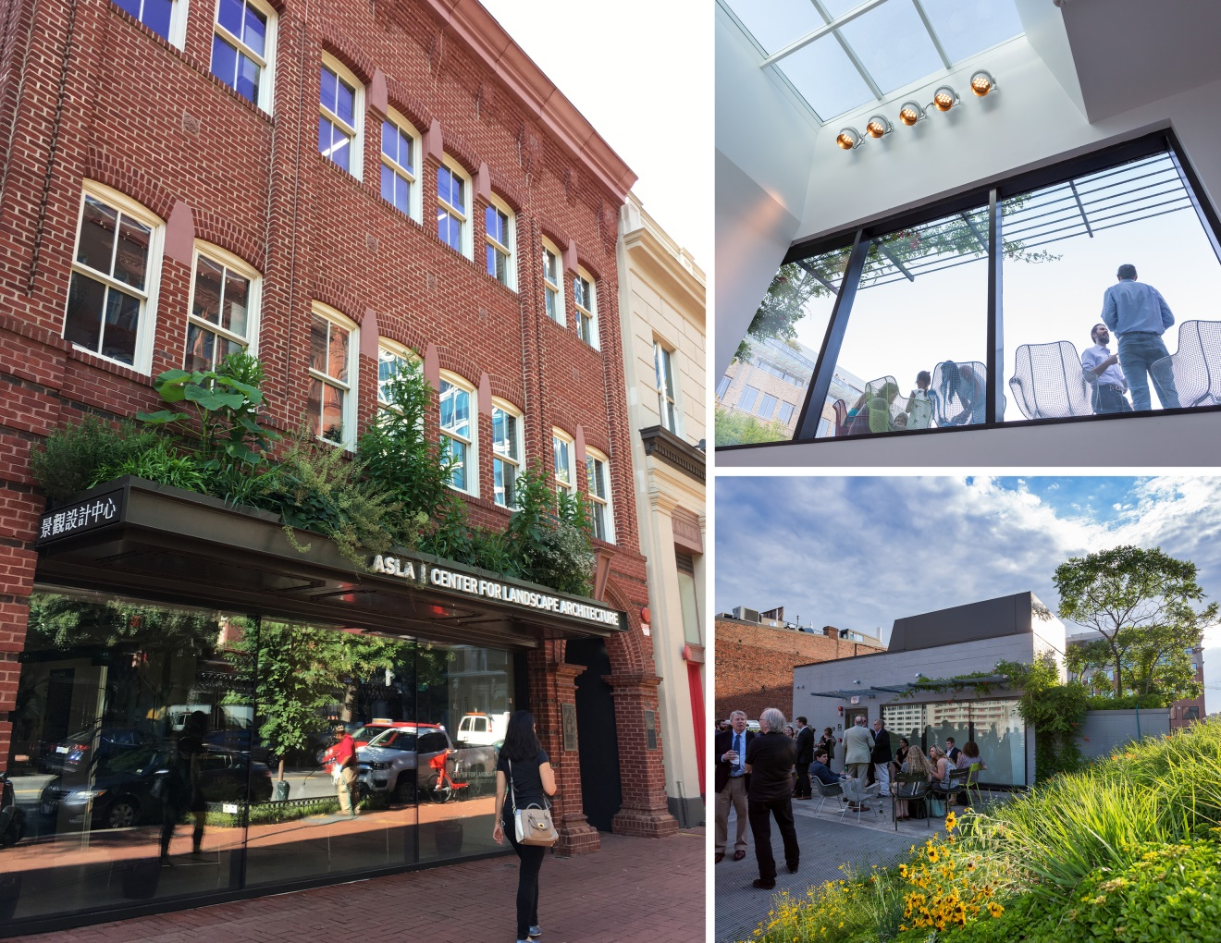
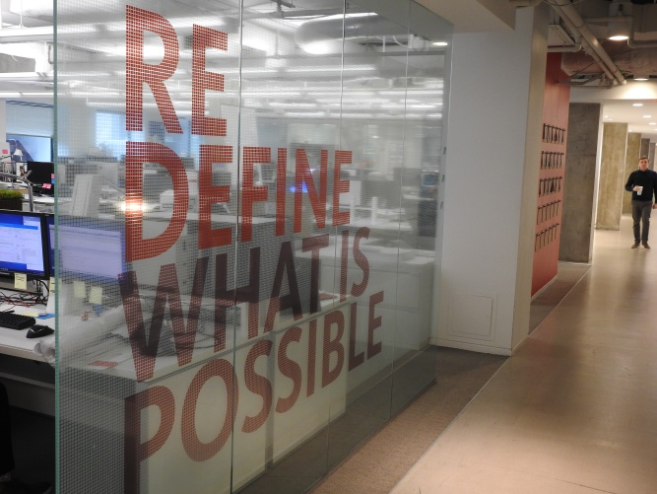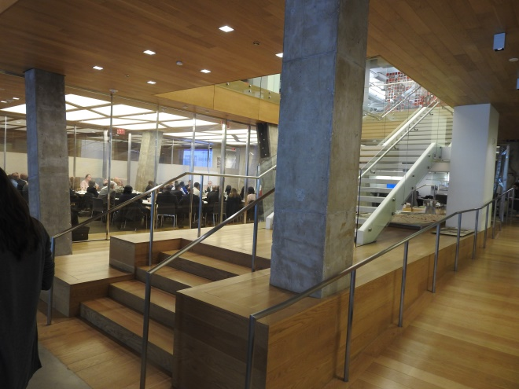
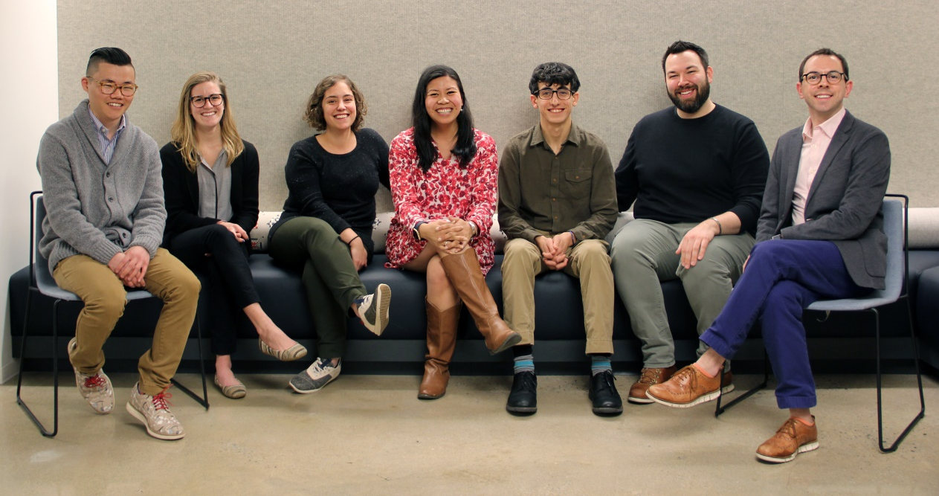
Left to right: Paul Roman, Abby Young, Liz Resenic, Fatima Perez, Sean Richardson, Gregory Plavcan, Benjamin Holsinger

