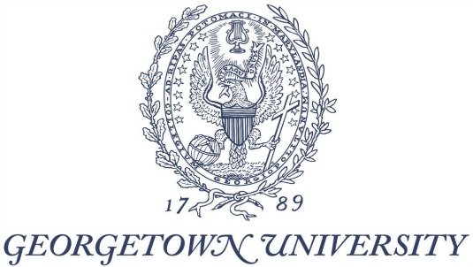

Georgetown University
Winner of 2018 District Sustainability Award

Georgetown’s Office of Sustainability is committed to the integration of sustainable practices into all aspects of our work, guided by a framework for sustainability which includes operations, teaching and research, engagement and investments. Within the framework area of operations, we are guided by a long term vision of surpassing carbon neutrality, water neutrality, and integrating circular economy principles into our material use practices.
In the most recent academic year, one of Georgetown’s biggest sustainability accomplishments has been the integration of sustainable practices into our Master Planning, design and construction. Our commitment to a sustainable physical campus is evident in the completion of our two newest green buildings, including Pedro Arrupe, S.J. Hall, which is currently LEED-registered with a goal of Gold, and the John R. Thompson Jr. Intercollegiate Athletics Center, which achieved LEED Gold. In total, our campus now features 8 LEED-registered and LEED-certified buildings. We have nearly 1 million square feet of LEED space. Arrupe Hall includes an indoor bicycle parking room with over 70 bike parking spaces, permeable pavement, bioswales and a green roof. The Thompson Center has an integrated water management system including a 10,000 gallon cistern that captures rainwater and uses it for flushing toilets in the building, reducing stormwater pollution while minimizing potable water usage. In our four most recent construction projects, we have installed green infrastructure that mitigates 4.6 million gallons of stormwater each year, and have planted a net 150 new trees on campus. Our emphasis on building green has helped achieve a 24% reduction in greenhouse gas emissions per square foot of building space since 2006.
In Earth Month 2017 Georgetown announced a major new solar energy project to be installed on six University buildings, which will increase clean power while serving low-income residents in the District. The project will generate about 1.5 million kilowatt hours of power each year, contributing to a cleaner electric grid and reducing overall emissions equivalent to planting over 546,000 new trees. Under the PPA structure, Community Renewable Energy (CRE) will own the panels, the environmental attributes, and any incentives the system may provide, while Georgetown will use the power at a guaranteed price. Construction is set to begin in 2017 and be completed in 2018. Once the project is complete, a portion of the revenue from the sale of the system’s SRECs will be dedicated toward reinvestment in DC neighborhoods, including through a Community Investment Fund supporting clean energy projects in low-incomes areas of the District. The fund is expected to total hundreds of thousands of dollars over the life of the project, and projected to catalyze over $1.5 million in total community investment. The project is a collaboration between Georgetown, CRE, and Root + Branch, a benefit corporation (B-Corp) founded by Georgetown Alumna Laura Recchie (MSPP ™10). The Community Investment Fund will be advised by Georgetown students, faculty and staff in collaboration with Root + Branch. Through this community-based reinvestment approach, the benefits of clean energy will be amplified throughout the Washington DC community, increasing clean energy and reducing energy costs for underserved community members.
Content:

Georgetown plays a leading role in addressing critical sustainability challenges through its academic mission, physical footprint, and financial operations. The university takes an integrated and holistic approach to sustainability, placing value on a "quadruple" bottom line: people, planet, prosperity, and purpose, guided by our Catholic and Jesuit values and our commitment to the common good.
Georgetown integrates sustainability into all that we do as an institution. Examples include:
- Georgetown is a signatory to the District of Columbia College & University Sustainability Pledge, a pledge between universities based in the District and the District of Columbia Mayor’s Office to advance mutual sustainability goals.
- Georgetown is committed to sustainable building design and construction through our pledge that all new construction and major renovations will be designed to LEED Silver or higher, with a goal of Gold. To date we have achieved LEED certification for nearly 1 million square feet of building space.
- The university is committed to reducing its greenhouse gas emissions at least 50% by the year 2020, and achieved this goal six years ahead of time in 2014 by purchasing renewable energy certificates for 100% of electricity. We have also reduced our location-based emissions 25% during this time, through a combination of conservation, efficiency, and a cleaner local grid. In June 2017, Georgetown reaffirmed its public commitment to pursuing solutions in alignment with the global Paris Climate agreement. Our work is guided by a long-term vision of surpassing Carbon Neutrality to achieve a net positive impact on the climate and our local and global communities.
- We invest in efficiency for our infrastructure on an ongoing basis. Over the past year we have completed major new energy efficiency initiatives such as LED lighting retrofits, tankless hot-water heater upgrades, variable frequency drives and pipe insulation projects in our buildings and our central heating and cooling plant. Currently, we are pursuing several major efficiency projects. A new chiller optimization project in the central plant will enable Georgetown to cool campus buildings more efficiently. A new demand-controlled ventilation system is being installed at Regents Hall which will optimize energy performance of ventilation. We are also establishing a continuous commissioning program which will use real-time data to inform energy management for 8 buildings. Combined, these three projects will reduce our campus-wide emissions by almost 6%, cutting about 6,400 tons of carbon per year. We partner with the District of Columbia Sustainable Energy Utility on an ongoing basis in pursuit of mutual energy efficiency goals.
- In Earth Month 2017 Georgetown announced a major new solar energy project to be installed on six University buildings, which will increase clean power while serving low-income residents in the District. The project will generate about 1.5 million kilowatt hours of power each year, contributing to a cleaner electric grid and reducing overall emissions equivalent to planting over 546,000 new trees. Under the PPA structure, Community Renewable Energy (CRE) will own the panels, the environmental attributes, and any incentives the system may provide, while Georgetown will use the power at a guaranteed price. A portion of revenue from the sale of the solar renewable energy certificates (SRECS) will seed a Community Investment Fund to support clean energy projects in underserved neighborhoods in Washington DC. Construction is set to begin in 2017.
- Sustainability has been integrated as a core theme in our 2016-2036 Campus Plan, which includes an emphasis on improving and increasing green space, advancing multimodal transportation, and making efficient use of infrastructure.
- Georgetown pursues sustainable transportation solutions. 71% of Georgetown students, staff and employees arrive to school or work by walking, bicycling, carpooling or transit with less than 29% driving a single-occupancy vehicle. Georgetown is the first campus in the District of Columbia to achieve designation as a Bicycle Friendly University by the League of American Bicyclists.
- We integrate sustainable solutions into our material use cycles. Georgetown has a decades-long history of recycling on campus. Since April 2015, we compost approximately 20 tons per month of pre-consumer food waste from our main campus dining hall and other campus food establishments at local organic waste facility Maryland Environment Services where it is turned into soil products used for gardening and landscaping in the local region.
- Sustainability is also a key part of Georgetown’s research, teaching and curriculum. In fall 2017 Georgetown will debut our new Core Pathways on Climate Change Program, an innovative educational initiative through which Georgetown undergraduates can satisfy core curricular requirements through the lens of Climate Change studies.
- The Georgetown Environment Initiative (GEI), established in 2012, is a multi-campus effort to advance the interdisciplinary study of the environment in relation to society, scientific understanding, sound policy, and the broad and complex challenges we face as stewards of the planet’s natural resources. GEI has a network of over 60 Georgetown faculty members from a range of departments who are leaders in scholarship and teaching on the environment.
- The nonpartisan Georgetown Climate Center seeks to advance effective climate and energy policies in the United States and serves as a resource to state and local communities that are working to cut carbon pollution and prepare for climate change. The Center informs the development of state and federal policies that reduce carbon pollution from power plants and stationary sources, support clean and resilient transportation options, and help communities adapt to climate change.
- The Georgetown University Energy Prize challenges towns, cities, and counties to rethink their energy use, and implement creative strategies to increase efficiency. Currently, a select group of communities are leading the way by bringing together their local governments, residents, utilities, and to demonstrate success in reducing energy consumption over a two-year period.
- Georgetown University is committed to justice and the common good. As an academic community, we educate men and women to be lifelong reflective learners, to be responsible and active participants in civic life and to live generously in service to others.
- Our integrated and holistic approach to sustainability embodies our commitment to social justice and the common good.
- A key example of this integrated approach is our annual Move Out Drive. Now in its eleventh year, the Move Out Drive is Georgetown’s end-of-the-school-year contribution to our community and the environment, inviting students to repurpose their packing at the end of the semester by donating gently-used household items to local charities. This program helps significantly reduce the 250,000 pounds of unwanted clothing, books, school supplies, food and household goods that are generated at the end of each school year, keeping many of these items out of a landfill and into the hands of families and individuals living in poverty in the Washington DC region. Georgetown partners with KEYS for the Homeless, a local not-for-profit, to collect and donate these items, providing everyday basic household goods to meet real-life needs of those living in poverty. In the spring of 2017, the Move Out Drive collected and donated approximately 25 tons of materials, providing over $150,000 worth of value to the local community.
- Another example of our integrated approach is our new on-site solar project. Once the project is complete, a portion of the revenue from the sale of the system’s SRECs will be dedicated toward reinvestment in DC neighborhoods, including through a Community Investment Fund supporting clean energy projects in low-incomes areas of the District. The project is a collaboration between Georgetown, CRE, and Root + Branch, a benefit corporation (B-Corp) founded by Georgetown Alumna Laura Recchie (MSPP 2010). The Community Investment Fund will be advised by Georgetown students, faculty and staff in collaboration with Root + Branch. The fund is expected to total hundreds of thousands of dollars over the life of the project, and projected to catalyze over $1.5 million in total community investment. Through this community-based reinvestment approach, the benefits of clean energy will be amplified throughout the community, increasing clean energy and reducing energy costs for underserved community members.
- Countless student associations and clubs participate in community events in and around the Georgetown community such as the annual Earth Day weekend clean-up of Glover Archbold Park.
- Additionally, numerous academic departments and centers advance Georgetown’s commitment to social justice and the common good. Several examples include:
- In order to advance justice and the common good, Georgetown’s Center for Social Justice Teaching, Research and Service (CSJ) promotes and integrates community-based research, teaching and service by collaborating with diverse partners and communities.
- Georgetown University’s Kalmanovitz Initiative for Labor and the Working Poor develops creative strategies and innovative public policy to improve workers’ lives in a changing economy, with a mission of advancing workers’ rights and economic justice.
- Dozens of other initiatives and programs focused on topics such as peacebuilding, health disparities, homelessness, humanitarian assistance and more can be found at https://csj.georgetown.edu/socialjustice.
Georgetown plays a leading role in addressing critical sustainability challenges through its academic mission, physical footprint, and financial operations. The university takes an integrated and holistic approach to sustainability, placing value on a "quadruple" bottom line: people, planet, prosperity, and purpose, guided by our Catholic and Jesuit values and our commitment to the common good. We now seek to deepen our impact through additional investments in renewable energy, efficiency, and conservation. On Earth Day 2017, Georgetown announced a major new solar panel initiative that will contribute to a cleaner electric grid, reduce costs and serve low-income residents in the city. We integrate sustainability into the student experience through programs like the annual Switch It Off energy conservation challenge and the Think Global Drink Local waste reduction initiative. Since 2008, all new buildings and major renovations have achieved LEED Silver or higher, with over one million square feet of LEED green building space on campus. Georgetown was also the first university in D.C. to be designated a Bicycle Friendly University by the League of American Bicyclists. Georgetown’s 2017-2018 Core Pathway on Climate Change will allow students to fulfill core and elective requirements through an interdisciplinary collection of courses addressing the complex global challenge of climate change.

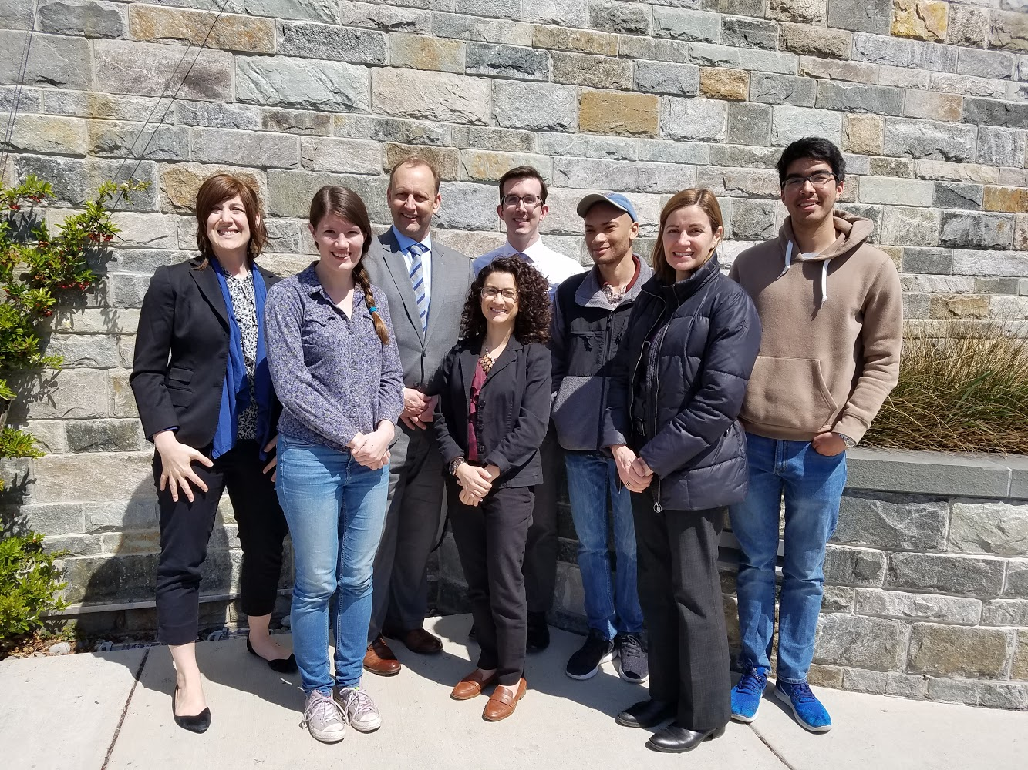
(Left to Right) Audrey Stewart, Cassidy Gasteiger, Robin Morey, Giulia Manno, Greg Miller, Charles Johnson, Carla Tiberi, Ben Bollero

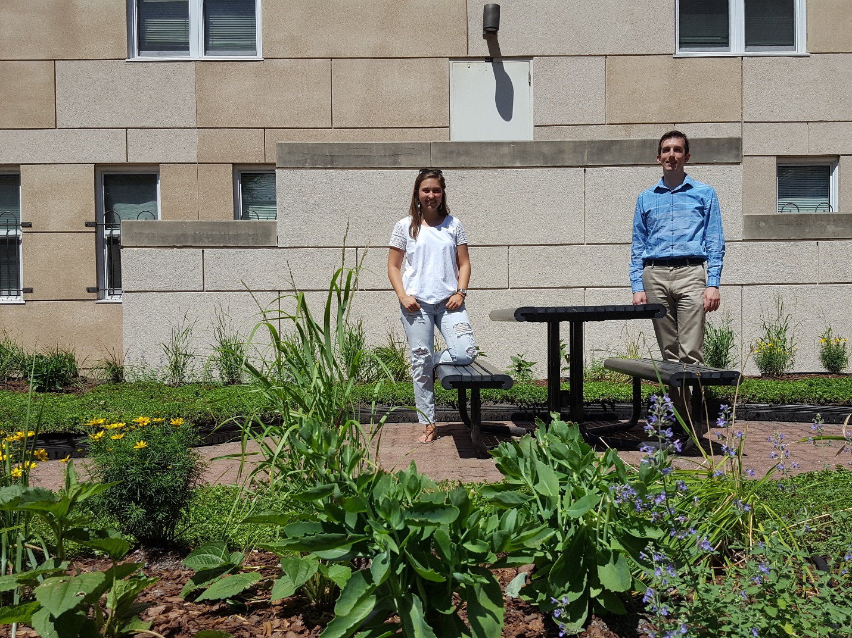
Mandy Lee and Greg Miller

