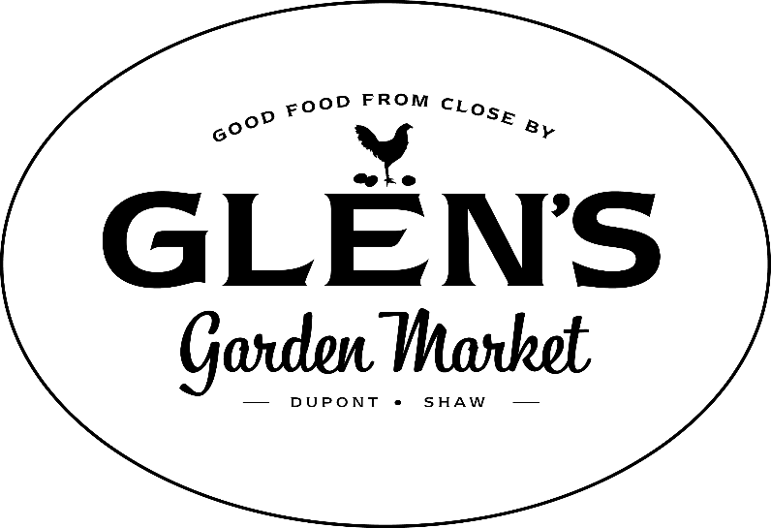

Glen's Garden Market
Winner of the 2018 District Sustainability Award

In 2017 we forged a partnership with MilkCrate for Communities, a new sustainability and impact tracking platform. We invited, our Neighbors to create a user account that can be used to connect and engage within our community and to have a little fun competing along the way! Our Neighbors who join the Glen's Community on the Milkcrate platform are prompted to perform activities to help further our mission of climate change progress outside of our stores. Activities include bringing compost from their homes to our stores for proper disposal, walking or biking rather than driving, donating to Chesapeake Conservancy, joining a community garden, and more.
With our location in Dupont Circle , Glen’s Garden Market exists to make climate change progress one bite at a time by serving Good Food from close by, and growing relationships with partners, who treat their land, their animals and their ingredients with respect. The short distance our food travels to get here means less fuel consumption and transportation emissions. Also, sourcing from small, mindful farmers, ranchers and artisans reduces harmful agricultural production impacts in our region’s air, land and water.

When we source products that are important to rounding out our product mix, but which are not being grown or created within our Watershed, we specifically seek out items that meet our high standards of quality and environmental stewardship. We do not compete great, locally made products against non-indigenous national brands.
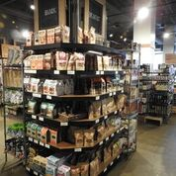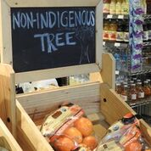
If products come from beyond the Watershed, but are domestically produced, we apply a strict set of sourcing standards (articulated on our website). If they come from outside the United States, they must meet all of our sustainability criteria, and we offset the transportation emissions incurred in their travels to our stores.

We have partnered with the Chesapeake Conservancy to invest in local projects to reduce the impacts of climate change and improve the vitality of the Chesapeake Bay. Those efforts are intended to offset the negative environmental impacts of bringing in a small set of mindfully sourced products from beyond our region.

Beyond the products and produce on our shelves, our stores were built mindfully, as well. In the photograph provided, our bar alone is outfitted with reclaimed wood from a nearby working farm, cardboard composite, and light fixtures make of repurposed corrugated cardboard and energy efficient bulbs. We encourage manual transportation to work, providing bike racks and showers for our employees. We invite our Neighbors and employees to bring their compost from home and deposit into
Glen's has a no-waste mandate, through which we strive to assure no food goes to waste at any step of our operation. As a result, we are not able to send food to food banks on a daily basis in the way larger, traditional grocery stores may. Each Thanksgiving and Christmas when we close for one day, we donate all perishables to Martha's Table.
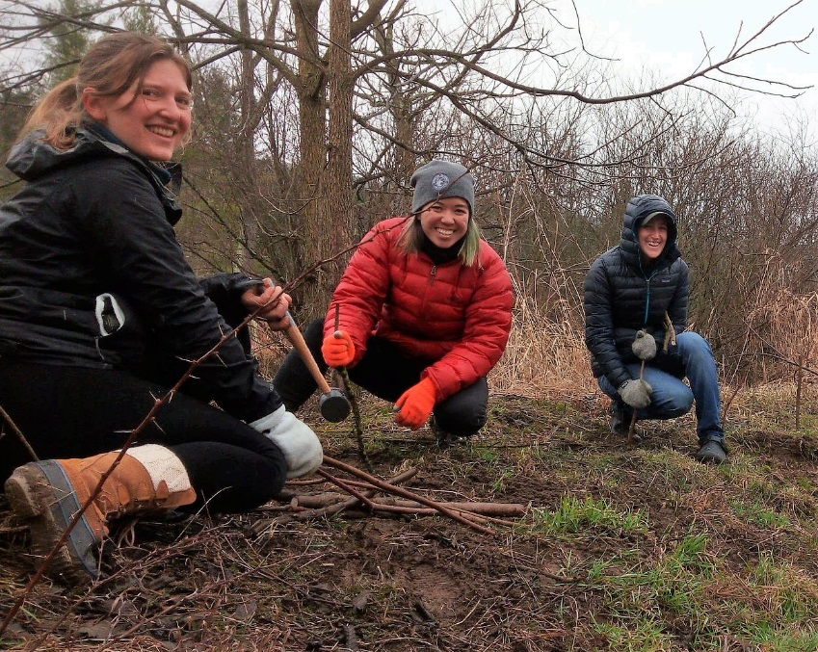
August 20-27 is DC Beer Week, we will be holding events every day at both of our locations. For the entirety of the week, rather than use traditional glassware that requires extensive dishwashing, we will be using compostable cups for all events. On August 20th, we will be leading a team of staff and community members to participate in a Watershed Workday on the Anacostia River with the Anacostia Watershed Society and Chesapeake Conservancy. Both stores will hold celebrations after the event in partnership with Dogfish Head Brewery, proceeds will go to AWS and CC.
Every decision we make for our business is made with the environment in mind. That includes, most impactfully, sourcing our products almost entirely from the states that surround ours. It also includes everything from the building and packaging materials we choose, to the equipment we use, to the fact that we purchase wind power credits to offset our energy consumption. It includes our no-waste mandate, our composting and recycling programs, and the fact that we actively encourage environmentally responsible eating and transportation. Whether or not our neighbors share our commitment to slowing climate change, we’ve created a space in which all food choices are good ones from an environmental perspective and we’ve created a community in the process.
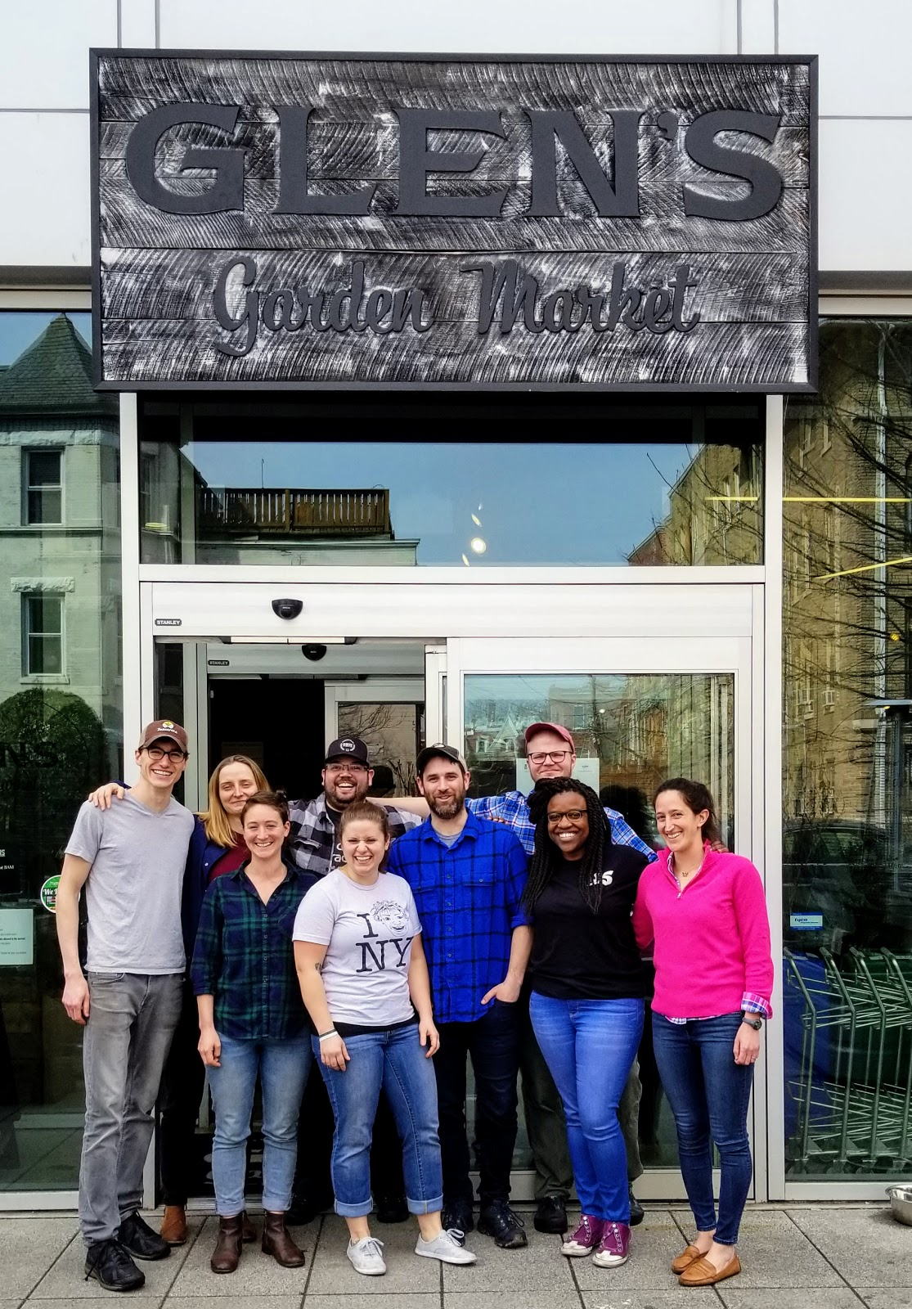
Our staff photo is attached and the names are as follows:
(Left to Right) Stephen, Marta, Virginia, Josh, Sam, James, Will, Shana, and Danielle

