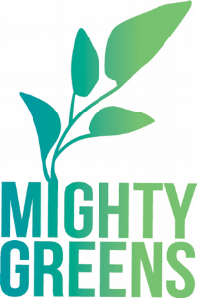
Mighty Greens
Winner of the 2019 District Sustainability Award
http://cityblossoms.org/youth-entrepreneurship-cooperative

City Blossoms’ Mighty Greens program is a DC-based youth-led green business based on urban agriculture. Mighty Greens participants grow and distribute over 3,000 seedlings annually, and incorporate organic growing practices and pest management to maintain a healthy shared green space. Staff members build up pollinator gardens to attract and support local bee populations while also using crop rotation to keep soil healthy.
