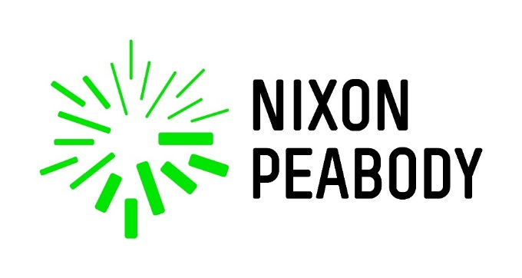
Nixon Peabody LLP

Nixon Peabody LLP developed and installed the first Community Solar Project in the DC area. As a first-mover in this space, we installed three rooftop arrays, forming a collective 180kW system that is interconnected with a local utility and generating clean renewable energy and we donate all of the energy we produce to low-income tenants elsewhere in the District . NP Solar is the largest solar installation on DC commercial property.

NP formed a non-profit (New Partners Community Solar) to help facilitate this project. All of the financial benefits of the energy production has been allocated in net metering billing credits and given to low-income individuals and families in Washington, DC at no cost. Rather than keeping or selling the renewable energy produced from the panels, we work with our partners to ensure that tenants of affordable housing projects around the District share all of the energy billing credits at no cost. For the first phase, 100 tenants will each receive approximately $20 per month as a credit on their Pepco energy bills.

The rooftop array atop our offices at 799 9th Street NW also serves as a living classroom to educate the community (including students) about solar energy, community solar and sustainable building. These presentations, especially to other building owners, about the financial and environmental benefits of community solar, and on using solar power to benefit affordable housing and the larger community, provide a tested model for other commercial owners. Expanding participation of this large building sector can enhance the environmental benefits to the District and help to mitigate the negative environmental impacts (greenhouse gas emission, landfill contribution, energy and water consumption) of the built environment. We also host environmental groups, school groups, affordable housing sponsors and others.

The NP Solar project was a result of Nixon Peabody’s negotiation of a green lease with the building owner to promote our sustainability program, facilitate our achievement of LEED® Platinum for our office, and help push the limits for sustainable development in the District.

One of the best ways to understand how our project works is to view this video of our launch ceremony: https://youtu.be/puKLzvVCjik

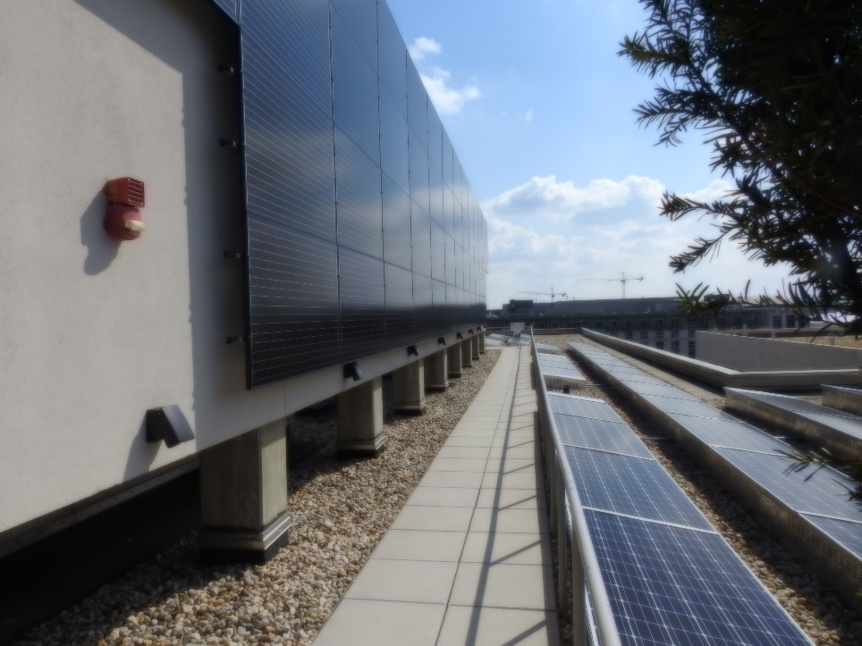
Solar array

Nixon Peabody has been among one of the first law firms to design and implement a corporate sustainability initiative across its many offices. Our Legally Green® initiative transforms our philosophy into practice as we help our clients achieve their business goals and unite in promoting environmental responsibility. Legally Green® signifies the firm’s unique combination of legal experience, thought leadership, and responsible citizenship, and our commitment to serving our clients and our community well in the changing world. We implement creative and innovative solutions to reduce our organization’s environmental impact projects like the DC Community Solar Project outlined above.

Nixon Peabody is proud to be one of the first law firms in the nation to embrace sustainable building practices. Four NP offices are LEED® certified. Our San Francisco office was first among law firms in the U.S. to pursue and secure LEED® certification by the U.S. Green Building Council and is a model for sustainable design and green building practices. In 2015, the DC office achieved LEED® Platinum certification. The Los Angeles office and the Albany office are also LEED® certified. We plan to have our New York office, which recently moved to a new building, as LEED® certified in the near future.

Nixon Peabody reduces its environmental footprint by:

- Defaulting all printers to print double-sided for paper management
- 640+ pounds of batteries recycled, 390+ eyeglasses recycled. 2,575 holiday cards recycled
- NP Preferred Hotels follow environmentally sustainable practices
- Rental Car Options for fuel efficient and low emissions vehicles
- Green Jeans Friday in the DC office for those who commute in an environmentally-friendly way
- Green Jeans Thursday in the DC office through our Generous Associates campaign
- Pro Bono Support of organizations that focus on sustainability, including BIER
- Annual Earth Day celebration and activities (over $3,149 worth of donations collected on Earth Day)

Nixon Peabody is active in giving back to the local community. In 2016, NP logged nearly 417 hours of sustainable community service and assisted 18 non-profits with our time and resources. Our Boston and DC offices have engaged in community solar projects, which have resulted in reducing electric bills for families in the low-income/affordable housing arena. NP’s bro bono program has a green track for green-related projects. Our DC office has supported local affordable housing developments with an annual community service day, in addition to volunteering at a local food bank, undertaking an annual warm coat drive, giving many non-profits access to our office for meetings or special events, and partnering with an affordable housing sponsor for back-to-school and holiday events.

Nixon Peabody takes a holistic approach to sustainability -- integrating it into our people, our places, our policies and our legal practice. We provide integrated services across legal, scientific and engineering disciplines to help our clients deliver sustainable buildings, technologies, products and solutions. We drive sustainability throughout our own organization, seeking to reduce our environmental impact. And we strive to be thought leaders and corporate citizens, sharing our experience and partnering with stakeholders to develop innovative solutions to social and environmental challenges. Being responsible stewards of our environment is part of our firm culture. We have identified priority areas and implement sustainable policies and practices firm wide, continuously challenging ourselves to be creative and innovative. We have been recognized as a pioneer in sustainability -- the law firm benchmark for effective strategy and execution. We are frequently recognized as the go-to firm for domain knowledge in this space.

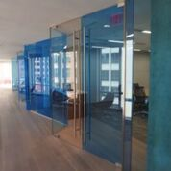

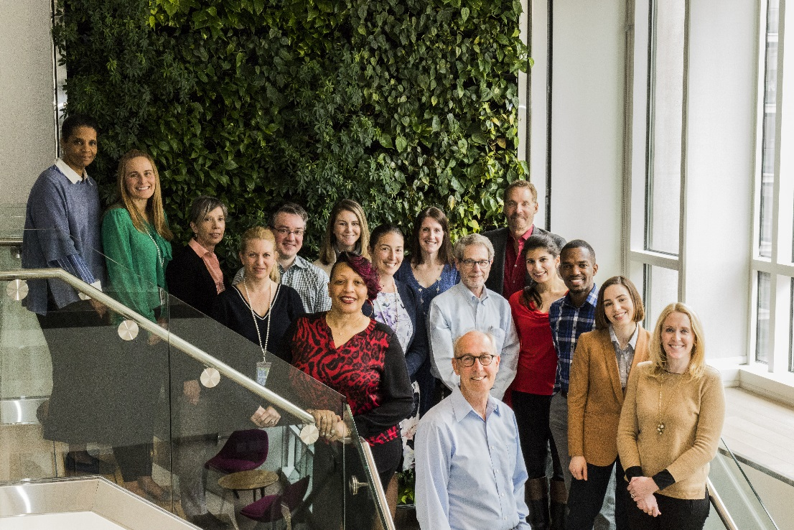
Nixon Peabody, LLP Staff

