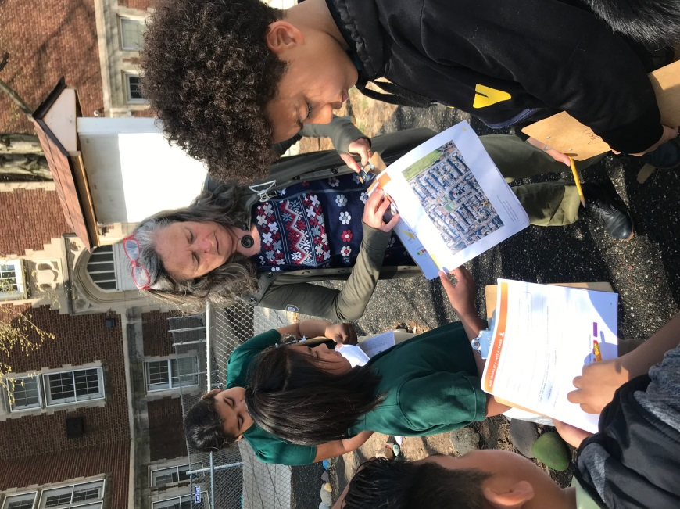
Rebecca Davis

For over ten years, Ms. Davis has worked tirelessly to deliver and advance environmental and sustainability education in DC schools. She works with numerous schools, provides professional development for teachers, testifies to DC Council on behalf of DC Environmental Education Council (DCEEC) members, and provides input on District education initiatives.

