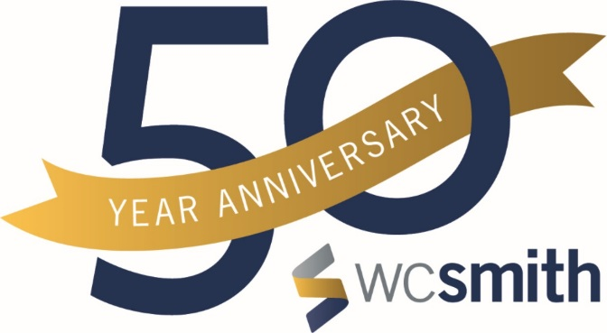

https://www.wcsmith.com/

WC Smith
Winner of the 2018 District Sustainability Award

In 2017, WC Smith will complete Archer Park, a 190-unit affordable multifamily building with a 200 KW solar array. It is anticipated to provide 60% of the common area electricity needs for the building. It is modeled on the success at Sheridan Station, a 104-unit multifamily building near the Anacostia Metro, with a 104 KW solar array that provides 58% of the common area energy needs. Sheridan Station was the first multifamily building in DC to be awarded LEED platinum. Like Sheridan Station, Archer Park will have low-flow fixtures, Energy Star appliances and windows, providing utility savings to the residents.

WC Smith has built a number of environmentally-friendly buildings. 2M, which opened in 2014 in the NoMa neighborhood is a LEED Gold building with a rainwater harvesting, a green roof, and electric car charging stations. WC Smith led the development of Canal Park, a LEED Gold park in the Capitol Riverfront, with native plants, an extensive and innovative storm water recycling system and geothermal heating and cooling. WC Smith completed Park Chelsea, a LEED Silver building in the Capitol Riverfront, in 2016. In addition to a green roof, rainwater recycling and electric car charging stations, Park Chelsea includes a bike elevator, bike lockers and a bike repair station to encourage residents to bicycle, and community gardens where residents can reserve a plot to grow food.

Charitable giving is a big part of the culture at WC Smith. Two of the main efforts are THEARC, (the Town Hall Education Arts and Recreation Campus) and the Skyland Workforce Center, both in Ward 8. The company organizes regular drives and volunteer opportunities for staff. In 2016, the company contributed $489,000 to local charities (primarily THEARC, the Skyland Workforce Center and Training Grounds), as well as $189,000 in in-kind donations. In addition to corporate giving, staff regularly organize charitable drives, including one to buy furniture for families whose apartments were damaged by a tornado and another for a cancer fundraising ride in honor of a fellow employee.

WC Smith incorporates green practices into all of our projects, not just through the infrastructure but also by encouraging residents and employees to live healthier, more sustainable lives. We encourage biking, exercising, and gardening at a number of our properties. In all projects, market-rate or affordable, new construction or renovation, we look for ways to incorporate environmentally-friendly features, including solar arrays, green roofs, storm water recycling, Energy Star appliances and windows, low-flow fixtures, walkable public spaces and bicycle racks and amenities.

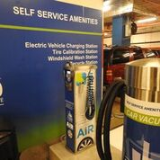
Electric Charging Station
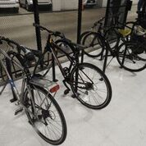

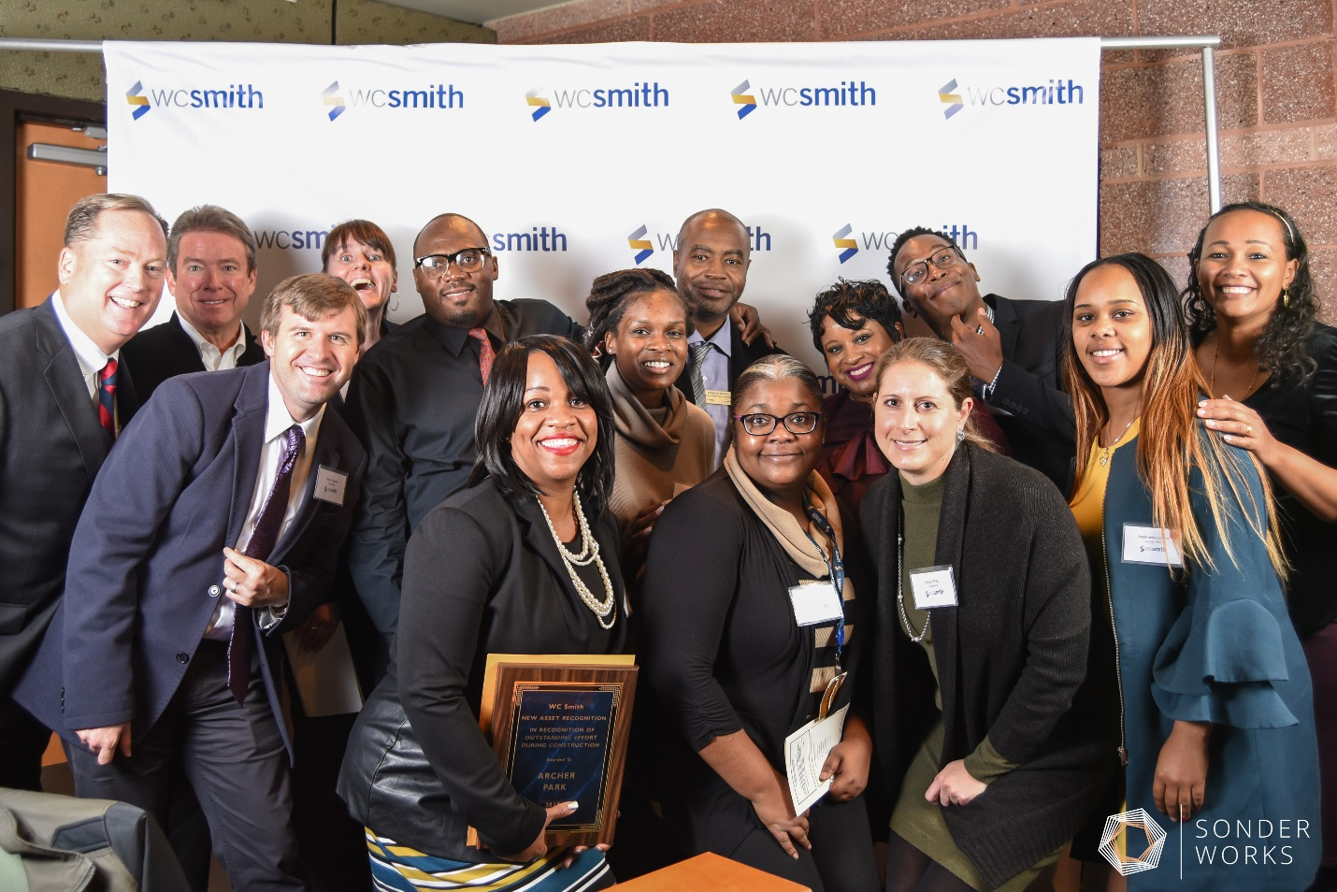
WC Smith staff

