ATTACHMENT B:
CLEAN AIR ACT § 110(a)(2)(D)(i)(I) – Interstate Transport Provisions

“Each such plan shall […] contain adequate provisions
- Prohibiting, consistent with the provisions of this subchapter, any source or other type of emissions activity within the state from emitting any air pollutant in amounts which will:
- Contribute significantly to nonattainment in, or interfere with maintenance by, any other State with respect to any such national primary or secondary ambient air quality standard, or

The District of Columbia (District) does not contribute to nonattainment in, or interference with maintenance by, any other state with respect to the 2012 fine particulate matter (PM_{2.5}) national ambient air quality standards (NAAQS). As explained below, pollutant levels in the ambient air are below the standards. Emissions of PM_{2.5} from sources in the District are small relative to those from other states. State Implementation Plan (SIP)-approved regulations to reduce emissions from sources that emit PM_{2.5} and its precursors are in place as appropriate.

PM_{2.5} Trends

Ambient measurements of PM_{2.5} are collected at three air monitoring sites in the District. Results demonstrate that PM_{2.5} concentrations have dropped over time. Figure 1 shows that PM_{2.5} design concentrations are well below both the 2012 annual and daily standards. These downward trends are likely a result of Federal control programs that limit emissions from nonroad gasoline and diesel engines, locomotives, and heavy-duty diesel trucks.

Figure 1: PM_{2.5} Design Values in the District Over Time
Compared to the Annual and Daily NAAQS

The trend is similar to design value trends in the Washington DC-MD-VA maintenance area as a whole (shown in Figure 2, which includes 2014 preliminary values).

Figure 2: Design Values in the Washington DC-MD-VA Area Over Time
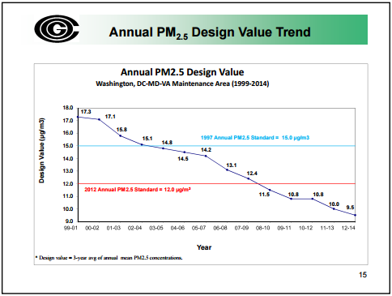
Compared to the Annual and Daily NAAQS

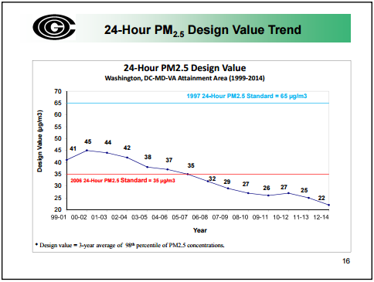

Source: Kumar, Sunil for MWAQC Meeting. Ozone Season Summary (September 29, 2015),
accessed at: http://www.mwcog.org/environment/committee/committee/documents.asp?COMMITTEE_ID=14

Emissions Reductions

PM emissions are estimated as PM-primary, which are particulates that are directly emitted by a source; PM-filterable, which are emissions that are collectable using a filter; and PM-condensable, which are formed after they are emitted. Filterable plus condensable emissions equate to PM-primary emissions, so PM_{2.5}-PRI emissions are reviewed below.

Emissions of PM_{2.5}-PRI in the District primarily come from the area source sector.

Figure 3. PM_{2.5}-PRI Emissions by Sector

EGUs & Non-EGUs: In general, point sources in the District contribute a small amount of PM_{2.5} compared to other sectors. There are no electric generating units (EGU) or other large industrial sources of PM_{2.5} emissions. The District’s last remaining EGUs were decommissioned in 2012, in part to meet permit requirements incorporated into the District’s Regional Haze SIP (77 Fed. Reg. 5191, codified at 40 C.F.R. § 52.470(e)).

As indicated in Figure 4, the main source of area source PM_{2.5} emissions is fuel combustion (in purple). The largest sources of course PM (PM₁₀) emissions, which are not as relevant for the purposes of the fine PM NAAQS, are construction and road dust.)

Figure 4. Area Source Emissions of PM in the District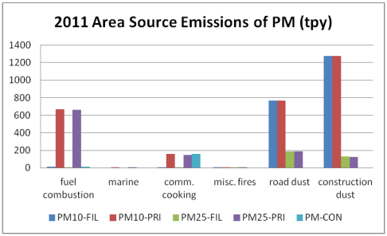

Figure 5 shows that within the area source fuel combustion category, there was a large uptick in residential wood combustion (RWC) emissions in the 2008 National Emissions Inventory for the District. This was due to changes in the calculation methodology and is not representative of actual emissions increases.

Figure 5. Fuel Combustion Emissions of PM_{2.5}-PRI in the District

The commercial/institutional and residential sectors (not related to RWC) are the dominant area source sectors. PM_{2.5} emissions are primarily due to the use of distillate oil, which has dropped in recent years, and natural gas. The District recently proposed a regulation to reduce the sulfur content of home heating oil used in the District (62 DCR 9314; July 3, 2015), and intends to submit a final regulation to EPA for SIP approval. Since sulfates are a precursor to PM_{2.5}, the District anticipates that distillate-related PM_{2.5} emissions will be reduced in future years.

Mobile Sources: Regional and EPA modeling indicates that onroad emissions are expected to continue going down in future years as Tier 3 clean vehicle and fuel standards are implemented and vehicle turnover occurs, despite increases in population. Mobile sources, both onroad and nonroad combined, contribute roughly one quarter of the PM_{2.5} emissions in the District. In 2011, diesel-powered vehicles (which release more PM than gasoline-powered vehicles) accounted for 54 percent of PM_{2.5} emissions from the onroad sector and 88 percent of PM_{2.5} emissions from the nonroad sector.

The District implements an Enhanced Vehicle Inspection and Maintenance (I/M) program to control emissions from onroad vehicles, approved by EPA at 40 C.F.R. 52.470(c)). The District also does extensive outreach to educate tour bus drivers and others who may be impacted by the District’s strict engine idling time limits at 20 DCMR § 900.1. Otherwise, the District relies heavily on federal measures to reduce emissions from onroad and nonroad engines.

Contributions from Other States

There is no EPA assessment of PM_{2.5}-related transport across state boundaries. Generally, PM_{.2.5} levels follow similar trends as ozone levels.

In the Cross State Air Pollution Rule (CSAPR) related to ozone transport, EPA used a contribution screening threshold of one percent of the 2008 ozone NAAQS to identify upwind states that may significantly contribute to downwind nonattainment or maintenance problems. According to EPA’s ozone transport modeling, the largest ozone contributions from the District to 2017 projected nonattainment areas in other states is 0.73 parts per billion (ppb), and to 2017 projected maintenance-only areas in other states is 0.64 ppb. Since the one percent contribution threshold for the 2008 NAAQS is equivalent to 0.76 ppb, the District’s projected contributions are below the threshold, meaning that the District does not significantly contribute to ozone nonattainment or maintenance issues in any other state. Thus, it is reasonable to hypothesize that the District does not currently contribute to any downwind PM_{2.5} issues.

Conclusion

The District of Columbia is a small jurisdiction with no significant sources of PM_{2.5} emissions and little opportunity to reduce emissions. The District’s SIP contains adequate provisions, as discussed in the Infrastructure SIP submission, to prohibit sources from emitting air pollutants at levels that would significantly contribute to nonattainment or interfere with maintenance by other states with the 2012 PM_{2.5} NAAQS. While the District does what it can to adopt new control measures, it historically has and will likely continue to rely heavily on Federal measures and measures in other states.

U.S. Environmental Protection Agency [EPA-HQ-OAR-2015-0500; FRL-]. “Notice of Availability of the Environmental Protection Agency’s Updated Ozone Transport Modeling Data for the 2008 National Ambient Air Quality Standard (NAAQS).” Found at: http://www3.epa.gov/airtransport/pdfs/FR_Version_Transport_NODA.pdf (signed by Stephen D. Page, July 23, 2015).

