APPENDIX 9
DOEE Priority Watersheds
Clean Water Construction Project Scoring Criteria for Stormwater Grey Infrastructure and Stormwater Green Infrastructure projects award points to projects that benefit a District Priority Watershed. The subwatersheds on this list drain to tributaries that have recently had stream restoration work, or will have restoration work performed in the near future.
Project applications to the Notice of Funding and Partnership Availability for Fiscal Year 2019 Clean Water Construction Treatment Works Projects will receive up to five points for providing a water quality benefit to the following District Priority Watersheds:

- Pinehurst Branch
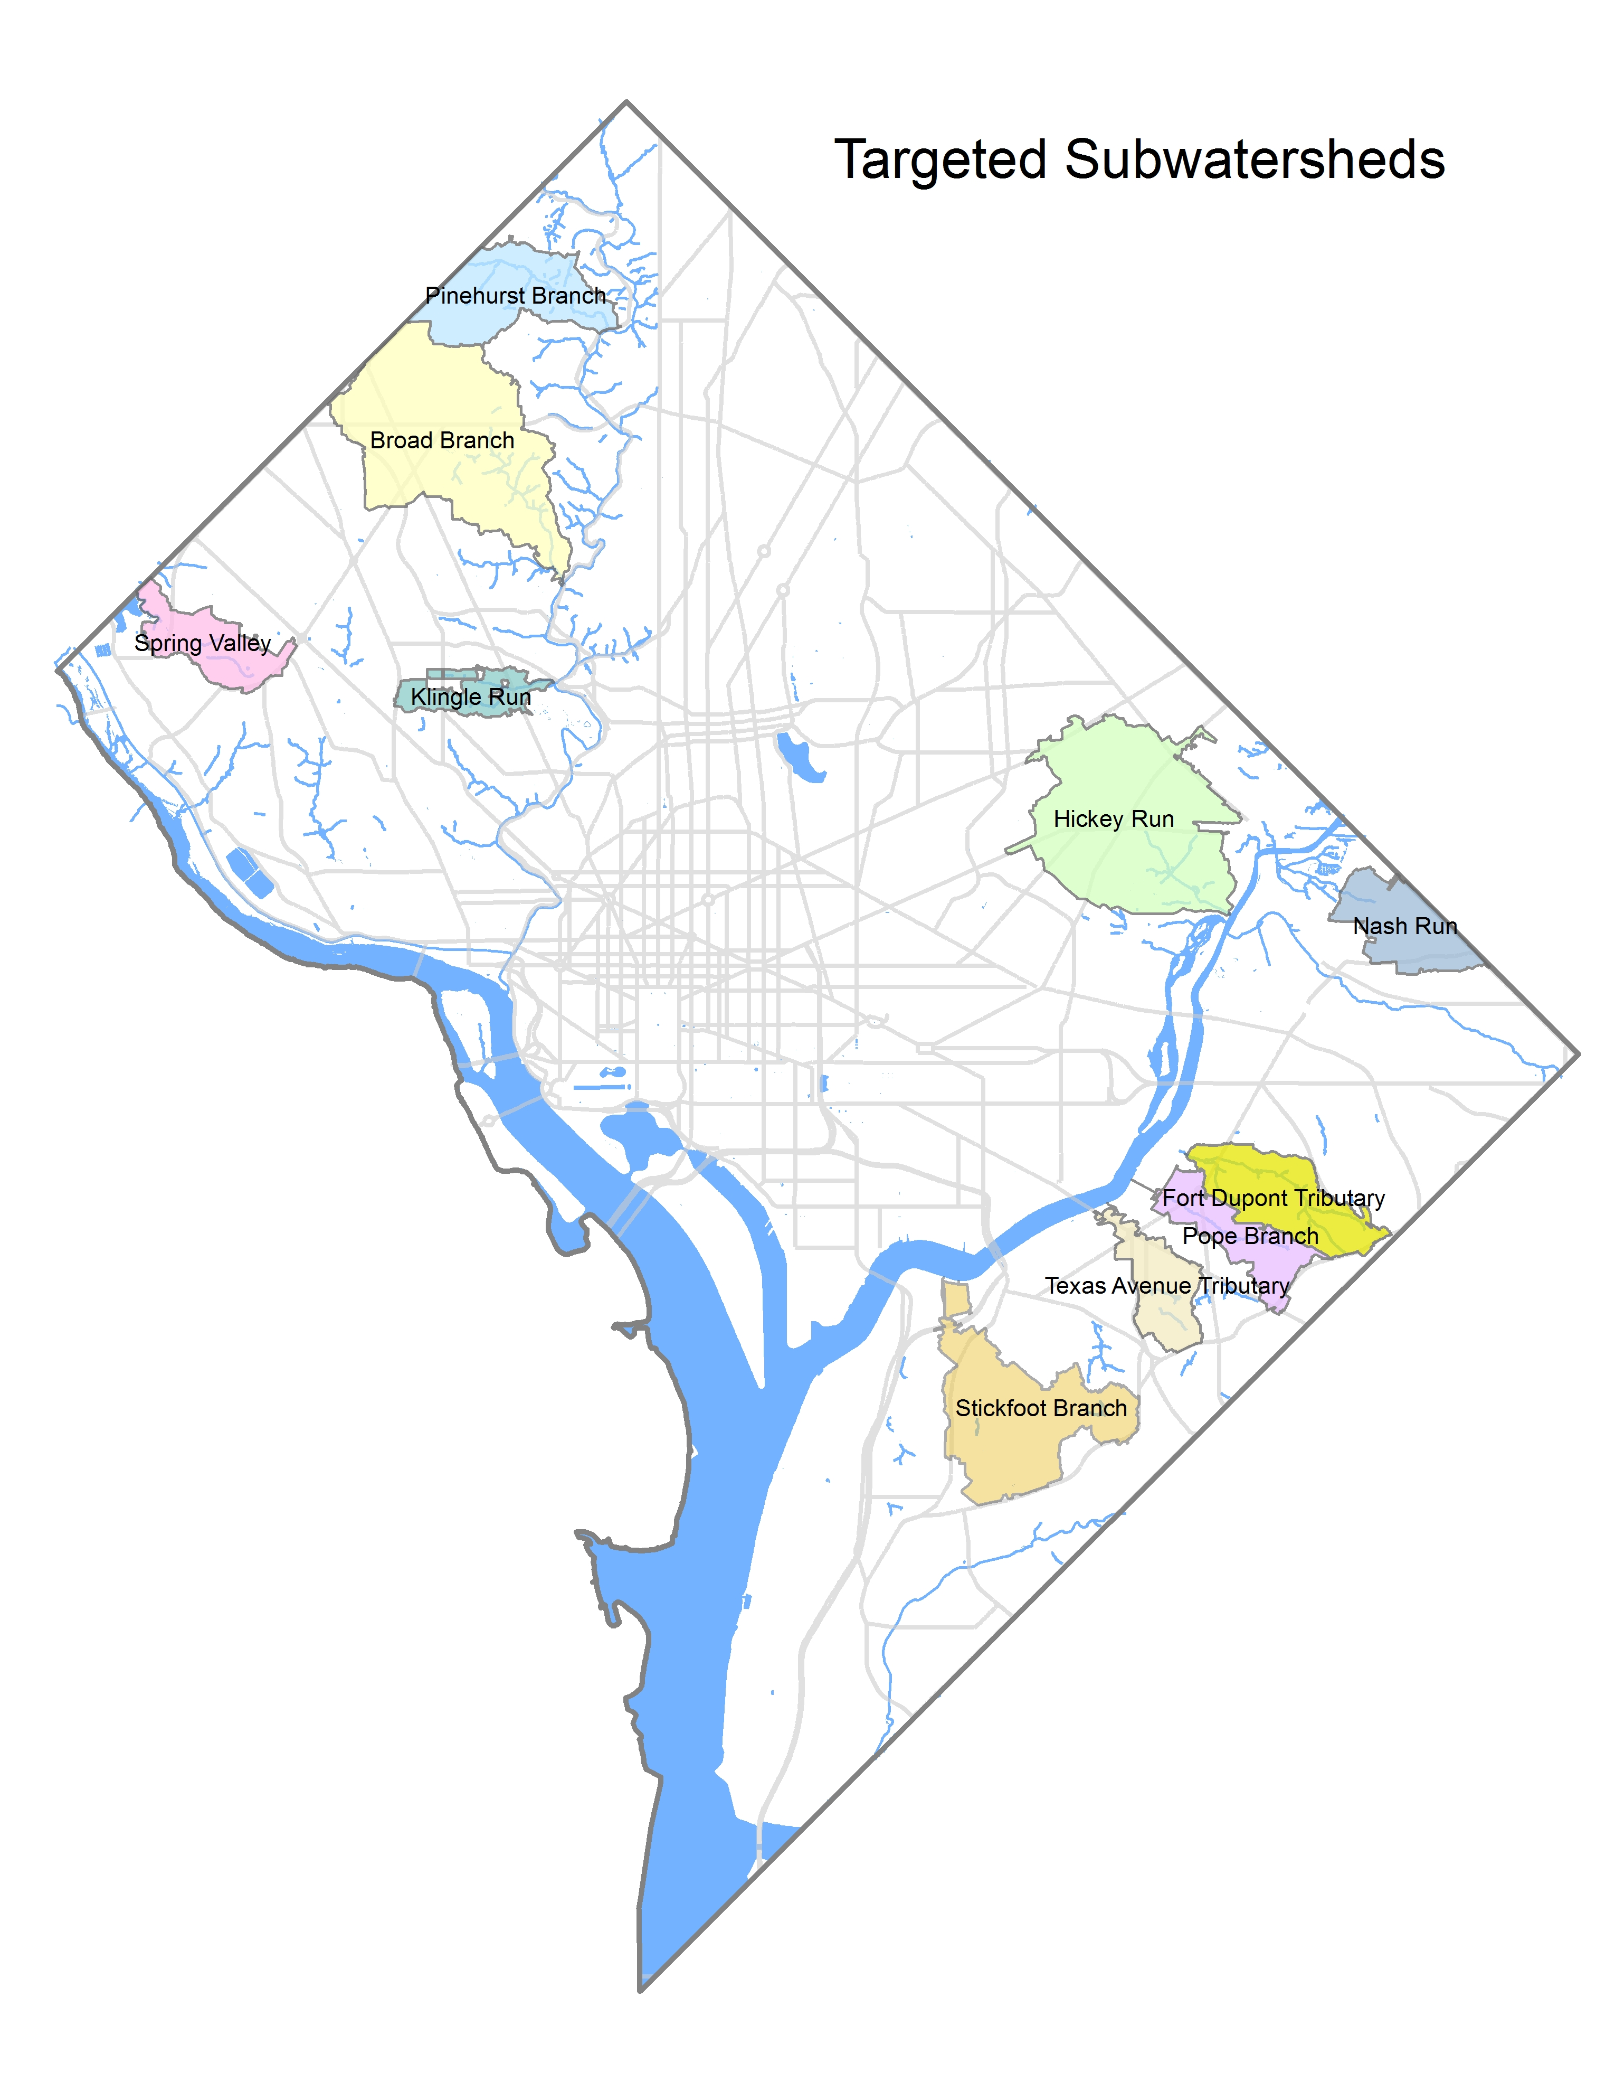

- Broad Branch

- Spring Valley

- Klingle Run

- Hickey Run

- Nash Run

- Stickfoot Branch

- Texas Avenue

- Pope Branch

- Fort Dupont

To determine if your project is located in a District Priority watershed, follow this link to ArcGIS Online Targeted Watersheds 2017, and enter the street address in the search bar found in the upper right-hand corner of the map.

