Sustainable Energy Utility Advisory Board (SEUAB) Regular Meeting
Tuesday, March 14, 2023
10:00 AM – 12:00 PM

Call to Order
Chair Bicky Corman called the meeting to order at 10:02 AM, March 14, 2023. Chair Bicky Corman called a quorum of the Sustainable Energy Utility Advisory Board (SEUAB or Board) at 10:05 AM. This was a Microsoft Teams video conference call meeting.

Roll Call/Instructions
Roll call was taken at 10:04 AM and the following people were in attendance:

Board Members
Name | In Attendance? | FY 2023  Special Meetings  Attendance Record | FY 2023  Sub Committee Meeting  Attendance Record | FY 2023 Regular Meetings  Attendance Record
Bicky Corman - Board Chair (Mayor’s Designee) | Yes | 4/4 | 1/1 | 4/5
Marshall Duer-Balkind – Vice Chair (Councilmember Cheh) | Yes | 4/4 | 1/1 | 5/5
Sandra Mattavous-Frye (or OPC proxy) | Yes | 4/4 | 1/1 | 5/5
Merancia Noelsaint (PSC) | Yes | 3/4 | 0/0 | 5/5
Donna Cooper (Electric Company) | Yes | 4/4 | 1/1 | 5/5
Eric Jones (Building Management) | Yes | 4/4 | 1/1 | 5/5
Nina Dodge (Environment) | Yes | 3/3 | 0/0 | 5/5
Jamal Lewis (Low-Income Community) | Yes | 4/4 | 0/0 | 4/5
Mishal Thadani (Economic Development) | No | 1/4 | 0/0 | 1/5
Sasha Srivastava (Renewable Energy) | Yes | 2/4 | 1/1 | 5/5
Vacant (Building Construction) | N/A | N/A | N/A | N/A
Vacant (Council Chairperson Mendelson) | N/A | N/A | N/A | N/A
Manny Geraldo (Gas Utility) | No | 0/0 | 0/0 | 1/5

Other Attendees: Sarah Kogel-Smucker (OPC), Ernest Jolly (DCSEU), Benjamin Burdick (DCSEU), Tamara Christopher (DCSEU), Jennifer Johnston (DOEE), Angela Johnson (DCSEU), Dave Epley (DOEE), Dr. Lance Loncke (DOEE), Dr. Nick Burger (DOEE), Patti Boyd (DCSEU), Crystal McDonald (DCSEU), Dollie Banks (Pepco), Joshua McClelland (WGL), John Richards (WGL), Jim Herndon (WGL), Brian Caldwell (OAG),

Approval of Agenda
- Chair Bicky Corman moved to approve the agenda and was seconded by Sarah Kogel-Smucker (OPC). All were in favor, and none were opposed.

Approval of February Minutes
- Chair Bicky Corman moved to approve the February meeting minutes. The motion was seconded by Dr. Donna Cooper (Pepco). All were in favor, and none were opposed.

FC1160 WGL EEDR Programs
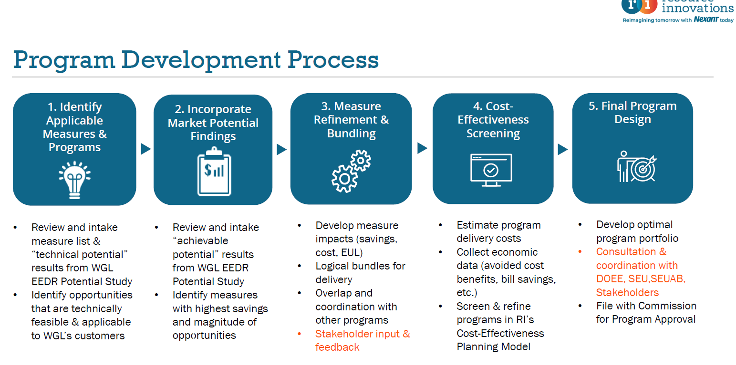
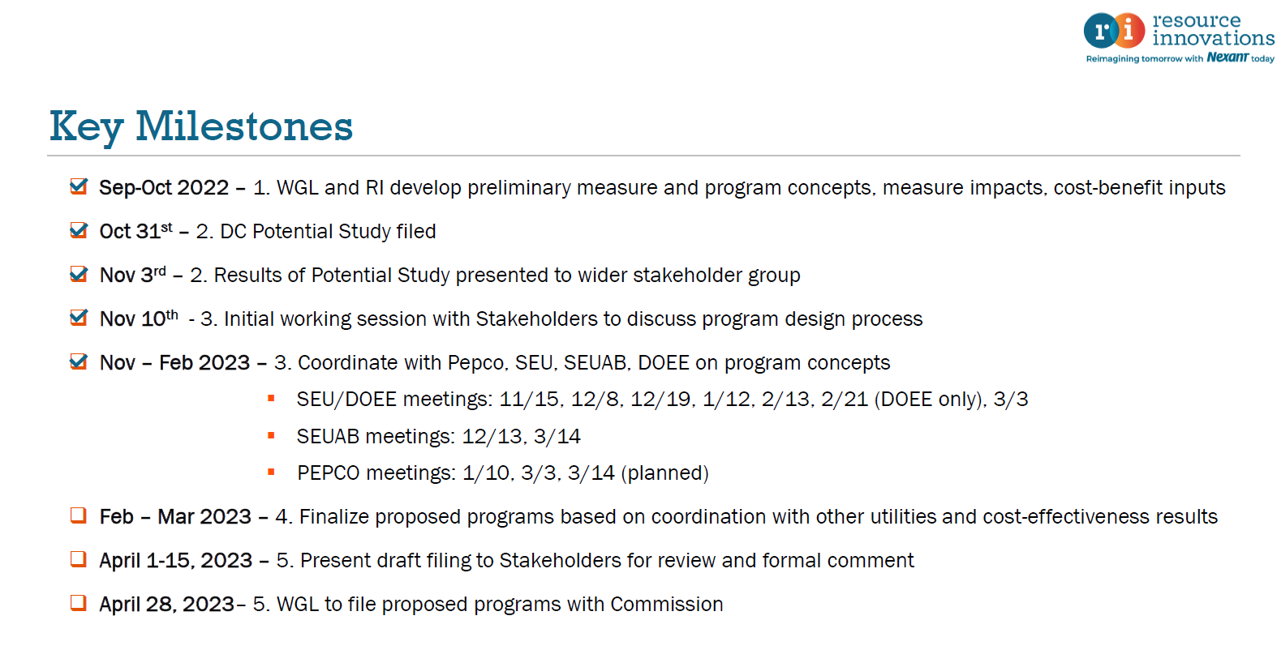

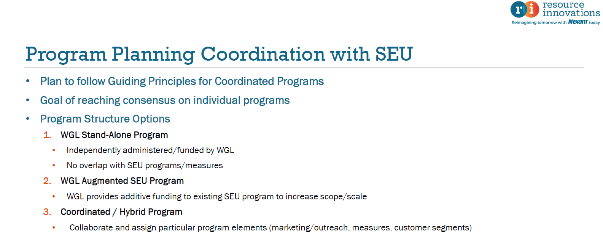
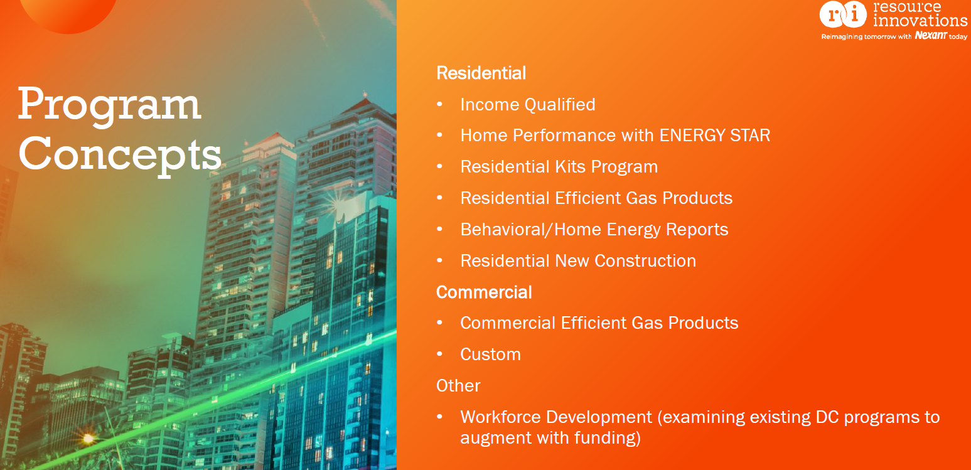
- Nina Dodge asked if the customer class of residential referred to single family homes, condos, or co-ops.
- Joshua McClelland (WGL) shared that WGL is looking at building stock and meter type.
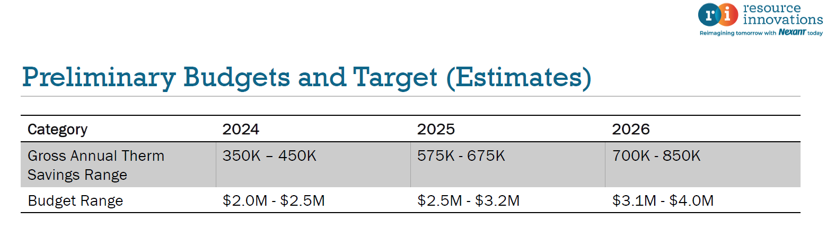
- Jamal Lewis inquired about the increasing budget.
- John Richards (WGL) attributed the rise in budget to the increase in savings goals each year.
- Dr. Donna Cooper (Pepco) underscored how Pepco is engaging in active conversations with WGL to ensure there is no duplication of efforts.
- Nina Dodge asked about the WGL program that focused on client behavior.
- John Richards (WGL) explained that the behavioral program is a home energy report that will allow customers to see their energy use compared to their neighbors.
- Jamal Lewis asked out of the 180,000 District resident’s WGL serves, how many are low-to-moderate-income (LMI) clients?
- John Richards (WGL) shared that about 28% of the 180,000 residents fall within the LMI bucket.
- Joshua McClelland (WGL) highlighted that WGL is exploring a couple different parameters that could be used to identify and categorize LMI customer.
- Nina Dodge raised the importance of coordinating with existing program that have defined LMI.
- Joshua McClelland (WGL) confirmed that the LMI categorization is one of the discussion items with the technical issues working group.
- Chair Bicky Corman mentioned that the utilities have access to the customer data that is not easily accessible to DCSEU. She asked if WGL’s behavioral programs will be measured based on the customer utility data (that can only be accessed by the utilities).
- Joshua McClelland (WGL) shared that the WGL contractor would have access to the customer data. He also highlighted that the behavioral program has data that does not overlap with DCSEU’s programs.
- Chair Bicky Corman shared that WGL’s behavioral program is more standalone because the DCSEU doesn't have access to the information, which doesn't mean the DCSEU should not have access to the information.
- Joshua McClelland (WGL) encouraged the Board to review the programs more thoroughly and circle back with any questions or comments.
- Sarah Kogel-Smucker (OPC) highlighted the need for the Board to discuss the overarching question of whether the Board is supportive of new energy efficient gas programs.
- Nina Dodge reminded the group that many members do not necessarily agree with WGL’s programs or think that the PSC should agree with all of them.
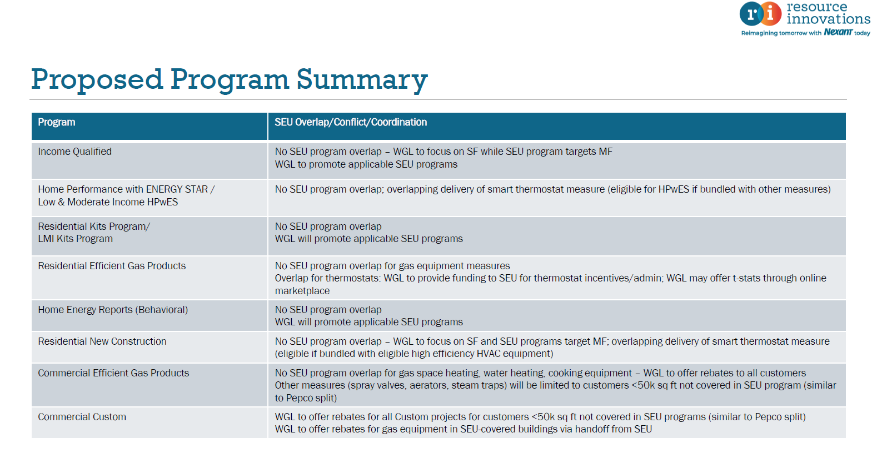
- Chair Bicky Corman commented that many of these programs are the prolong the use of gas equipment and asked is there an information component to these programs where a resident could have the option to receive a smart thermostat or electrify a resident’s home? What kind of communication will be used in these programs?
- Joshua McClelland (WGL) shared that electrification will be an ongoing consideration and highlighted that the goal of the program will be to have the most energy savings for WGL’s customers. WGL’s communication will focus on natural gas efficiency rather than electrification.
- Nina Dodge mentioned that many of the high efficient gas products run on medium pressure delivery where many areas of the city are on low pressure delivery. Project pipes include upgrades past medium pressure, to high pressure. How much of incorporating these energy efficient gas product will require upgrades to the pressure delivery? She also highlighted how these programs are end use while it is important to look at the whole picture.
- Joshua McClelland (WGL) explained that project pipes and pipe pressure configuration is not his areas of expertise, and he is more focused on the end use portion.
- Dr. Lance Loncke (DOEE) asked if WGL planned on claiming any type of savings for workforce development.
- Joshua McClelland (WGL) commented that WGL does not plan on quantifying any savings for workforce, but believes workforce is a crucial component to energy efficiency implementation.
- Chair Bicky Corman inquired about the topics to be discussed during the March 30th FC1160 EEDR working group meeting.
- John Richards (WGL) shared that the March 30th EEDR working group meeting would cover WGL’s potential study and the presentation provided today during the Board meeting.
- The Board thanked WGL for its time and information.
- Key upcoming dates discussed:
  - March 23: Special Board meeting
  - March 30: EEDR working group
    - Vice Chair Marshall Duer-Balkind to attend on the Boards behalf.
    - WGL to provide a more detailed document prior to meeting.
  - April 3-7: WGL to provide final draft of filing.
  - April 11: – next Board meeting
  - April 28: WGL planning to file programs to PSC
- Sarah Kogel-Smucker (OPC) highlighted that question facing the EEDR working group is different than the question facing the Board. There is a question for the Board is under DCSEU’s new scope, does installing a new gas appliances overlap with programs provided?
- Dr. Lance Loncke (DOEE) shared that it could be beneficial for the Board to hear DCSEU’s position before the Board submits its letter to the commission.
- Chair Bicky Corman posed the question, when should the Board provide its letter (late April)?
She shared for Pepco’s filing; the Board sent its letter before Pepco’s filing.
- Vice Chair Marshall Duer-Balkind confirmed the Board submitted its letter to the Commission prior to Pepco filing its EEDR programs.
- Nina Dodge mentioned that WGL’s timeline may be pushed back due to request of stakeholders.
- Dave Epley (DOEE) raised that the question Sarah Kogel-Smucker (OPC) mentioned has a low for practical implications. He highlighted how the Board advised on DCSEU’s contract to remove or ban incentivizing gas equipment. This contractual change makes it more challenging for the DCSEU to meet its benchmarking goals. WGL’s programs are in direct conflict with DCSEU’s programs.
- Nina Dodged moved for the Board to meet outside of the regular meeting to discuss the questions raised and timeline. Chair Bicky Corman seconded the motion. All were in favor, and none were opposed.

Board Action Items
- Approval of February meeting minutes
- Approval of Board’s special meeting on March 23rd at 10am

Future Agenda Items
- Special Board Meeting (March 23)
  - Discussion of Board position on WGL’s EEDR Program & overall position
- DCSEU FY23 Q1 Performance
- Approval of March Meeting Minutes
- Tracking bills and legislation
- Timeline for Board’s Annual Report
- Presentation on storage

Adjournment
- Chair Bicky Corman adjourned the meeting at 11:59 AM.

Acronyms used during this meeting
- CAEA - Clean Affordable Energy Act
- CEDC Act – Clean Energy DC Act
- DCSEU - District of Columbia Sustainability Energy Utility
- DOEE - Department of Energy and Environment
- EEDR – Energy Efficiency and Demand Response
- OPC - Office of the People’s Counsel
- PHI – Pepco Holdings
- PSC - Public Service Commission
- WGL – Washington Gas Light
Minutes prepared by Jennifer Johnston, DOEE

