District Stormwater Retrofit Plan

Prepared by:
District Department of the Environment
1/22/2014
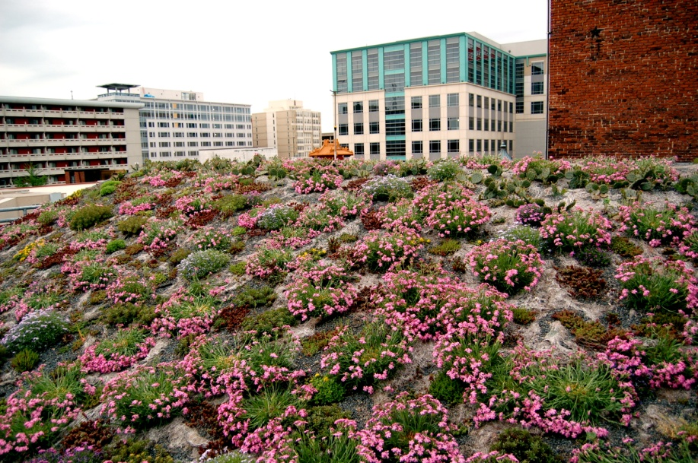
Green Roof Demonstration Project at the American Society of Landscape Architects Headquarters

Table of Contents
1 Program Introduction and Regulatory Requirements 1
2 Retrofit Programs 1
2.1 Stormwater Management Regulations 1
2.2 District Direct Investment in Retrofits 2
2.3 Retrofit Incentive Programs 2
3 Eligible Retrofit Projects 2
4 Performance Measures 4
4.1 Public Right-of-Way Projects 5
5 Reporting on Stormwater Retrofit Installations 5

Program Introduction and Regulatory Requirements
As required by Section 4.1.5.1 of the District’s Municipal Separate Storm Sewer System (MS4) Permit, this document establishes performance metrics that will be utilized to track progress in retrofitting existing impervious surfaces throughout the District. These metrics are consistent with the District’s stormwater management regulations and guidance document that require development projects to retain stormwater runoff. In addition, these performance metrics present a methodology for crediting the area of retrofits for projects that achieve more or less than the 1.2” retention standard.
The MS4 Permit is issued by the EPA under the Clean Water Act, and establishes the conditions under which the District may discharge stormwater to surface water bodies. Per Section 4.1.5.4 of the Permit, the District must retrofit 18,000,000 square feet of impervious surface, with 1,500,000 required to be projects in Public-Right-of-Way (PROW), by the end of permit term (October 2016).

Retrofit Programs
The District has multiple drivers that will result in the retrofit of existing impervious surfaces to improve stormwater management and comply with the MS4 Permit. These include regulations for development and substantial improvement projects, direct public investment in stormwater retrofits and financial incentives for voluntary stormwater retrofits. The following sections provide an overview of these programs.

Stormwater Management Regulations
On July 19, 2013, DDOE finalized the 2013 Rule on Stormwater Management and Soil Erosion and Sediment Control (2013 Stormwater Rule), which amended Chapter 5 (Water Quality) of Title 21 (Water and Sanitation) of the District of Columbia Municipal Regulations (DCMR)., Major land-disturbing activity must retain the first 1.2” of rainfall on-site or through a combination of on-site and off-site retention. Major substantial improvement activity must retain the first 0.8” of rainfall on-site or through a combination of on-site and off-site retention. Retention is achieved with Best Management Practices (BMPs) that infiltrate, evapo-transpire, and/or harvest stormwater runoff for non-potable use.
The stormwater management regulations will be a critical driver of retrofits as the vast majority of development projects in the District involve the redevelopment of existing impervious surfaces that were previously developed without strong stormwater management controls. On average, regulated development projects disturb approximately 15 million square feet of land per year. Further, Major Substantial Improvement projects will result in a significant amount of additional stormwater retrofits. As more sites are retrofitted through regulated development, the District will gradually be transformed into a “spongier” landscape with healthier streams and rivers.

District Direct Investment in Retrofits
To support the implementation of the MS4 Permit, the District collects a Stormwater Fee from all properties with impervious surfaces. The Stormwater Fee is charged based on the size of a property’s impervious surface. The Stormwater Fee provides a dedicated funding source for compliance with the District’s MS4 Permit and includes funding to implement stormwater retrofit projects primarily on public property. These projects include installing green roofs, roadside bioretention, planting trees and other stormwater control practices that increase stormwater retention and help the District meet the retrofit requirement.

Retrofit Incentive Programs
The District also leverages the stormwater fund by utilizing incentive programs to help residents, non-profits organizations and commercial properties implement stormwater projects that typically include retrofits to impervious surfaces. District incentive programs are:
- RiverSmart Subsidy Programs – Provides subsidies to homeowners and larger property owners who install stormwater retention practices such as green roofs, rain barrels, and rain gardens.
- RiverSmart Rewards – Provides a discount on stormwater fees for properties that retain stormwater runoff from impervious or compacted surfaces.
- Stormwater Retention Credit (SRC) Trading – Allows property owners that voluntarily install stormwater retention practices and regulated projects that install retention capacity that exceeds the required volume to create SRCs that can be sold to meet up to 50% of a regulated projects retention obligation.
These programs provide layered incentives that potentially provide a reasonable return on investment that will spur voluntary retrofits of impervious surfaces.

Eligible Retrofit Projects
Projects in the District that remove impervious surfaces or effectively reduce the area of imperviousness by retaining stormwater runoff from those surfaces will be eligible for credit as retrofits.
The design and volume of retention achieved by these projects will be determined in accordance with the Districts 2013 Stormwater Management Guidebook (SWMG). The SWMG provides the technical guidance required to comply with the District’s stormwater management regulations, including the criteria and specifications engineers and planners use to plan, design, and construct regulated sites and stormwater BMPs.
To help residents and developers comply with the 2013 Stormwater Rule, DDOE created the 2013 General Retention Compliance Calculator and the 2013 Rainwater Harvesting Retention Calculator. Each regulated project must use the General Retention Compliance Calculator to demonstrate proper BMP selection and sizing to achieve the required amount of stormwater retention and/or water quality treatment. These calculators must be used to prepare a Stormwater Management Plan that is required as part of the permit process for regulated construction and redevelopment sites. Further a 2013 SRC Calculator has developed and must be used to calculate the eligible retention capacity of any site that is applying to generate SRCs.
The SWMG allows for the following stormwater retention practices:
- Green Roofs
- Extensive green roof
- Intensive green roof
- Rainwater Harvesting
- Impervious Surface Disconnection
- Simple disconnection to pervious areas with the compacted cover designation
- Simple disconnection to conservation areas with the natural cover designation
- Simple disconnection to a soil compost amended filter path
- Infiltration by small infiltration practices (dry wells or French drains)
- Filtration by rain gardens or stormwater planters
- Permeable Pavement Systems
- Enhanced Permeable Pavement
- Standard Permeable Pavement
- Bioretention
- Standard Bioretention
- Enhanced Bioretention
- Stormwater Infiltration Practices
- Infiltration trench
- Infiltration basin
- Open Channel Systems
- Grass channels
- Dry swales/bioswales
- Wet swales
- Ponds
- Micropool extended detention pond
- Wet pond
- Wet extended detention pond
- Wetlands
- Shallow wetland
- Extended detention shallow wetland
- Trees
- Proprietary Practices, if specifically approved by DDOE

Detailed performance criteria for each of the above are presented in Chapter 3 of the SWMG. These criteria govern feasibility, conveyance, pretreatment, treatment, landscaping, construction sequence, maintenance, and stormwater retention calculations.

Performance Measures
As required by the MS4 Permit, the District will calculate the area of retrofit based on the retention capacity of each practice relative to the regulatory requirement of retaining the volume of runoff generated by a 1.2” storm event. For example, a project that has the capacity to retain the volume generated by a 1.2” storm from 100 square feet of impervious surface will be credited with retrofitting 100 square feet. However, a similar project that achieves less than 1.2” of retention capacity would be credited with less than 100 square feet of retrofit, while a project that achieves more than 1.2” of retention would be credited with retrofitting more than 100 square feet of impervious surface.
To determine the value of retrofit for projects that retain greater than or less than 1.2” capacity, DDOE examined the hourly data from a 30-year record of precipitation in the District to determine the volume of runoff generated by impervious surfaces with varying retention capacity from a 1.2” storm event. The volume calculation also accounted for a presumed 72 hour draw down period for retention practices after a storm event. This volume was then normalized to results for practices that had the capacity to retain the full 1.2” storm.
The data demonstrates that practices that achieve less than 1.2” of retention capacity perform better than simply pro-rating the capacity by comparing to the 1.2” baseline. For example, a 0.6” retention practice uses its full capacity much more frequently than a 1.2” sized practice, so when its performance is normalized to the 1.2” practice it can be credited with achieving 0.747 square feet of effective retrofit. Table 1 summarizes the results of this analysis with the retrofit credit that will be awarded for each 10th of an inch in retention capacity. The data and calculator utilized to determine this retrofit credit will be available on the DDOE website.

Public Right-of-Way Projects
The Public Right-of-Way (PROW) occupies approximately twenty five percent (25%) of the impervious area of the District of Columbia, which makes it one of the most significant sources of stormwater runoff impacting District water bodies. PROW projects provide many opportunities to incorporate LID to manage stormwater runoff. However, as nearly all PROW projects in the District involve the maintenance and upgrade of existing streets, they are faced with a multitude of unique site constraints that vary widely. Issues such as utility conflicts, public safety, and mature trees can limit the size or design of LID in the PROW. Competing interests for the use of public space in urban areas can also pose a challenge. Some LID facilities require a large area in order to be effective and this may be difficult to achieve when trying to balance pedestrian, biking, safety, transit and vehicular traffic in the same limited space. Given the unique constraints that routinely exist, PROW projects are required to achieve the 1.2” retention capacity to the maximum extent practical (MEP). The Stormwater Management Guidebook outlines the process that a PROW project will follow to demonstrate that opportunities to achieve stormwater retention have been utilized to the MEP.
In addition, the District Department of Transportation (DDOT) has released Draft Design Standards for Low Impact Development and Green Infrastructure for the PROW in the District. Design standards have been developed for vegetated systems, permeable pavement, and tree space design and the manual contains design guidelines, drawings, and specifications. These designs requirements are intended to refine and clarify what design practices are preferred within the public PROW
PROW projects that are designed to the MEP retention standard will be granted full “credit;” that is, one square foot of PROW retrofitted to the MEP will be credited as one square foot of retrofit.

Reporting on Stormwater Retrofit Installations
DDOE will continue to report on progress toward meeting the 18,000,000 square feet retrofit goal in the MS4 Annual Report utilizing the performance metrics defined in this document.

Table 1 Retrofit Performance Metrics
BMP Retention Capacity (inch) | Impervious Surface (square feet)
0.10 | 0.168
0.20 | 0.321
0.30 | 0.454
0.40 | 0.568
0.50 | 0.665
0.60 | 0.747
0.70 | 0.814
0.80 | 0.869
0.90 | 0.912
1.00 | 0.948
1.10 | 0.977
1.20 | 1.000
1.30 | 1.019
1.40 | 1.035
1.50 | 1.046
1.60 | 1.056
1.70 | 1.063

To view the guidance documents for the 2013 Stormwater Rule go to www.ddoe.dc.gov/swregs.
To view the 2013 Stormwater Rule go to: http://green.dc.gov/node/610592
A major land-disturbing activity is any activity that disturbs over 5,000 square feet or greater of land area.
A major substantial improvement activity is a substantial improvement activity and associated land-disturbing activity, including such activities that are part of a common plan of development, for which the combined footprint of improved building and land-disturbing activity is five thousand square feet (5,000ft2) or greater.
To view the 2013 Stormwater Management Guidebook go to: www.green.dc.gov/node/610622.
The General Retention Compliance Calculators are located on the DDOE website at www.ddoe.dc.gov/swregs.
Retrofit Performance Metrics based on Average Annual Retention Achieved by BMP from 1 Square Foot of Impervious Surface, Normalized to standard where 1 = 1.2” of Retention

