Sustainable Energy Utility Advisory Board (SEUAB) Meeting
Friday, November 3, 2023
12:00 PM – 1:00 PM

Call to Order
Chair Bicky Corman called the meeting to order at 12:05 PM, November 3, 2023. Chair Bicky Corman called a quorum of the Sustainable Energy Utility Advisory Board (SEUAB or Board) at 12:06 PM. This was a Microsoft Teams video conference call meeting.

Roll Call/Instructions
Roll call was taken at 12:04 PM and the following people were in attendance:

Board Members
Name | In Attendance? | FY 2024 Special Meetings  Attendance Record | FY 2024 Regular Meetings  Attendance Record
Bicky Corman - Board Chair (Mayor’s Designee) | Yes | 1/1 | 1/1
Mansi Talwar (Councilmember Allen) | Yes | 1/1 | 0/0
Sandra Mattavous-Frye (or OPC proxy) | Yes | 1/1 | 1/1
Danielle Gurkin (PSC) | No | 0/0 | 1/1
Pending - (Electric Company) | N/A | N/A | N/A
Eric Jones (Building Management) | No | 0/0 | 1/1
Nina Dodge (Environment) | Yes | 1/1 | 1/1
Jamal Lewis (Low-Income Community) | Yes | 1/1 | 1/1
Jaleel Shujath (Economic Development) | Yes | 1/1 | 1/1
Sasha Srivastava (Renewable Energy) | Yes | 1/1 | 1/1
Giuls Kunkel (Building Construction) | Yes | 1/1 | 0/0
Dr. Larry Martin – Vice Chair (Council Chairperson Mendelson) | Yes | 1/1 | 1/1
Pending – (Gas Utility) | N/A | N/A | N/A

Other Attendees: Ernest Jolly (DCSEU), Patti Boyd (DCSEU), Angela Johnson (DCSEU), Ben Burdick (DCSEU), Alyssa Annino (VEIC), Ben Plotzker (VEIC), Robert Stephenson (VEIC), Hussain Karim (DOEE), Dr. Lance Loncke (DOEE), Jennifer Johnston (DOEE), Kinteshia Scott (OPC), Portia Hurt (WGL), Rebecca Foster (VEIC)

Societal Benefit Cost Test
- Kinteshia Scott (OPC) shared that DCSEU’s societal benefit cost test is in line with other tests such as the Total Resource Cost Test (TRC) and Jurisdiction Specific Test (JST). Kinteshia mentioned that Dr. Miriam, OPC’s senior economist was not able to join the meeting however he recommended included an equity adder to the societal benefit cost test.
- Kinteshia Scott (OPC) provided comparisons to other benefit tests:
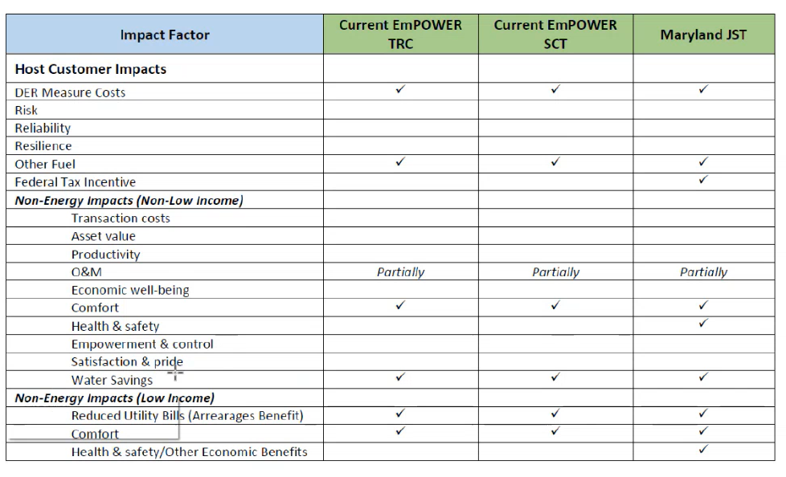
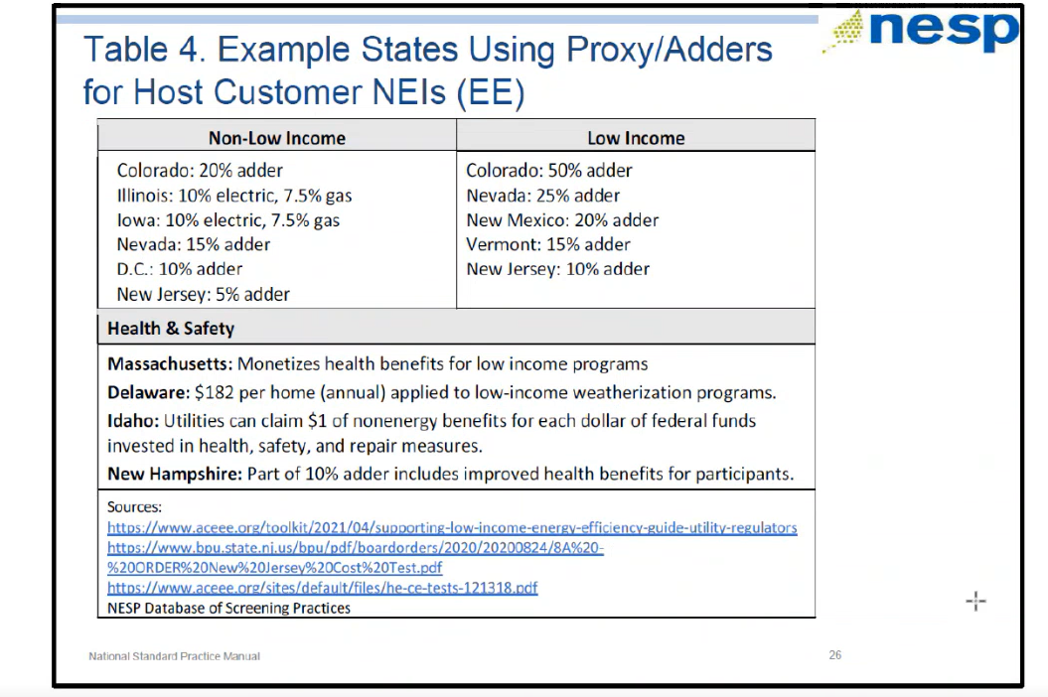
- Chair Bicky Corman asked:
  - Is OPC doing this in conjunction with a proceeding?
  - Out of the energy efficiency programs, do the majority have an equity adder?
- Kinteshia Scott (OPC) mentioned that OPC submitted comments on the societal benefit cost test for energy efficiency programs in GD-2019-04-M. Kinteshia explained that the Public Service Commission (PSC) had not taken a position yet. The PSC issued GD-2019-04-M to solicit feedback about what qualities should be considered in the cost benefit analysis for energy efficiency programs. OPC wants to ensure the test is consistent across utilities.
- Kinteshia Scott (OPC) highlighted that majority of states have an equity adder, however she would need to confirm.
- Nina Dodge inquired how an adder worked.
- Kinteshia Scott (OPC) shared that an adder itself is used to enhance the result of a specific test.
- Nina Dodge suggested including a foot note under the societal benefit cost test section of the Board’s FY22 annual report highlighting the effect of an equity adder.
- Vice Chair Dr. Larry Martin mentioned that GD-2019-04-M is in relation to the Clean Energy Act Implementation Working Group which is the working group looking at with a number of issues associated with complying with the Clean Energy Omnibus Amendment Act of 2018. Dr. Martin shared that the idea of looking at the societal cost benefit test poses a larger question of the benefit cost analysis for how energy work is done in the District. Dr. Martin added that the equity adder suggested by OPC comes from the National Standard Practice Manual. Dr. Martin emphasized the importance of having a standardized cost benefit test across all energy initiatives, so the benefit test considers the same variables when comparing the impact of different programs.
- Kinteshia Scott (OPC) confirmed and agreed on the importance of having the same societal benefit cost test across all utilities.
- Chair Bicky Corman asked:
  - Does the Board want to advocate for the utilities to change its societal benefit cost test at the same time as the DCSEU? How does changing the benefit cost test impact DCSEU’s competitiveness?
- Nina Dodge shared that the utilities follow the DCSEU’s benefit cost test and agreed the utilities should follow DCSEU’s test to maintain consistency.
- Dr. Lance Loncke (DOEE) shared that more research will need to be done to better understand OPC’s position on the equity adder.
- Chair Bicky Corman asked:
  - Does DOEE or DCSEU have a sense of whether the equity adder is duplicative and already included in DCSEU’s societal benefit test?
- Director Ernest Jolly (DCSEU) shared that he believes his team put forward a good model for the benefit cost test and the DCSEU would not want to wait until the PSC comes to a decision.
- Nina Dodge suggested the Board not vote or put a motion forward on the societal cost test until the Board receives more information from the OPC.
- Chair Bicky Corman asked:
  - Whether or not including an equity adder would be more of a burden on the DCSEU?
- Dr. Lance Loncke (DOEE) clarified that the PSC had an initial agreement for all utilities to follow a societal cost test, so at a high level, all programs (across utilities) could be compared.
- Dr. Lance Loncke (DOEE) highlighted the proposed changes put forth by the DCSEU to the societal benefit cost test:
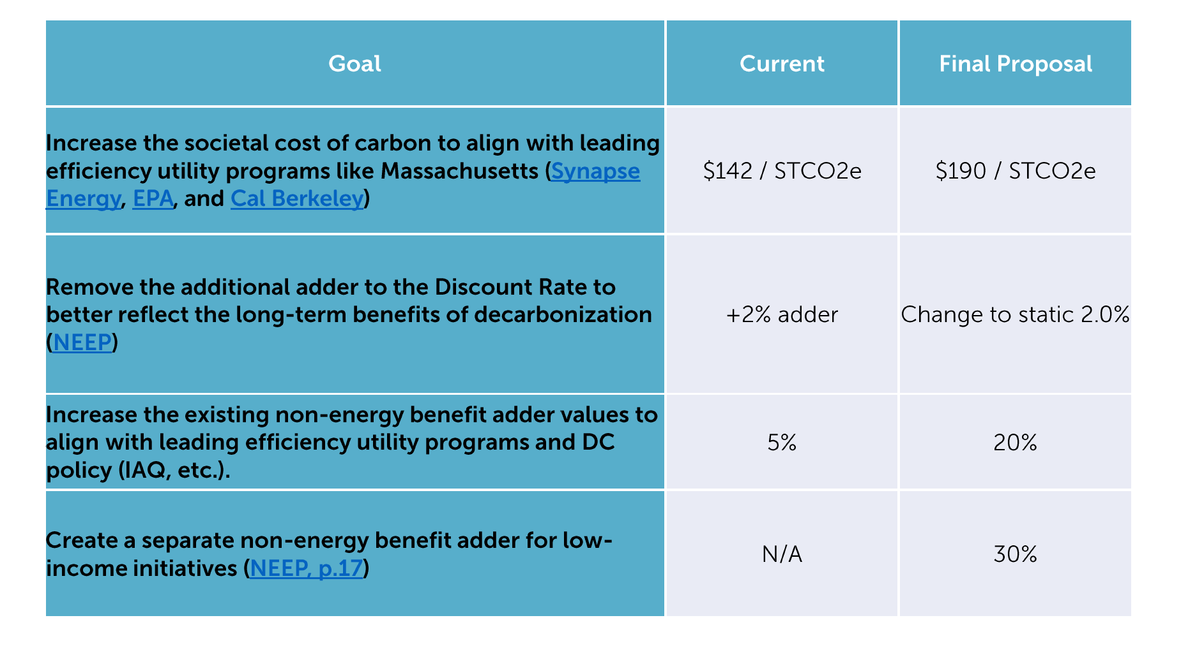
- Chair Bicky Corman asked:
  - What is the EPA’s level price for carbon?
- Dr. Lance Loncke (DOEE) shared the Biden administration has been using the Interagency Working Group’s interim value of $51 per metric ton of CO2. But earlier this month, EPA quietly proposed increasing that number to $190.
- Vice Chair Dr. Larry Martin asked:
  - whether or not there is any cost of carbon figure used by any other district program and whether what the DCSEU is doing would be consistent with or in conflict with what other agencies are using elsewhere?
- Dr. Lance Loncke (DOEE) highlighted that the societal costs test is the only place where we use the cost of carbon.
- Chair Bicky Corman asked:
  - What is being applied for using a discount rate?
- Dr. Lance Loncke (DOEE) mentioned that the discount rate is used to tell us what the item is valued at in today's terms.
- Nina Dodge asked if Dr. Loncke could provide an example in simple math.
- Dr. Lance Loncke (DOEE) provided an example:
  - If we are looking at this test and we think that doing a particular program is going to save us 5$ over the next 10 years, we want to know what that translates into today's value, whether that's going to be $0.80 or $0.75.
- Kinteshia Scott (OPC) asked:
  - What would be the impact of removing the additional adder (the discount rate) here?
- Dr. Lance Loncke (DOEE) shared that the impact of the discount rate depends on else goes into the equation for the test. For example, we know we must have a discount rate value in the test, but to show the impact, it will depend on whether we are reducing that number. If we change that from 6% down to 2%, we would have to do some modeling.
- Patti Boyd (DCSEU) shared the impact of including an adder:
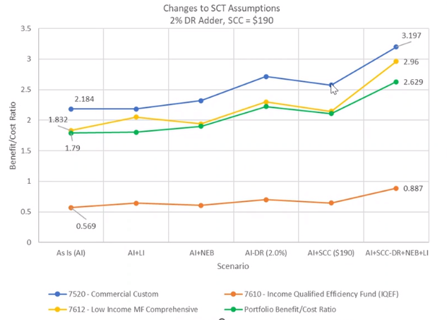
- Board members determined they would vote on the benchmark negotiations during the November meeting.

Board’s FY22 Annual Report
- Board members intend to discuss and vote on the report during the November meeting.

Future Agenda Items
- Approval of October & November Meeting Minutes
- Approval/Feedback on DCSEU Performance Benchmarks
- Approval of Board’s FY22 Annual Report
- DCSEU’s FY23 Q4 Update
- Discussion of Board providing comments on WGL’s EEDR application and/or Pepco’s Climate Plan

Adjournment
- Chair Bicky Corman adjourned the meeting at 1:01 PM.

Acronyms used during this meeting
- ATO - Authorization to Operate
- CAEA - Clean and Affordable Energy Act of 2008
- CREF - Clean Renewable Energy Facility
- DCSEU - District of Columbia Sustainability Energy Utility
- DOB – Department of Buildings
- DOEE - Department of Energy and Environment
- EEDR – Energy Efficiency and Demand Response
- JST - Jurisdiction Specific Test
- MOTA – Mayor's Office of Talent and Appointments
- OPC - Office of the People’s Counsel
- PSC - Public Service Commission
- SBCT - Societal Benefit Cost Test
- SETF - Sustainable Energy Trust Fund
- TAG - Technical Advisory Groups
- TRC - Total Resource Cost Test
- WGL – Washington Gas Light
Minutes prepared by Jennifer Johnston, DOEE

