Sustainable Energy Utility Advisory Board (SEUAB)
Public Service Commission (PSC) Committee Meeting
Monday, February 5, 2024
11:00 AM – 12:00 PM

Roll Call/Instructions
Roll call was taken at 10:03 AM and the following people were in attendance:

Board Members
Name | In Attendance? | FY 2024 Special Meetings  Attendance Record | FY 2024 Committee Meetings Attendance Record | FY 2024 Regular Meetings  Attendance Record
Pending - Board Chair (Mayor’s Designee) | N/A | N/A | N/A | N/A
Mansi Talwar (Councilmember Allen) | No | 1/1 | 1/3 | 3/4
Sandra Mattavous-Frye (or OPC proxy) | Yes | 1/1 | 3/3 | 3/4
Danielle Gurkin (PSC) | No | 0/1 | 0/3 | 2/4
Pending - (Electric Company) | N/A | N/A | N/A | N/A
Eric Jones (Building Management) | Yes | 0/1 | 3/3 | 4/4
Nina Dodge (Environment) | Yes | 1/1 | 1/3 | 4/4
Jamal Lewis (Low-Income Community) | Yes | 1/1 | 1/3 | 4/4
Jaleel Shujath (Economic Development) | No | 1/1 | 2/3 | 4/4
Sasha Srivastava (Renewable Energy) | Yes | 1/1 | 2/3 | 4/4
Giuls Kunkel (Building Construction) | No | 1/1 | 2/2 | 2/4
Dr. Larry Martin – Vice Chair (Council Chairperson Mendelson) | Yes | 1/1 | 2/3 | 4/4
Pending – (Gas Utility) | N/A | N/A | N/A | N/A

Other Attendees: Jahmai Sharp (DCSEU), Patti Boyd (DCSEU), Jahmai Sharp (DCSEU), Ernest Jolly (DCSEU), Jennifer Johnston (DOEE), Dr. Lance Loncke (DOEE), Hussain Karim (DOEE), Dr. Yohannes Mariam (OPC), Kintéshia Scott (OPC), Adam Carlesco (OPC)

Public Service Commission (PSC) Committee Board Discussion
- Vice Chair Dr. Larry Martin opened the meeting by clarifying the purpose of the committees discussion-> to determine whether the DCSEUAB would like to provide comment on FC1130 Synapse’s VDER Study. Dr. Martin provided the following slides to guide conversation:

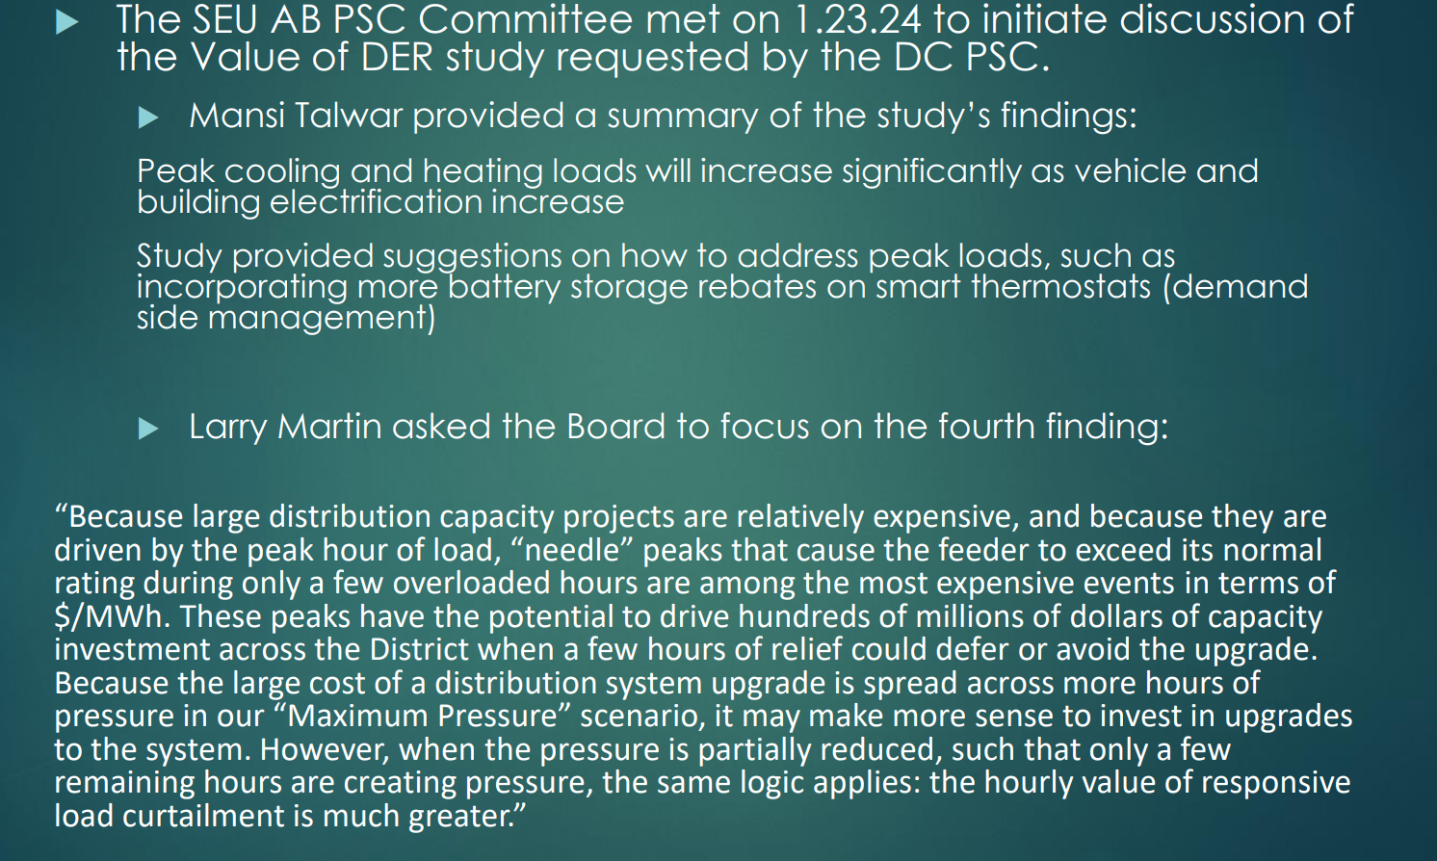
- Dr. Yohannes Mariam (OPC) found the FC1130 Synapse’s VDER Study did not highlight non wires alternatives as a means to reduce peak loads.
- Nina Dodge shared that non-wire alternatives are an affordable path to meet the District’s decarbonization goals. Nina mentioned that the peak time of year lasts only for a few days and the utilities base its overall capacity on those few days of peak usage. Nina also highlighted that the DCSEU’s participation in the Building Energy Performance Standards (BEPS) will help reduce peak demand. Nina asked Director Ernest Jolly:
  - What is your concept of building peak load management?
- Director Ernest Jolly shared that based on his experience, the peak represents the most expensive cost per kWh. Within the PJM system, there is technology that can be utilized at the customer level to help shift and control energy usage off peak. A lot of what we could do in peak control is cultural and technology combined so the DCSEU can assist customers in automating building climate controls.
- Nina Dodge highlighted that aggressive time of use rates can also address peak demand usage.
- Director Ernest Jolly mentioned that to have grid predictability, there needs to be a good regulatory environment. Director Jolly emphasized the importance of enforcing regulation to guarantee success on grid reliability.
- Jamal Lewis asked:
  - Does the DCSEU offer incentives for grid interactive water heaters?
- Patti Boyd shared that the DCSEU does not offer grid interactive water heaters because the DCSEU focuses on kWh reduction.
- Jamal Lewis shared that he would like to explore the contract to understand the possibility of including demand response products. If the Board is exploring Distributed Energy Resource (DER) and the concepts of this PSC proceeding, it warrants a discussion around what the difference is between the most compatible and the most impactful step forward.
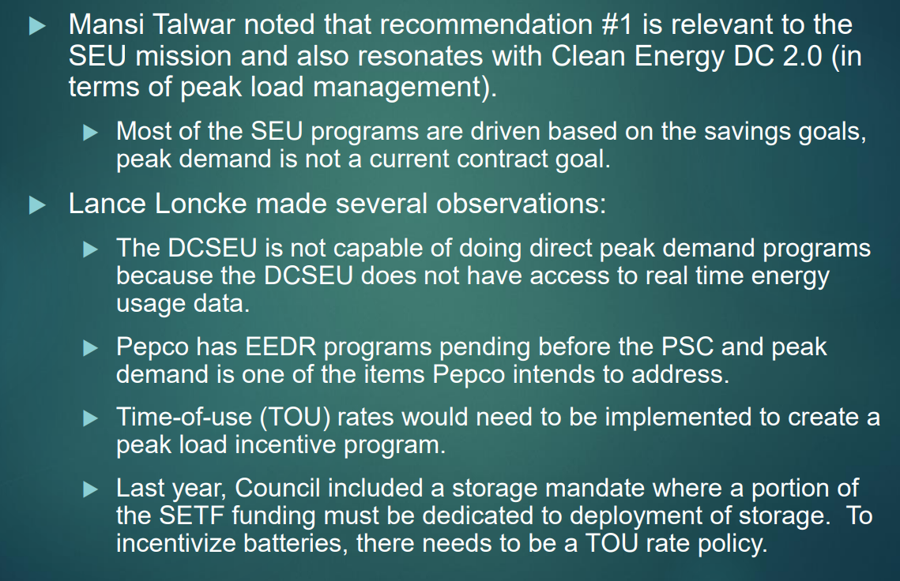
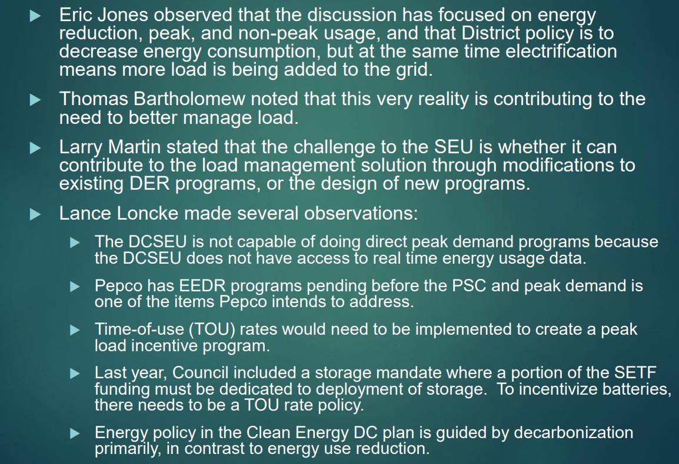
- Dr. Lance Loncke (DOEE) asked if Vice Chair Dr. Larry Martin could provide an example of a third-party program that could operate without having real time energy usage data.
- Vice Chair Dr. Larry Martin gave an example of interactive water heaters:
  - If we need to take all the electric water heaters offline or a percentage of them for the next two hours, that could be managed through the third party who doesn't have access to real time energy usage data.
- Dr. Lance Loncke (DOEE) reminded the group that Pepco runs a very similar program involving smart thermostats and could decide to expand that program to water heaters. Dr. Loncke highlighted that suggestions are often made in Board meetings but then are left open. Dr. Loncke shared that the DCSEU addresses peak demand through energy efficiency. Conversations regarding grid communication need to be brought to Pepco. Dr. Loncke observed that every few years the Board tries to explore this space.
- Nina Dodge agreed that the DCSEU can only do what is within its scope and as an advisory board, the DCSEUAB could recommend changes to the PSC (such as designing peak load reduction).
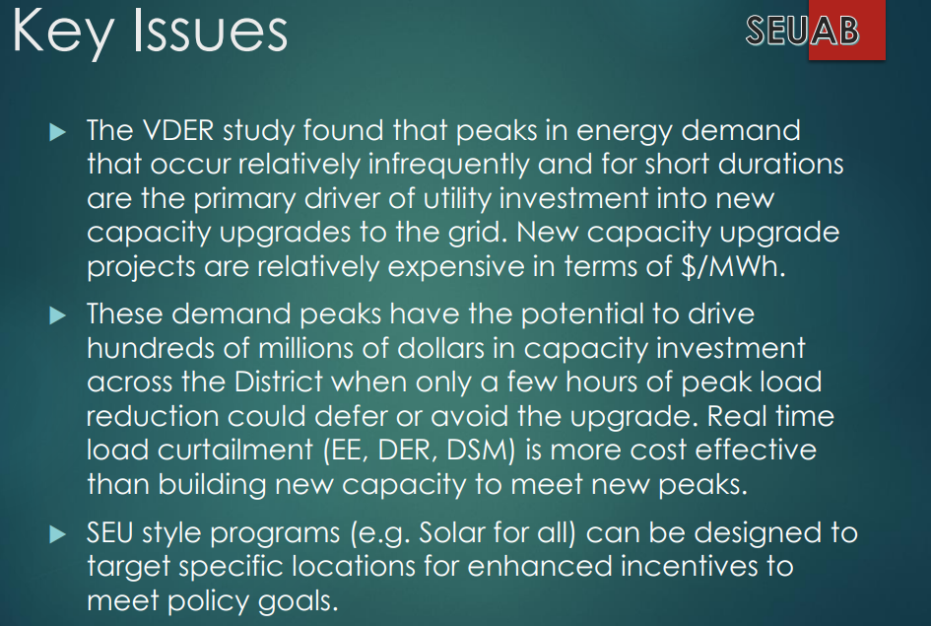
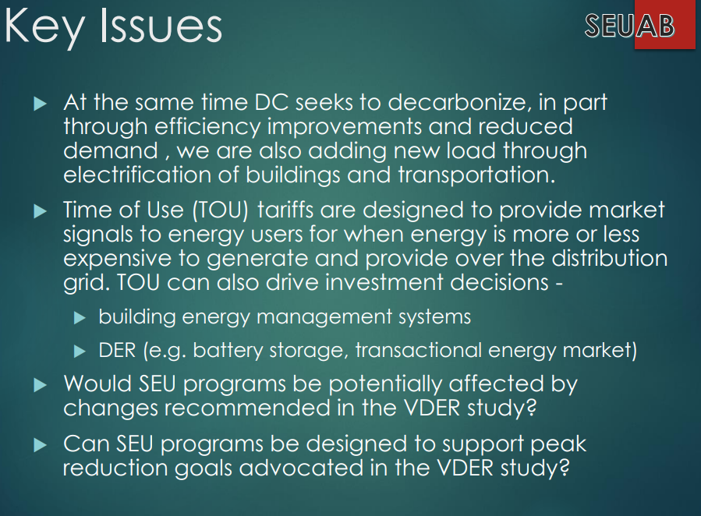
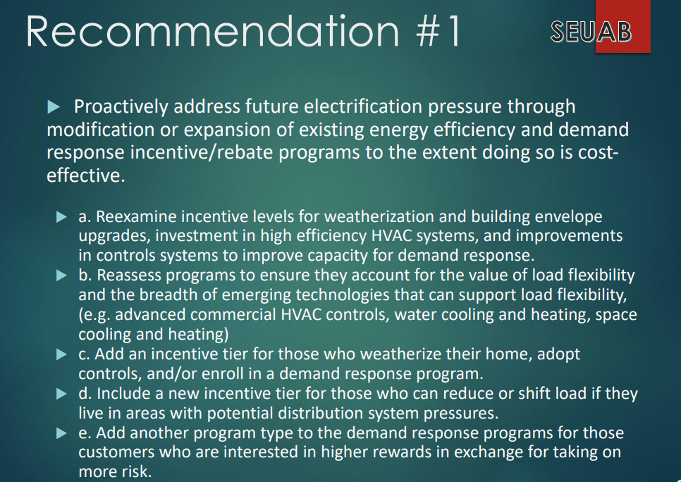
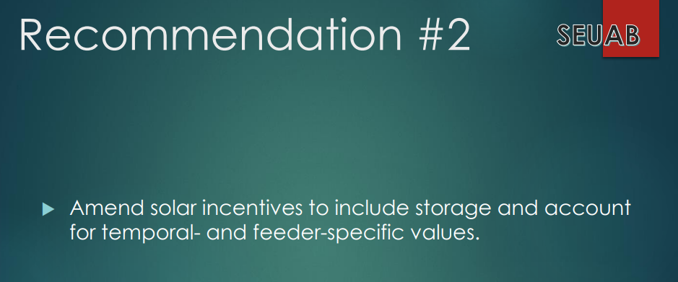
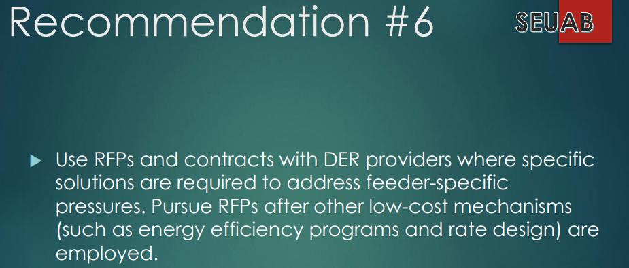
- Dr. Yohannes Mariam (OPC) asked:
  - Was the Pepco data for this study verified and at what point in time was the data collected?
- Vice Chair Dr. Larry Martin shared that the PSC did not question the data and assumed Pepco provided accurate information.
- Nina Dodge suggested the Board include the importance of data transparency and verification in its potential comments to the PSC.
- Vice Chair Dr. Larry Martin agreed that having this information would help the Board better understand the results of the study.
- Nina Dodge recommended the Board’s comments include the importance of designing and implementing solar where the grid is most strained.
- Dr. Lance Loncke (DOEE) shared that Pepco typically upgrades the circuit rather than exploring non-wire alternatives.
- Dr. Yohannes Mariam (OPC) shared that as part of a PSC order, Pepco is required to produce a monthly hosting capacity study, but the PSC has never enforced the requirement. Dr. Mariam wondered if the PSC cloud follow up on this requirement as the information could be helpful in identifying bottlenecks and issues leading to the location of solar/storage.
- Dr. Lance Loncke (DOEE) shared that DOEE is conducting a hosting capacity study. Dr. Loncke reminded the group that Solar for All has been deploying arrays based on locational need since 2019 (specifically ward 7 and 8).
- Hussain Karim (DOEE) clarified that the Committee on Transportation and Electrification mandated DOEE conduct a hosing capacity study. DOEE just awarded a grant for this study.
- Vice Chair Dr. Larry Martin proposed the PSC committee members meet again in February after consulting with DCSEU management on its position on the VDER study results and key findings.

Follow Up Items
- DCSEUAB members will meet with DCSEU management to discuss potential overlap.

Adjournment
- Vice Chair Dr. Larry Martin adjourned the meeting at 12:05 PM.

Acronyms used during this meeting
- AHRA - Affordable Housing Retrofit Accelerator
- ATO - Authorization to Operate
- BSA - Bill Stabilization Adjustment
- CAEA - Clean and Affordable Energy Act of 2008
- CEM - Certified Energy Manager
- CREF - Clean Renewable Energy Facility
- DCIA - DC Infrastructure Academy
- DCSEU - District of Columbia Sustainability Energy Utility
- DER - Distributed Energy Resource
- DOB – Department of Buildings
- DOEE - Department of Energy and Environment
- DOES - Department of Employment Services
- DSLBD - DC Department of Small & Local Business Development
- EEDR – Energy Efficiency and Demand Response
- MOTA – Mayor's Office of Talent and Appointments
- OPC - Office of the People’s Counsel
- PSC - Public Service Commission
- RFP – Request for Proposals
- SBCT - Societal Benefit Cost Test
- SEICBP - Sustainable Energy Infrastructure Capacity Building and Pipeline Program
- SETF - Sustainable Energy Trust Fund
- VPP - Virtual Power Plant
- WGL – Washington Gas Light
Minutes prepared by Jennifer Johnston, DOEE

