DC Sustainable Energy Utility Advisory Board (DCSEUAB) Meeting
Tuesday, May 13, 2025
10:00 AM – 12:00 PM

Call to Order
Chair Jamal Lewis called the meeting to order at 10:05 AM, May 13, 2025. Chair Lewis called a quorum of the DC Sustainable Energy Utility Advisory Board (DCSEUAB or Board) at 10:06 AM. The meeting was held virtually via Microsoft Teams video conference call meeting.

Roll Call/Instructions
Roll call was taken at 10:02 AM and the following people were in attendance:

Board Members
Name | In Attendance? | FY 2025 Special Meetings  Attendance Record | FY 2025 Regular Meetings  Attendance Record
Jamal Lewis - Board Chair (Mayor’s Designee) | Yes | 7/7 | 6/7
Mansi Talwar (Councilmember Allen) | Yes | 1/7 | 7/7
Sandra Mattavous-Frye (or OPC proxy) | Yes | 2/7 | 6/7
Danielle Gurkin (PSC) | Yes | 0/7 | 7/7
Pending (Electric Company) | N/A | N/A | N/A
Eric Jones (Building Management) | No | 2/7 | 5/7
Vacant (Environment) | N/A | N/A | N/A
Sidra Siddiqui (Low-Income Community) | Yes | 3/7 | 6/7
Jaleel Shujath (Economic Development) | Yes | 0/7 | 5/7
Sasha Srivastava (Renewable Energy) | Yes | 1/7 | 6/7
Giuls Kunkel (Building Construction) | Yes | 1/7 | 7/7
Dr. Larry Martin – Vice Chair (Council Chairperson Mendelson) | Yes | 7/7 | 7/7
Pending (Gas Utility) | N/A | N/A | N/A

Other Attendees: Ben Burdick (DCSEU), Tamara Christopher (DCSEU), Angela Johnson (DCSEU), Crystal McDonald (DCSEU), Jahmai Sharp (DCSEU), Philip Haddix (DCSEU), Philana Owusu (DCSEU), Patti Boyd (DCSEU), Emmett Deitcher (DCSEU), James Clark (DCSEU), Eddie Friebe (DCSEU), Shyaam Simpson (DCSEU), Rebecca Foster (VEIC), Jennifer Johnston (DOEE), Dr. Lance Loncke (DOEE), Hussain Karim (DOEE), Dave Epley (DOEE), Kinteshia Scott (OPC), Adam Carlesco (OPC), Yohannes Mariam (OPC)

Approval of Agenda
- Chair Jamal Lewis congratulated Ben Burdick on his new position as managing director of the DCSEU and highlighted that Ben is the perfect candidate for leading the DCSEU.
- Vice Chair Dr. Larry Martin moved to approve the agenda and was seconded by Sidra Siddiqui. All were in favor, none were opposed.

Approval of April and Special Meeting Minutes
- Chair Jamal Lewis moved to approve the April meeting minutes and was seconded by Sidra Siddiqui. All were in favor and none were opposed.
- Vice Chair Dr. Larry Martin moved to approve the special meeting minutes from May 1, 2025, and was seconded by Kinteshia Scott. All were in favor and none were opposed.

Approval of Benchmark Recommendations
- Chair Jamal Lewis thanked the Board members for providing feedback and helping to finalize the benchmark recommendations for the next DCSEU contract.
- Vice Chair Dr. Larry Martin thanked Dr. Lance Loncke for the time and information he provided during the seven special meetings.
- Chair Jamal Lewis moved to approve the Boards benchmark recommendations and was seconded by Vice Chair Dr. Larry Martin. All were in favor and none were opposed.

DCSEU FY25 Q2 Review
- Director Ben Burdick (DCSEU) shared that after eight years of serving as the DCSEU Director of Finance, Angela Johnson would be stepping down on Friday, May 16, 2025. Ben also mentioned that Tamara Christopher would be stepping in as the new Director of Finance.
- The Board thanked Angela for her dedication to the District and wished her well on her retirement. The Board congratulated Tamara on her new role.
- Director Ben Burdick (DCSEU) presented the following slides:
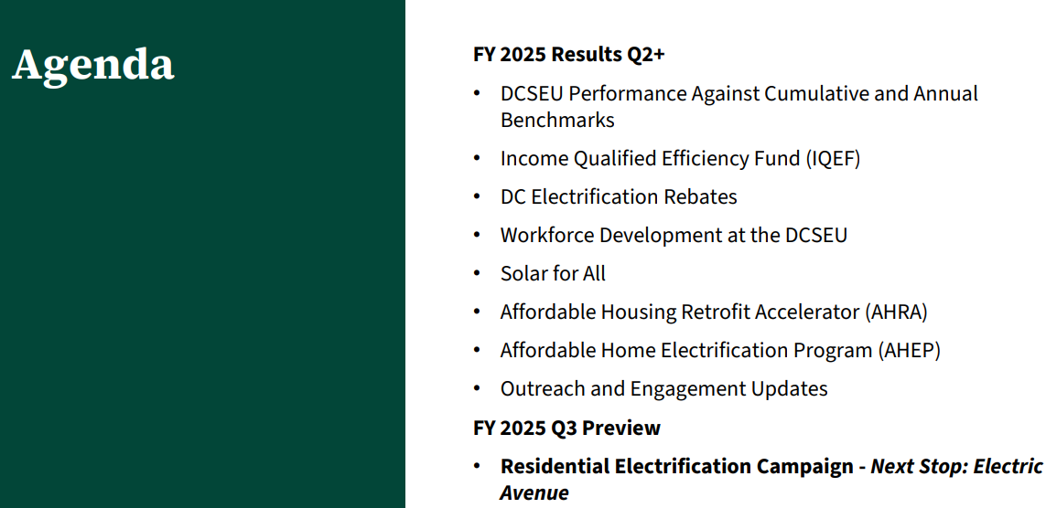
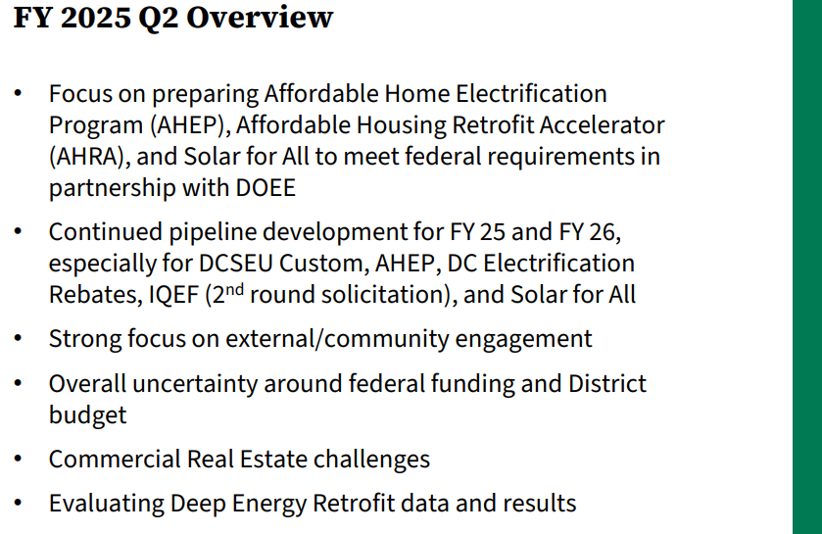
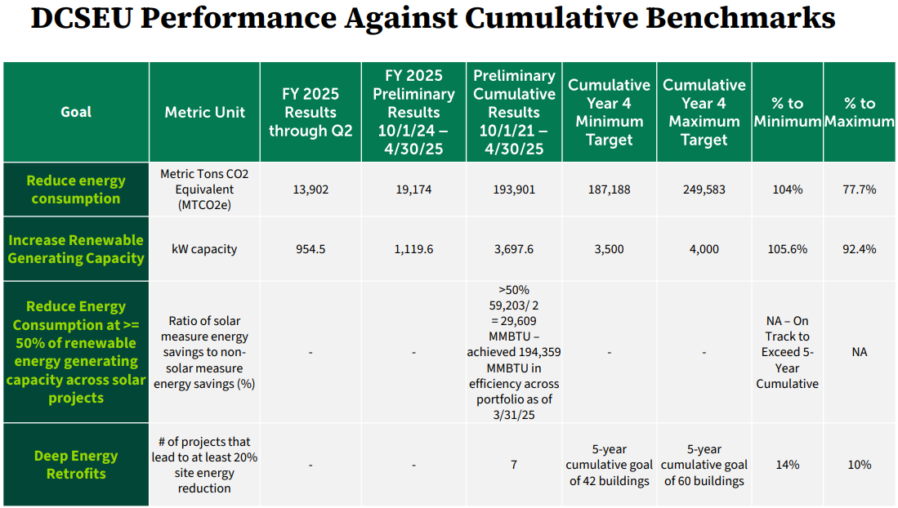
- Patti Boyd (DCSEU) shared that the number of deep energy retrofit projects is greater than seven, but there is something going wrong with the API connect to the U.S. DOE Standard Energy Efficiency Data (SEED) Platform. Patti shared that she would be putting together a presentation outlining the issue and solution.
- Chair Jamal Lewis requested the Board be informed once Patti discovered more about the error with SEED.
- Director Ben Burdick (DCSEU) explained that there are roughly 400 buildings where there are duplicate datasets which is creating discrepancies when comparing to benchmark data.
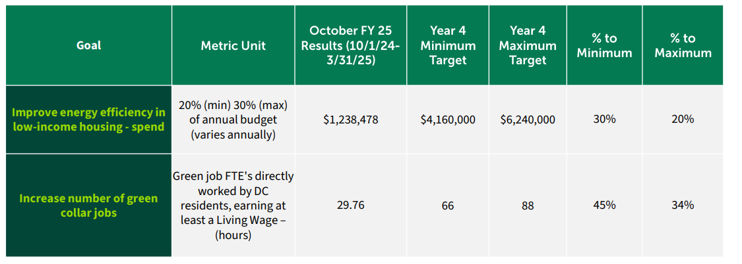
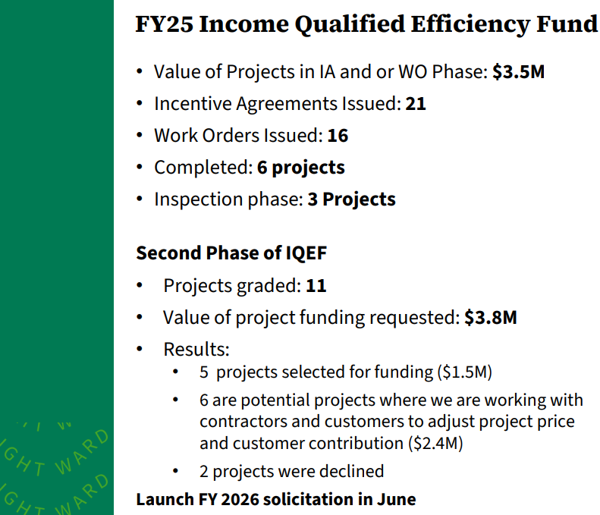
- Crystal McDonald (DCSEU) presented on the following slides:
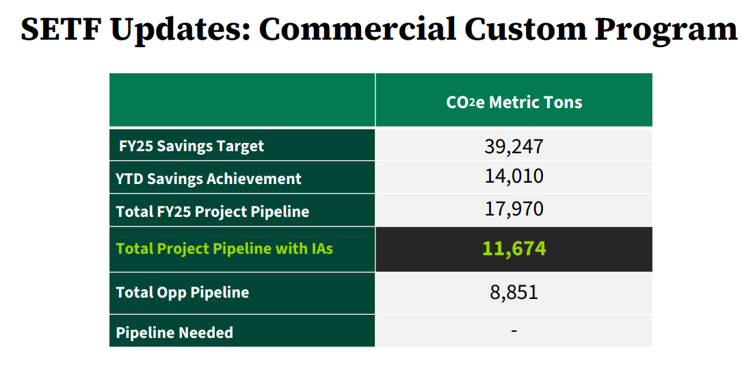
- Chair Jamal Lewis asked Sidra Siddiqui if she has been working with DCSEU on the resources for houses of worship.
- Sidra Siddiqui confirmed she had been in contact with DCSEU and highlighted how Interfaith Power and Light had been looped into the conversations as well.
- Vice Chair Dr. Larry Martin asked for an example of what is being done with the SETF commercial custom projects. Dr. Martin inquired about the most common projects seen.
- Crystal McDonald shared that several common technologies include chillers, variable frequency drives (VFDs), solar, HVAC equipment, and new construction with LEED certification.
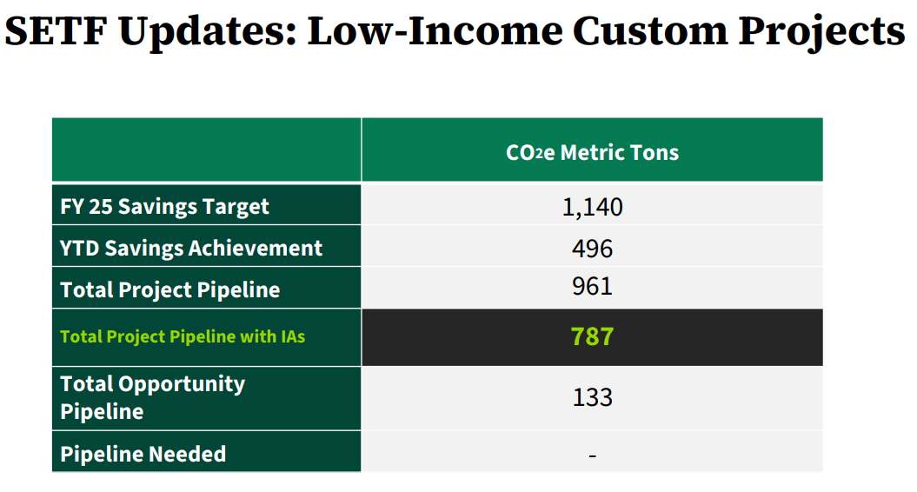
- Director Ben Burdick shared that the team is on track to meeting its low income target.
- Crystal McDonald (DCSEU) highlighted that the years of developing relationships are paying off for senior living and affordable housing construction projects.
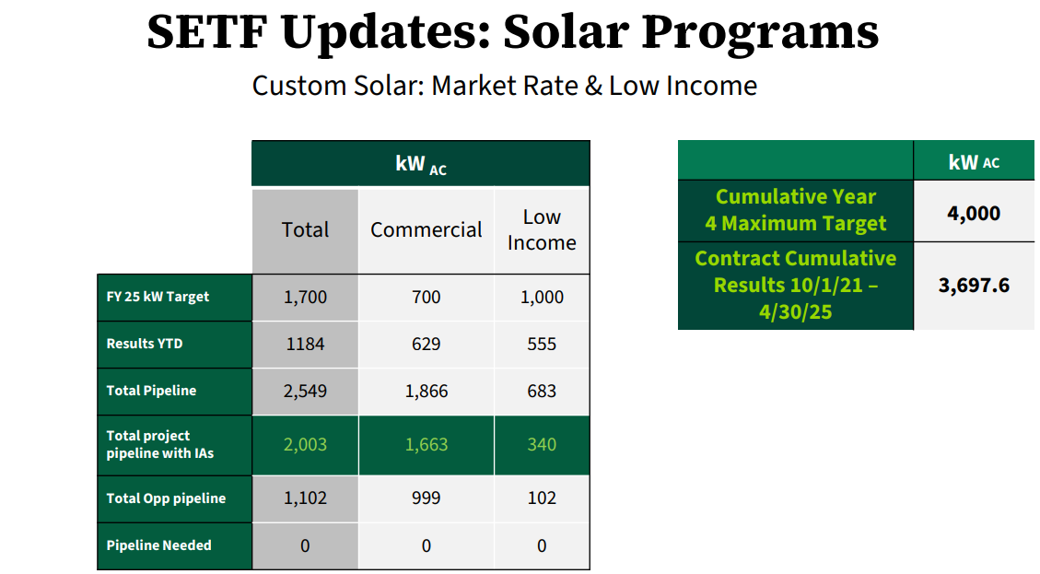
- Director Ben Burdick (DCSEU) shared that the DCSEU is on track to achieving the year four solar deployment benchmark and emphasized the strong pipeline.
- Jaleel Shujath mentioned that DC Water Blue Plans is the single largest energy consumer in the District and asked if the DCSEU did any work with the organization.
- Director Ben Burdick (DCSEU) shared that in the past, the DCSEU had been heavily involved with DC Water Blue Plans and is now one of the customers that DCSEU meets with monthly to discuss pipeline.
- Jaleel Shujath inquired about the DC Water contact they work with.
- Crystal McDonald (DCSEU) confirmed that she would follow up with their DC Water point of contact.
- Emmet Dietcher (DCSEU) presented on the following slides:
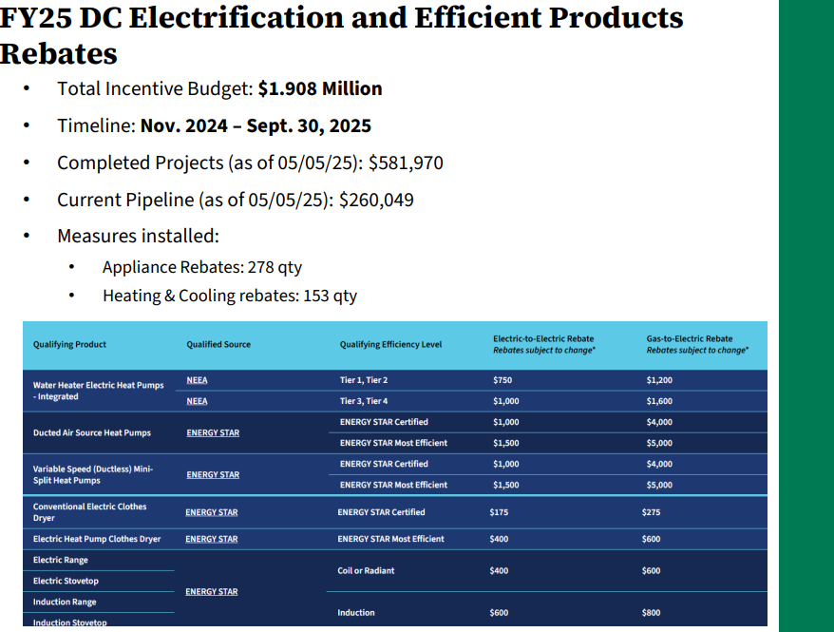
- Chair Jamal Lewis asked how soon after the equipment installation does an applicant have to apply for the rebates?
- Dr. Lance Loncke (DOEE) and Jennifer Johnston (DOEE) explained that if the equipment was installed after October 1, 2024, then an applicant can apply for a rebate up until September 30, 2026 (with the caveat that the rebate amounts may change depending on funding available).
- Emmet Dietcher (DCSEU) mentioned that renters can apply for the rebates as well.
- Crystal McDonald (DCSEU) invited the Board to the winter and spring cohort of the extern program (scheduled for Wednesday, Mary 14 12pm-1:30pm, registration available here).
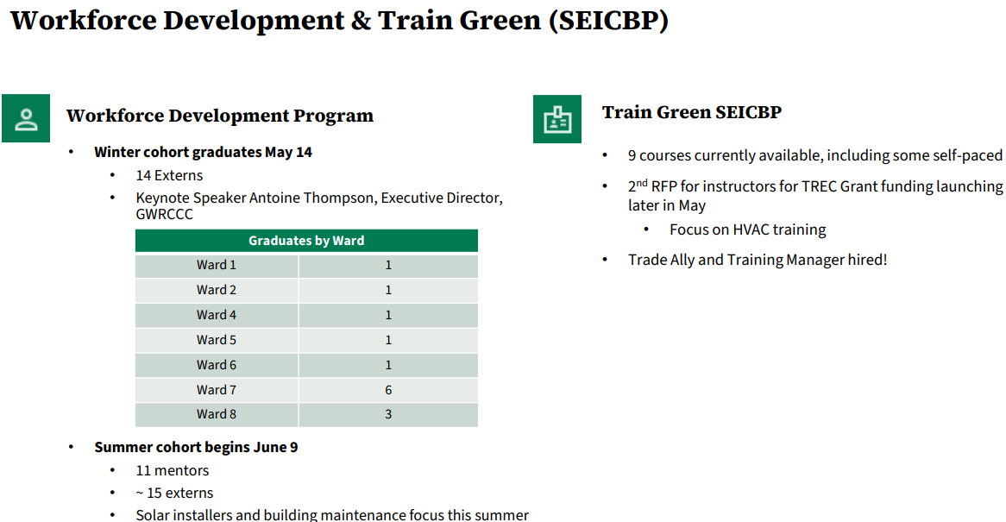

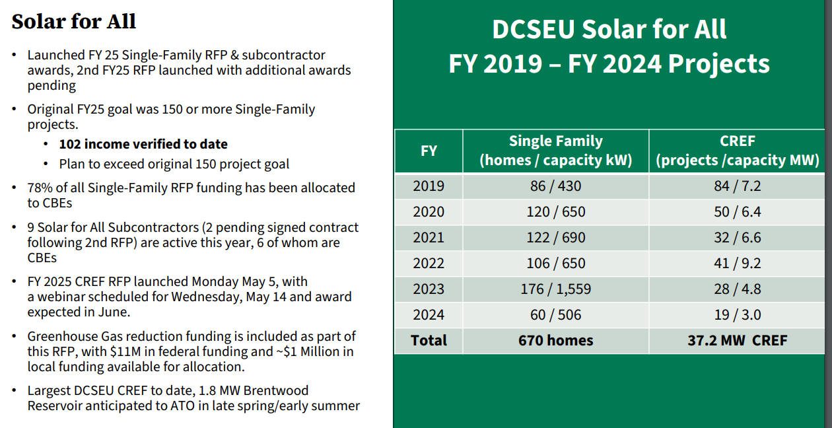
- Dr. Lance Loncke (DOEE) encouraged the Board member to spread the word about single family solar; the team is accepting applications.
- Kinteshia Scott (OPC) asked if James could speak to the declining trend for CREFs.
- James Clark (DCSEU) shared that last year DCSEU did not have any CREF installers. With the new CREF RFP, the DCSEU has included Build America, Buy America Act (BABA) and Davis Bacon requirements (per Greenhouse Gas Reduction Fund Guidance, GGRF, guidance). James also mentioned that the new incentive model will hopefully encourage more developer engagement.
- Kinteshia Scott (OPC) asked if the DCSEU is targeting larger projects (which would explain the decrease in the number of projects).
- James Clark (DCSEU) shared that depending on the size, it may take 12-18 months to complete a CREF project. The largest to date is the Brentwood installation at 1.8MW. In FY25, the type of CREFs will depend on the proposals received.
- Jaleel Shujath asked the following questions:
  - How do the companies interface with DCSEU?
  - Is the recommendation that homeowners come directly to DCSEU about their options or discuss them with those companies?
- James Clark (DCSEU) shared that with GGRF there are companies that can label their programs as Solar for All, but customers are encouraged to visit DCSEU’s web page and apply through the Districts’ program. If the installers are not listed on the web page, then they are not participating with DCSEU.
- Ben also highlighted the District’s Solar Switch program (ran by DC Solar United Neighbors)
- Phillip Haddix (DCSEU) presented the follow slide:
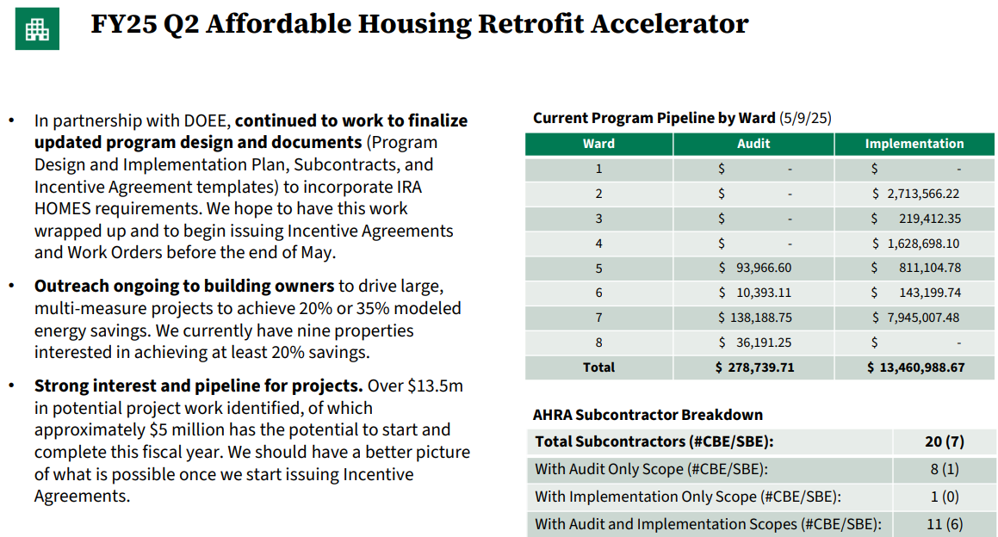
- Philana Owusu (DCSEU) presented the following slide:
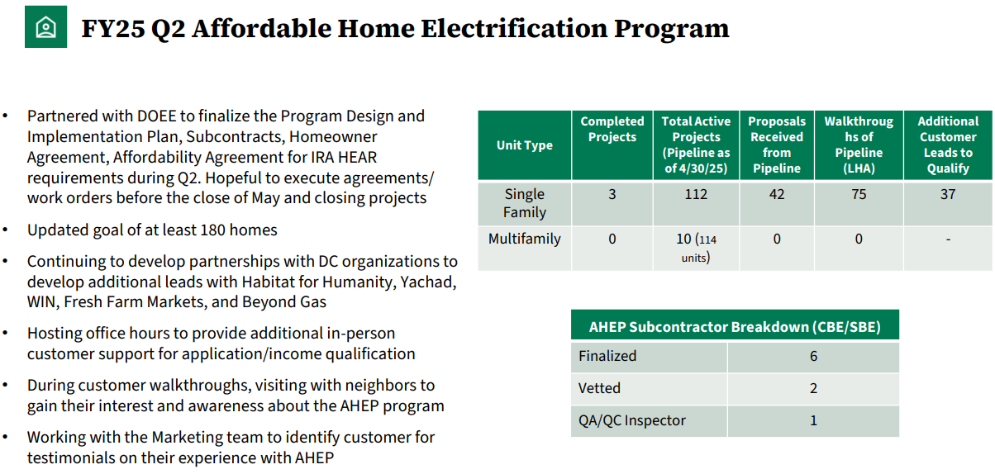
- Chair Jamal Lewis asked if the 42 pipeline projects were part of the 112 total active projects.
- Philana Owusu (DCSEU) confirmed the 42 pipeline projects are part of the 112 total active projects and the 37 are separate additional leads.
- Sindra Siddiqui inquired if the total active projects were households that had uncompleted work.
- Philana Owusu (DCSEU) confirmed.
- Kinteshia Scott (DCSEU) asked how federal funding will impact these projects.
- Director Ben Burdick (DCSEU) shared that DCSEU and DOEE are monitoring the federal funding.
- Dr. Lance Loncke (DOEE) mentioned that there have been no funding restraints to date. As far as DOEE knows, IRA funding is intact. Both IRA and local funding are being used to fund the AHEP projects.
- Jahmai Sharp (DCSEU) presented the following slides:

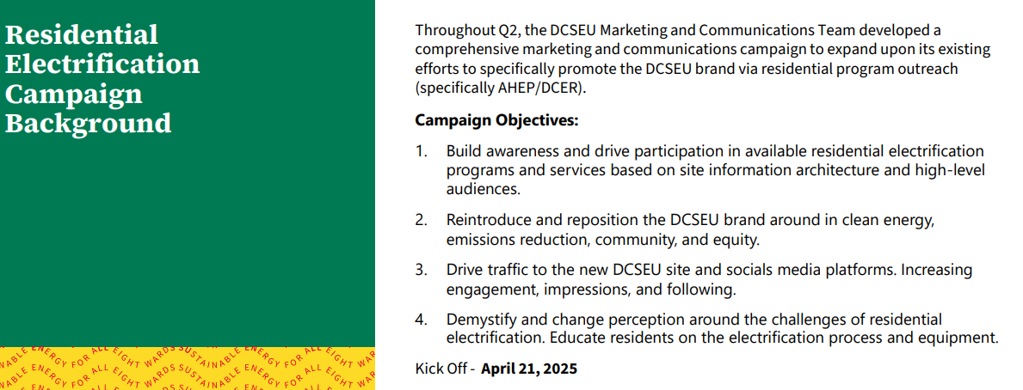
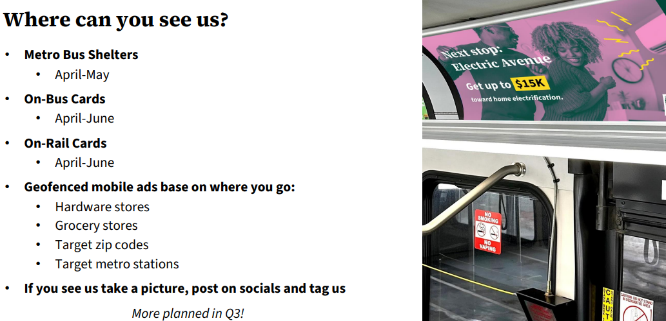


Regulatory Updates
- Hussain Karim (DOEE) mentioned that DOEE’s budget oversight hearing will most likely take place at the end of May. Right now, the budget process is on hold because it is unclear if the House is going to vote on the Fiscal Year (FY)25 budget. Later in May, there will most likely be a hearing for DOEE’s FY26 budget. Regarding the PSC, DOEE and the Office of Attorney General (OAG) have been involved with several gas cases, one involving gas leaks and another on WGL’s rate increase. On the electric side, DOEE is involved with several working groups for Pepco’s rate design.
- Sidra Siddiqui added that the Mayor unveiled the transformational growth agenda which touches on pausing BEPS.

New Business
- Giuls Kunkel announced that she would be stepping down as the building construction industry representative. She thanked DCSEU and DOEE for the opportunity to serve. The Board collectively thanked her for volunteering her time and expertise.
- Jennifer Johnston (DOEE) proposed moving the June Board meeting from Tuesday, June 10th to Monday, June 9th. Chair Jamal Lewis moved to adjust the June meeting to Monday, June 9th and was seconded by Mansi Talwar. All were in favor and none were opposed.
- Jennifer Johnston (DOEE) and Dr. Lance Loncke mentioned that the Board has $9,800 available, however there is currently a spending freeze across the entire District government.
- Chair Jamal Lewis proposed the Board explore the possible avenue(s) for spending the $9,800, although a waiver would be needed to spend the funding.

Follow-up items
- DCSEU
  - Patti Boyd to provide more information regarding the error with U.S. DOE SEED and counting the number of deep energy retrofit projects.
  - Crystal McDonald to provide Jaleel Shujath the contact information for Blue Plans project manager(s).
- Sidra Siddiqui to share information on AHEP congregation events.
- Board to explore the possible avenue(s) for spending the $9,800 (although a waiver would be needed to spend the funding).

Board Action Items
- Approval of Meeting Agenda
- Approval of April Minutes
- Approval of Special Meeting Minutes (May 1)
- Approval of Board Benchmark Recommendations
- Approval to move the June meeting to Monday, June 9

Future Agenda Items
- Approval of May Meeting Minutes
- DCSEU FY24 Financial Audit
- DCSEU
  - Deep energy retrofits, error with U.S. DOE SEED
  - Refrigeration
- FC 1182 Update
- Legislative/Regularity Updates
- New Business
  - Avenue(s) for spending the Board’s $9,800
- Public Comment

Adjournment
- Chair Jamal Lewis adjourned the meeting at 11:47 AM.

Acronyms used during this meeting
- AHRA - Affordable Housing Retrofit Accelerator
- ATO - Authorization to Operate
- BSA - Bill Stabilization Adjustment
- CAEA - Clean and Affordable Energy Act of 2008
- CBE - Certified Business Enterprise
- CREF - Clean Renewable Energy Facility
- DCSEU - District of Columbia Sustainability Energy Utility
- DOEE - Department of Energy and Environment
- FC – Formal Case
- EEDR – Energy Efficiency and Demand Response
- MOTA – Mayor's Office of Talent and Appointments
- OPC - Office of the People’s Counsel
- PSC - Public Service Commission
- SBCT - Societal Benefit Cost Test
- SEICBP - Sustainable Energy Infrastructure Capacity Building and Pipeline Program
- SETF - Sustainable Energy Trust Fund
- TAG - Technical Advisory Groups
- VPP - Virtual Power Plant
- WGL – Washington Gas Light

