Sustainable Energy Utility Advisory Board (SEUAB) Meeting
Tuesday, July 11, 2023
10:00 AM – 12:00 PM

Call to Order
Chair Bicky Corman called the meeting to order at 10:05 AM, July 11, 2023. Chair Bicky Corman called a quorum of the Sustainable Energy Utility Advisory Board (SEUAB or Board) at 10:06 AM. This was a Microsoft Teams video conference call meeting.

Roll Call/Instructions
Roll call was taken at 10:04 AM and the following people were in attendance:

Board Members
Name | In Attendance? | FY 2023  Special Meetings  Attendance Record | FY 2023  Sub Committee Meeting  Attendance Record | FY 2023 Regular Meetings  Attendance Record
Bicky Corman - Board Chair (Mayor’s Designee) | Yes | 6/6 | 1/1 | 7/8
Vacant (Councilmember Allen) | N/A | N/A | N/A | N/A
Sandra Mattavous-Frye (or OPC proxy) | Yes | 6/6 | 1/1 | 8/8
Danielle Gurkin (PSC) | Yes | 4/6 | 0/1 | 8/8
Pending -Valencia McClure (Electric Company) | Yes | 0/0 | 0/0 | 1/1
Eric Jones (Building Management) | Yes | 6/6 | 1/1 | 8/8
Nina Dodge (Environment) | Yes | 5/6 | 0/1 | 8/8
Jamal Lewis (Low-Income Community) | Yes | 6/6 | 0/1 | 6/8
Jaleel Shujath (Economic Development) | Yes | 0/0 | 0/0 | 1/1
Sasha Srivastava (Renewable Energy) | Yes | 6/6 | 1/1 | 8/8
Giuls Kunkel (Building Construction) | Yes | 0/0 | 0/0 | 1/1
Vacant (Council Chairperson Mendelson) | N/A | N/A | N/A | N/A
Pending – Portia Hurtt (Gas Utility) | Yes | 1/6 | 0/1 | 3/8

Other Attendees: Sarah Kogel-Smucker (OPC), Ernest Jolly (DCSEU), Patti Boyd (DCSEU), Angela Johnson (DCSEU), Ben Plotzker (DCSEU), Crystal McDonald (DCSEU), Solome Girma (DCSEU), Ben Burdick (DCSEU), Dave Epley (DOEE), Hussain Karim (DOEE), Jennifer Johnston (DOEE), Rachel Locus (FS Taylor & Associates)

New Board Members
- Chair Bicky Corman welcomed the newest Board members to the meeting, Giuls Kunkel the Building Construction representative, and Jaleel Shujath the Economic Development representative who were both sworn in on Friday, June 30th, 2023.
- Giuls Kunkel shared that she previously worked for DCSEU and VEIC for about 7 and is now the Associate Director of ESG for MetLife Investment Management.
- Jaleel Shujath mentioned that he was a Ward four resident and brings experience from his life sciences background.
- Valencia McClure introduced herself as the new region president and Pepco representative. Valencia also shared that she has been with Exelon for over 13 years and looks forward to continuing Pepco’s great relationship with DCSEU.
Approval of Agenda
- Chair Bicky Corman moved to approve the agenda and was seconded by Sarah Kogel-Smucker (OPC). All were in favor, and none were opposed.

Approval of May Minutes
- Chair Bicky Corman moved to approve the May meeting minutes and was seconded by Eric Jones. All were in favor, and none were opposed.

FS Taylor FY22 Financial Audit
- Rachel Locus, FS Taylor & Associates, presented on the FY22 financial audit findings.
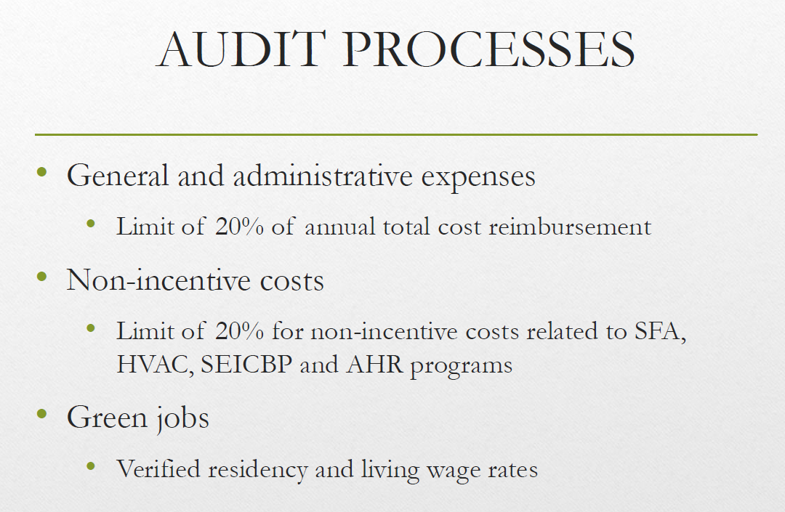
- Chair Bicky Corman asked for someone to clarify the meaning of non-incentive costs.
- Angela Johnson explained that 80% of the total funds go into incentives and the remaining 20% costs go into non-incentives which includes, labor, fringe, and indirect costs.
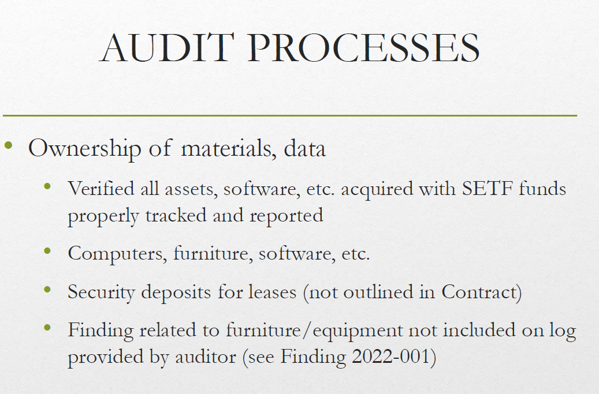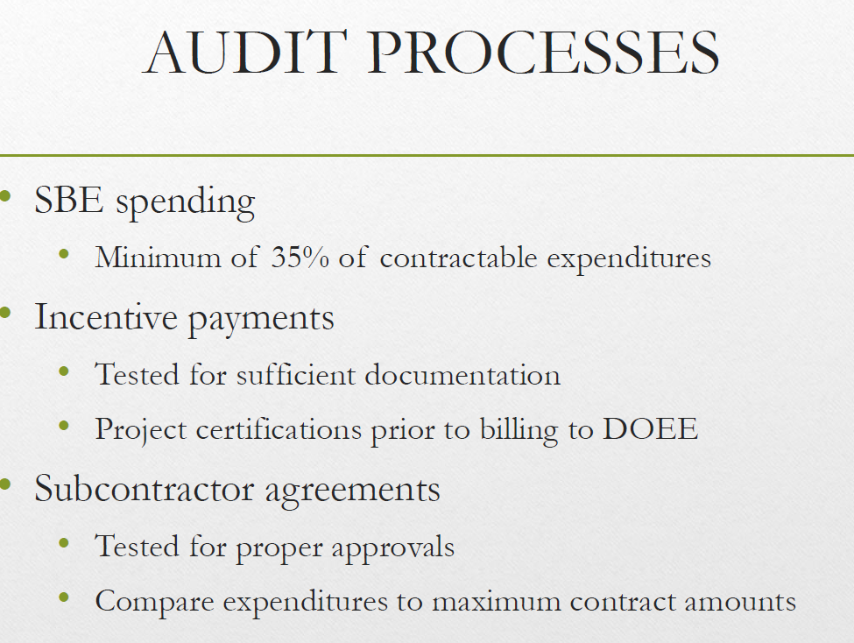
- Chair Bicky Corman asked for someone to clarify the 950,000 for performance benchmark incentives.
- Angela Johnson explained that:
  - 100K for annual green jobs benchmark
  - 100K for annual low-income spend benchmark
  - 750K for the cumulative benchmarks
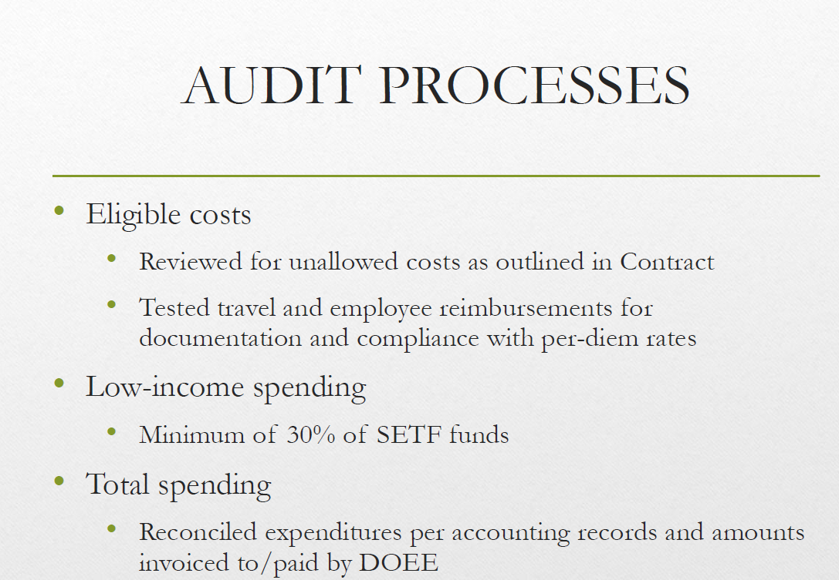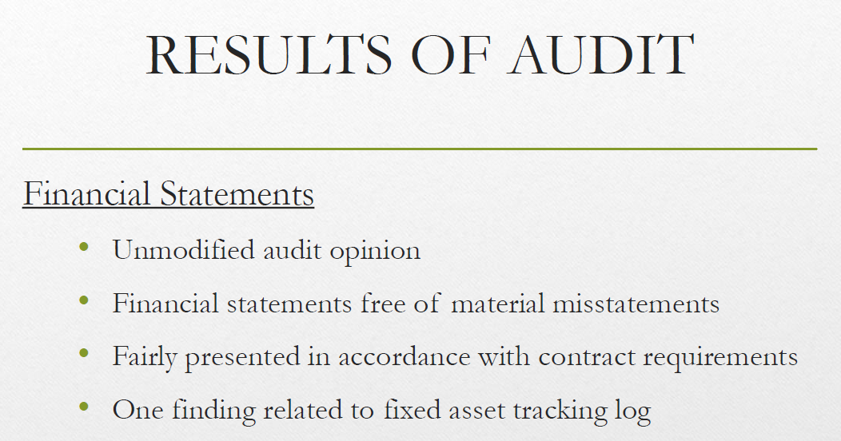
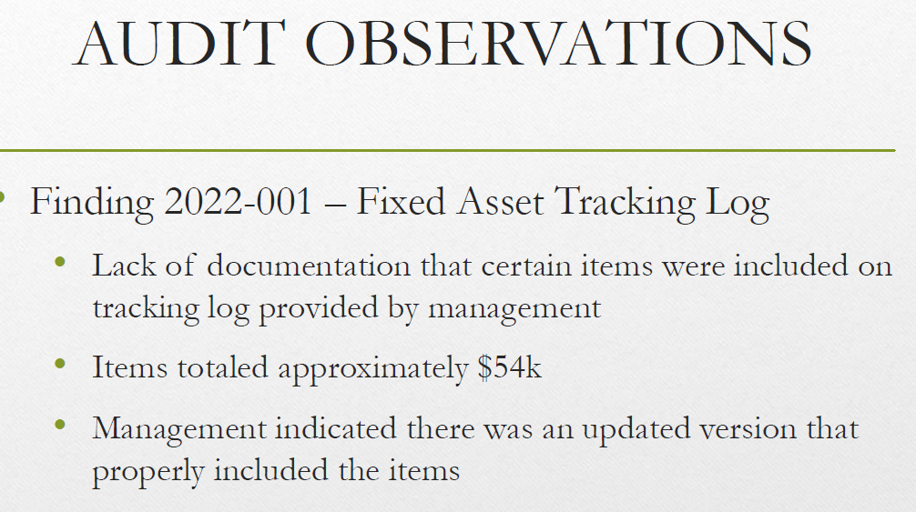

- Nina Dodge asked if there were any recommendations or changes implemented after the audit findings.
- Angela Johnson explained that while pulling together files, two items were left off the log list. When DCSEU was notified, staff provided the auditors proof of emails sent to vendors for the 54k spent. Angela also shared that a new staff member was added to the team and another layer of review on the DCSEU and VEIC level was incorporated.
- Nina Dodge thanked Rachel Locus for her presentation and suggested the Board highlight FS Taylor’s report in its FY22 annual report.
- Chair Bicky Corman asked if the DCSEU had any financial audit findings in the past.
- Angela Johnson explained that DCSEU financial audits have historically gone well, however, there have been some minor findings in years past. For example, in a prior audit there was a travel finding for under $50.00.

DCSEU FY22 Annual Report Refresher
- Ben Burdick provided DCSEU’s FY22 refresher.
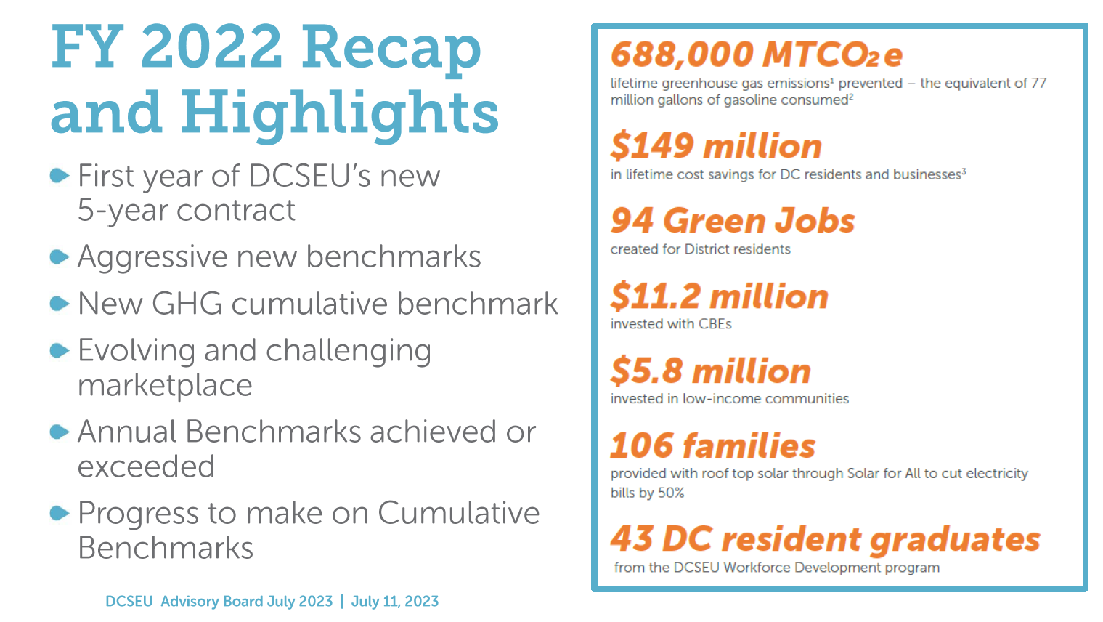
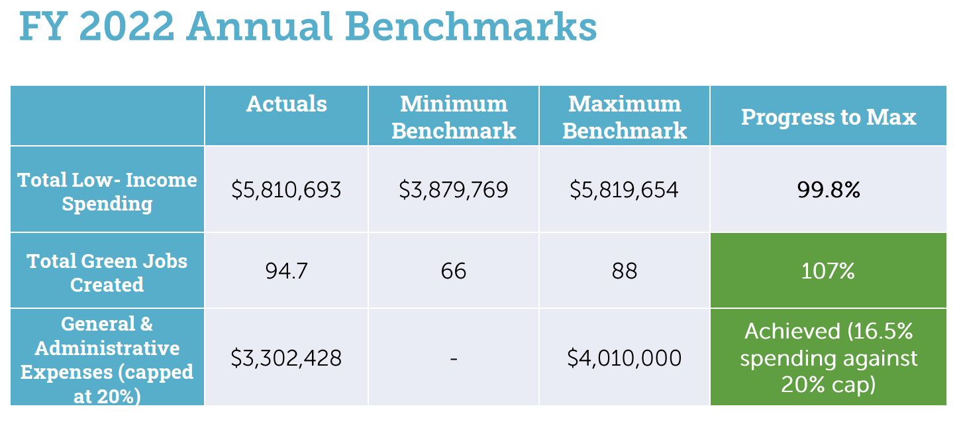
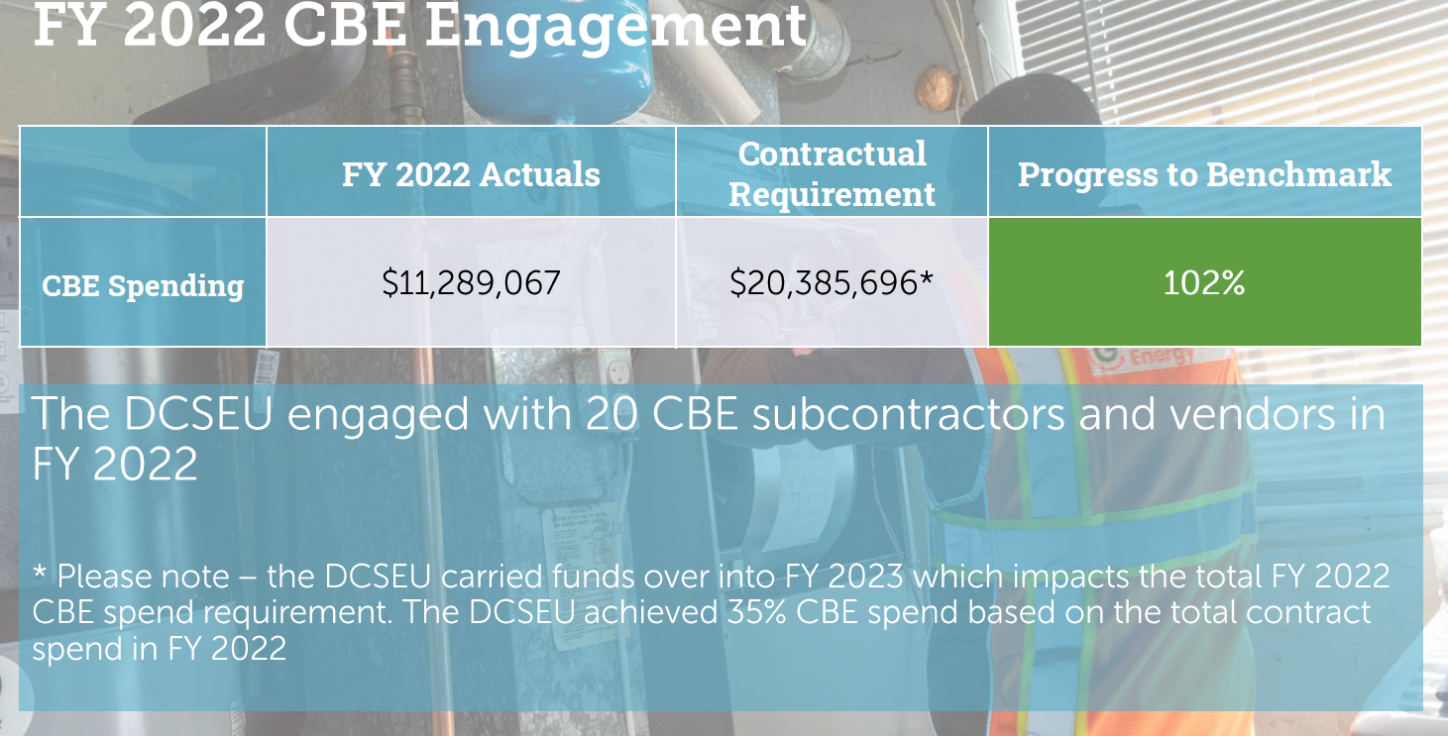
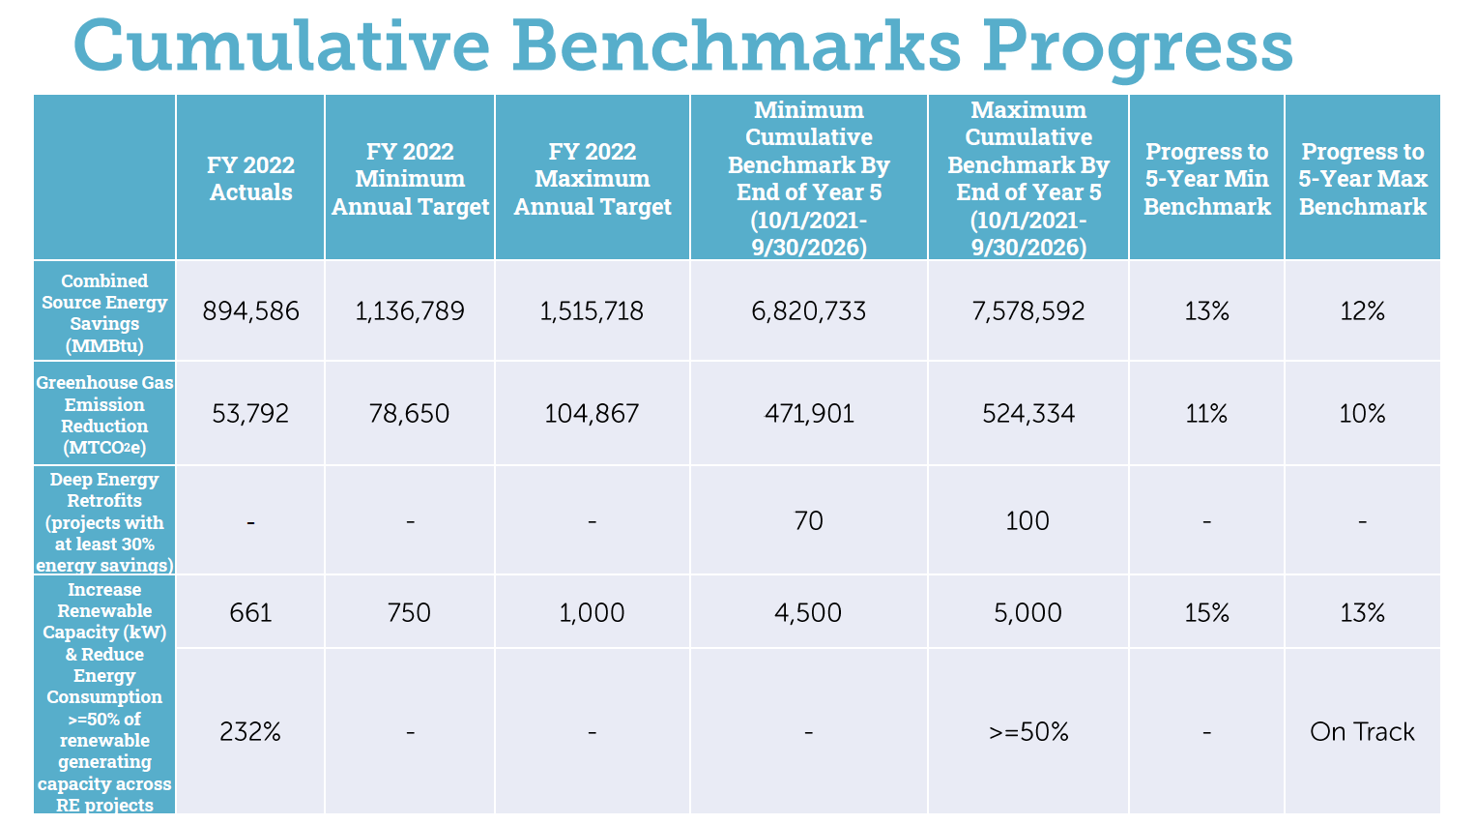
- Chair Bicky Corman asked how the DCSEU know it’s on track for the last benchmark (Increase Renewable Capacity (kW) & Reduce Energy Consumption >=50% of renewable generating capacity across RE projects)
- Ben Burdick explained that anytime DCSEU is incentivizing the installation of solar on a building, DCSEU makes sure that there is enough energy efficiency across the entire portfolio of solar installation to meet that greater than or equal to 50% goal.
- Sarah Kogel-Smucker (OPC) inquired how the DCSEU was meeting the Increase Renewable Capacity (kW) & Reduce Energy Consumption >=50% of renewable generating capacity across RE projects benchmark.
- Patti Boyd (DCSEU) shared that if a one-megawatt (MW) system produces 250 MWh, then 125MWh of energy efficiency measures would need to be implemented at the project site. Patti shared that DCSEU provides an incentive for the organization to install a solar system, but only if the organization also incorporates a lighting or chiller project (for example) to cover energy efficiency.
- Sarah Kogel-Smucker (OPC) recalled the DCSEU saying the Increase Renewable Capacity (kW) & Reduce Energy Consumption >=50% of renewable generating capacity across RE projects benchmark would be difficult to implement and asked what changed for the DCSEU to be on track.
- Patti Boyd (DCSEU) explained that the Increase Renewable Capacity (kW) & Reduce Energy Consumption >=50% of renewable generating capacity across RE projects benchmark was at first challenging because before the DCSEU team could communicate the goal externally, the internal team needed to understand it.
- Ben Burdick (DCSEU) clarified that he did not recall DCSEU expressing concern for that benchmark, but rather the Deep Energy Retrofits (projects with at least 30% energy savings) as a hard goal to achieve.
- Nina Dodge inquired if the Deep Energy Retrofits (projects with at least 30% energy savings) benchmark was connected to the Solar for All (SFA) or Building Energy Performance Standards (BEPS) programs.
- Ben Burdick (DCSEU) explained that the Deep Energy Retrofits (projects with at least 30% energy savings) benchmark is not part of SFA, however, the work could contribute to BEPS, though those buildings may not necessarily be targeted.
- Nina Dodge asked if the same offering was available to low income.
- Ben confirmed that services are available to low-income buildings as DCSEU is required to spend a portion of the annual budget on low-income communities.
- Nina Dodge inquired how DCSEU was spreading the word about the great work.
- Ben Burdick (DCSEU) shared a blog post highlighting a project at Washington Square:
  - https://www.dcseu.com/news-blog/news-blog/blog-posts/case-study-commercial-solar-meets-the-threshold
- Chair Bicky Corman asked the following questions regarding the Increase Renewable Capacity (kW) & Reduce Energy Consumption >=50% of renewable generating capacity across RE projects benchmark:
- Do you have optimism that when you hit the cumulative benchmarks, you'll be able to hit the solar piece if you could not find energy efficiency to couple with the project?
- If this benchmark (combining energy efficiency with renewables) is straightforward to achieve, then should Pepco and Washington Gas proposals include something similar if they don’t already? Should the Board advocate for all players in the marketplace to be working under the same requirement?
- Ben Burdick (DCSEU) explained that DCSEU has a high level of confidence in meeting the 4500-kW capacity and hitting the energy efficiency requirement across the solar portfolio. He provided an example - If we were presented with a large parking garage where a solar structure is built over a parking lot, the only energy efficiency you might be able to achieve there is upgrading a light fixture. The team plans to continue balancing these kinds of projects across the portfolio to meet the energy efficiency requirement.
- Patti Boyd (DCSEU) shared that DCSEU is currently the only player in the marketplace that provides solar incentives.
- Chair Bicky Corman asked for the DCSEU team to inform the Board if it would be helpful to provide comment to the PSC, although it may not be needed right now (given DCSEU is the only solar incentive distributor)
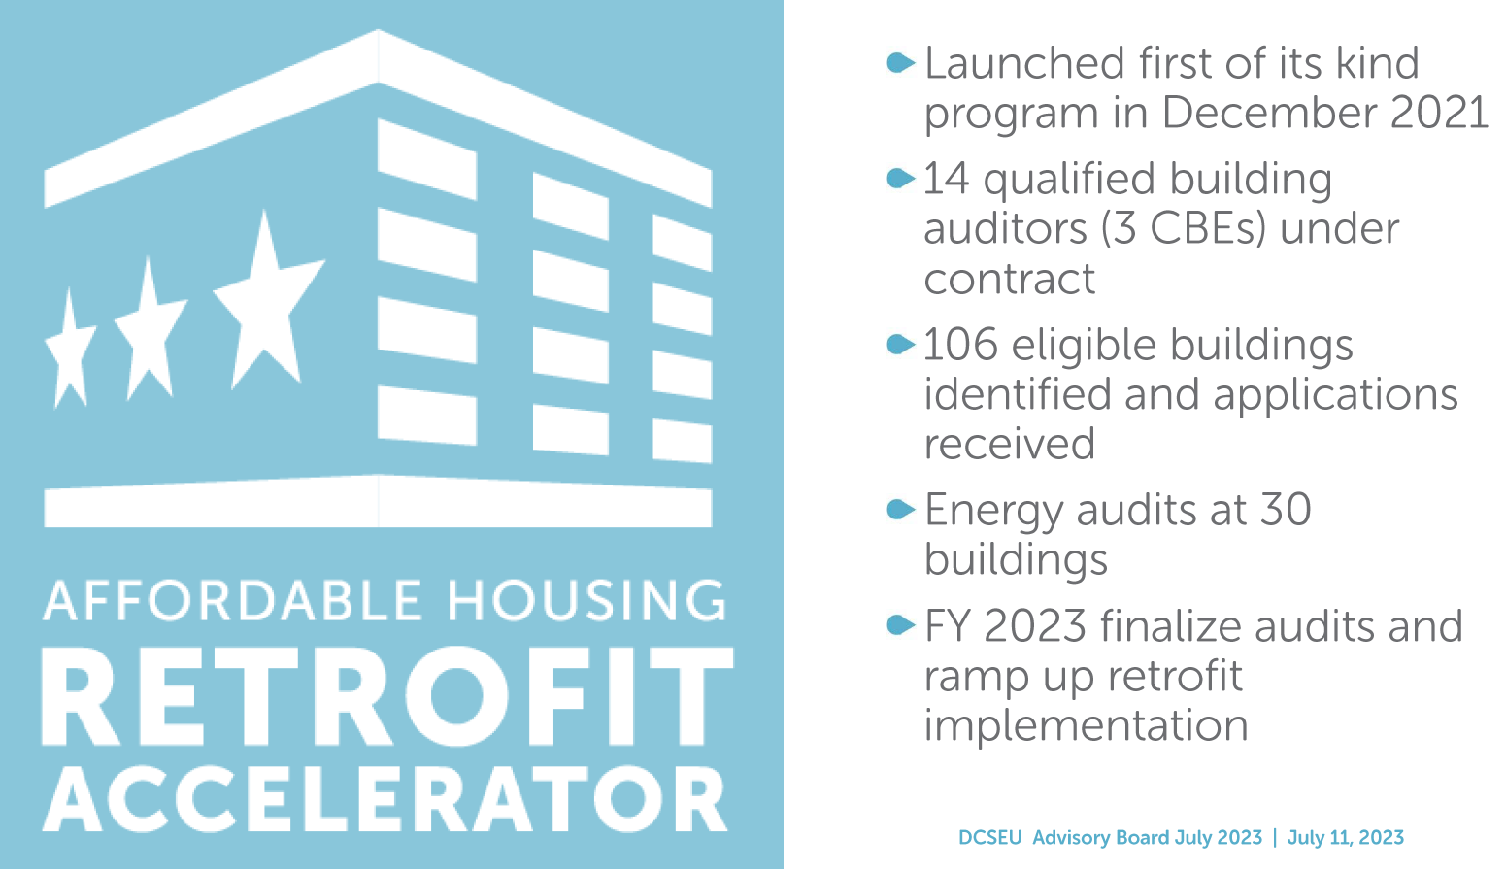
- Chair Bicky Corman asked if the DCSEU was on track with implementing the Affordable Housing Retrofit Accelerator (AHRA).
- Director Ernest Jolly (DCSEU) shared that the DCSEU is not as far along as it would like to be but is making progress and pushing hard to continue to close the gap.
- Chair Bicky Corman asked for DCSEU to elaborate on the gap and what is being fixed.
- Director Ernest Jolly (DCSEU) mentioned the market challenges where a lot of building owners are unsure if it is the right time to be investing in new measures. The DCSEU team is working through the educational piece with building owners and is in a good place to operate AHRA more effectively.
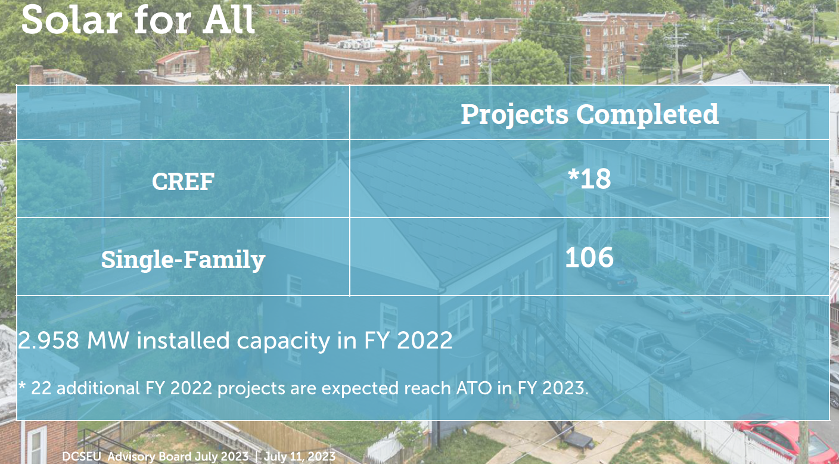
- Nina Dodge asked what DCSEU defined as completing a Clean Renewable Energy Facility (CREF) project.
- Hussain Karim (DOEE) shared that a CREF is considered complete when the subcontractor receives Authorization to Operate (ATO) from Pepco. DOEE manages the subscriptions, so DOEE is involved in making sure that the energy credits are properly assigned to beneficiaries.

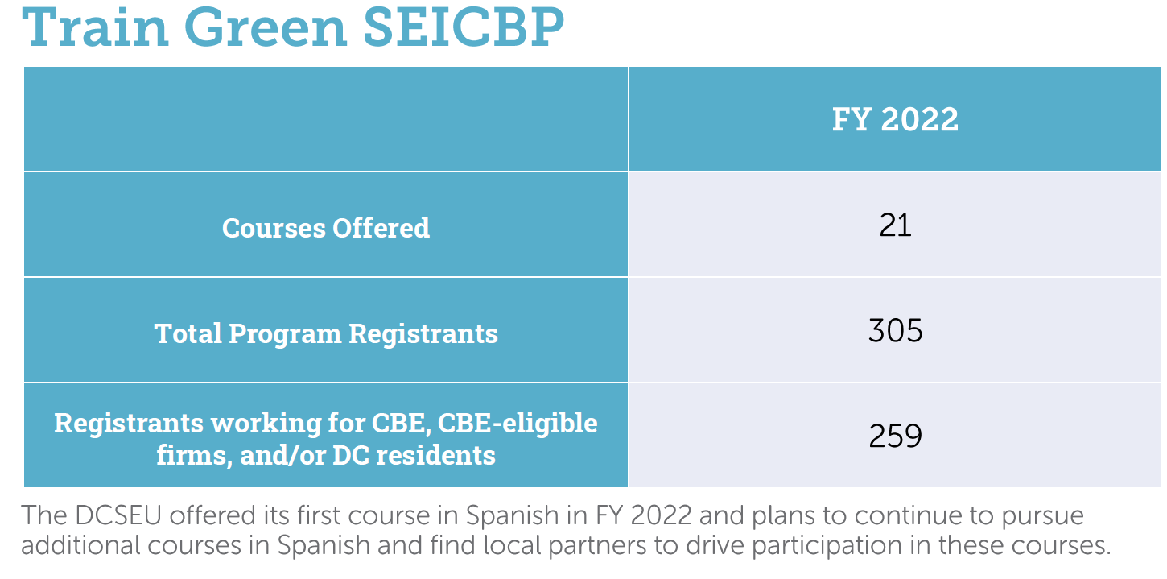
- Chair Bicky Corman asked if the DCSEU is where they want to be with the HVAC replacement program.
- Ben Burdick (DCSEU) shared that the HVAC Replacement program is in a good place for FY23.
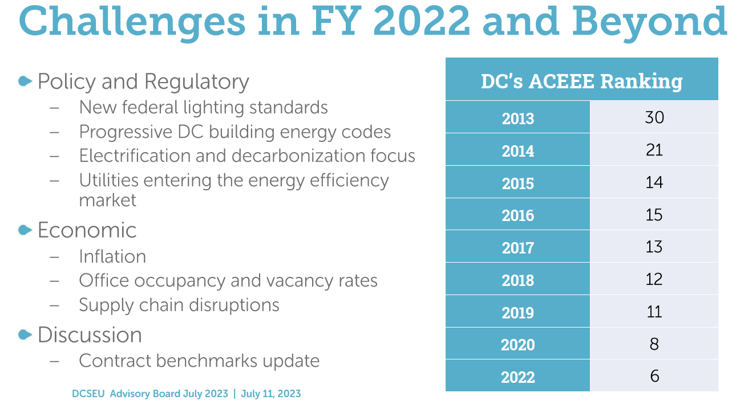

Societal Cost Test Overview
- Patti Boyd (DCSEU) provided an overview of DCSEU’s societal cost test.
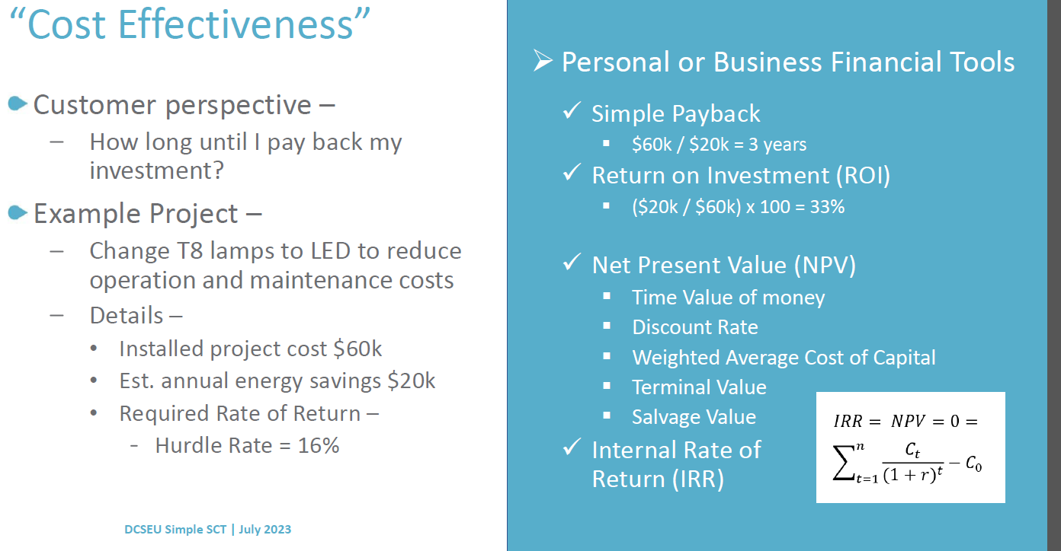

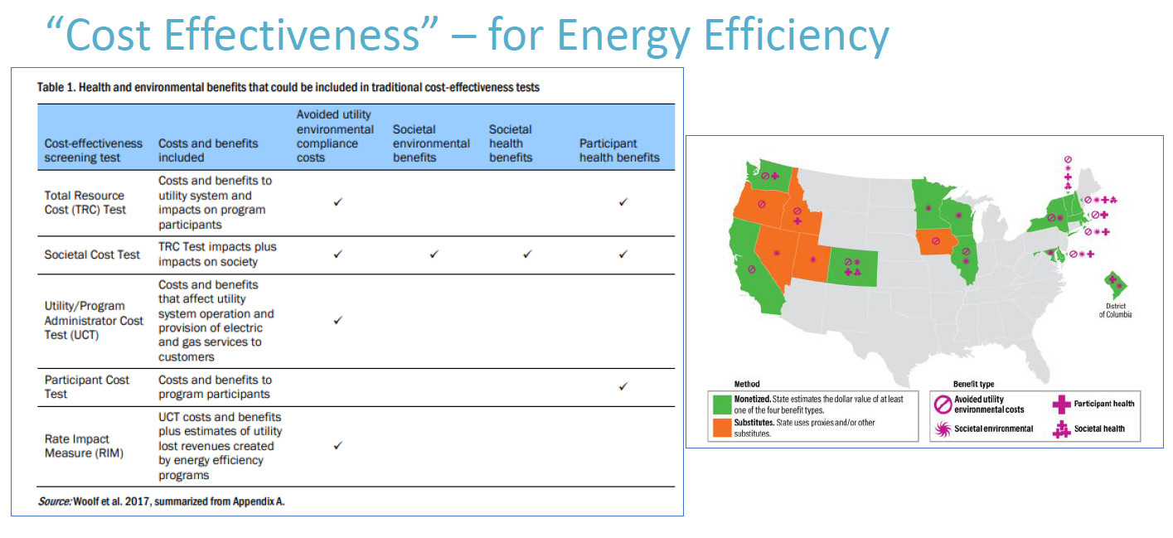
- Ben Plotzker (VEIC) provided an ACEEE link that defines cost-effectiveness: https://www.aceee.org/sites/default/files/he-ce-tests-121318.pdf
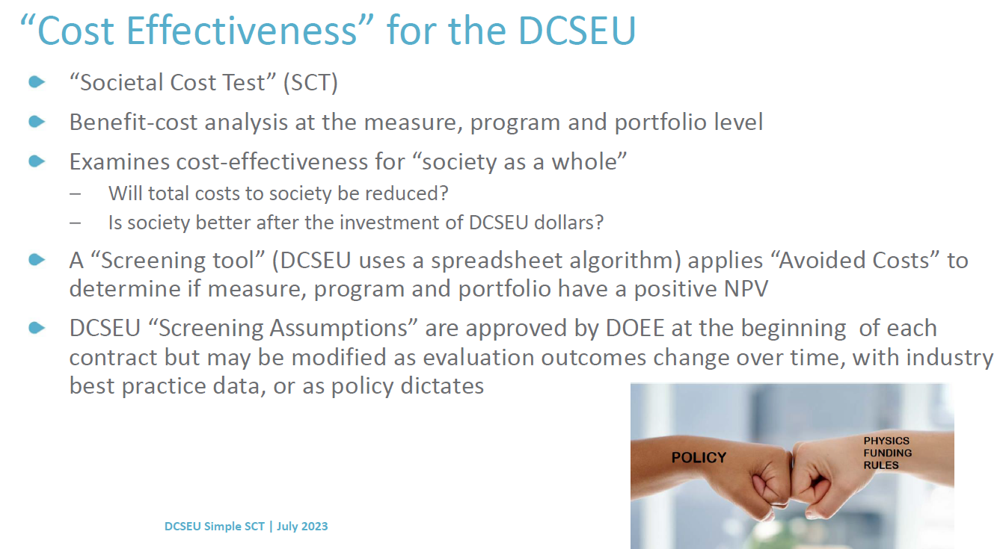
- Patti Boyd (DCSEU) highlighted that DCSEU’s avoided costs have been shared with the Public Service Commission, Pepco, and Washington Gas so those teams use the same assumptions and societal cost tests for their evaluation of proposed programs. Patti also mentioned that at the beginning of each contract the societal cost test is approved by DOEE, but it might be modified as the evaluation outcomes change, industry practices change, or as policy dictates.
- Ben Plotzker (VEIC) provided the table below to help explain the difference between other tests:
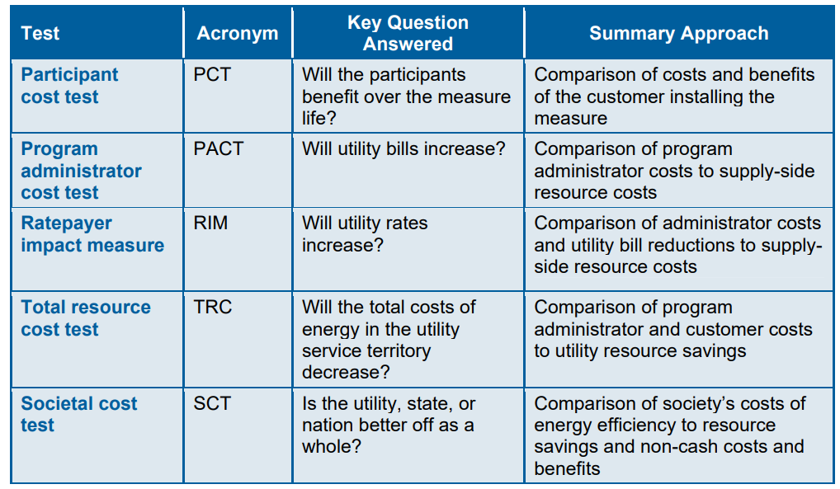
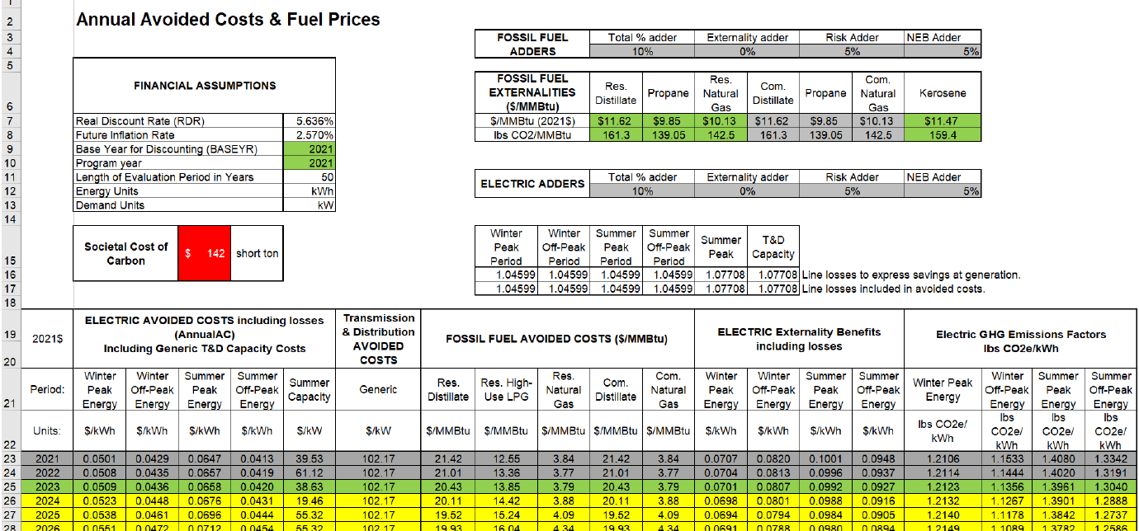
- Patti Boyd (DCSEU) pointed out that the societal cost of carbon in the current model is $142 (shown in red above) which is based on industry-standard data from utilities. Once the assumptions are entered into the model above, the screening tool provides a Net Present Value (NPV). The third-party evaluator (in the past NMR) has its own social cost test screening tool that is used to compare DCSEU’s NPV with the evaluators.
- Ben Plotzker (VEIC) shared that the societal cost test is more of a comprehensive review of the dollar value of avoiding burning carbon today, including some of the impacts of climate change, such as wildlife.
- Sarah Kogel-Smucker (OPC) inquired about the health benefits taken into consideration as her understanding of the societal cost test is providing the benefits to society as a whole, not building or District specific.
- Ben Plotzker (VEIC) highlighted how some of the nonenergy benefits are focused more on the health aspects of the work we do. For example, if a customer’s utility cost is reduced, in theory, the customer may be able to save more money for either groceries or avoid visits to an urgent care facility with better indoor air quality at home. Ben also mentioned that the societal cost test is a highly qualitative science, but it's a means of quantifying significantly more benefits beyond just the electric or natural gas bill.
- Sarah Kogel-Smucker (OPC) shared that she would like to know more about quantifying health benefits from indoor air quality and would follow-up after the meeting offline.
- Giuls Kunkel asked if the societal cost test calculations are used in other jurisdictions? She mentioned how in some jurisdictions, penalties are made for building performance standards laws based on the social cost of carbon.
- Ben Plotzker (VEIC) mentioned that the input of the sale cost carbon is external, negotiated with US DOE, and is independent of anything going on within the societal cost test.
- Nina Dodge asked if the societal cost test DCSEU uses was on par with other organizations.
- Ben Plotzker (VEIC) shared that DCSEU is aligning with a lot of other states that implement and administer energy efficiency programs and the societal cost, such as New York, Massachusetts, or California. Societal cost tests are typically a regulatory requirement for the state. For the DCSEU, a societal cost test is required for programs as stated in the Clean and Affordable Energy Act of 2008.
- Nina Dodge noted that she was not aware of any legislation that requires a consistent societal cost test standard overall and in the District. Nina would like to know more information on where the District stands on this.
- Eric Jones shared the below comment in the Teams chat. In the interest of time Eric encouraged the conversation to continue.
  - Question about the cost test. I know it talked about the pure fiscal terms similar to a fiscal impact, but what about the economic impact. For example, you talked about the removal of the need to transmit energy, but what about the lost of jobs associated and the reduction in the turnover of funding associated.

Legislative Updates
- Hussain Karim (DOEE) reminded the group that Pepco and Washington Gas were required to file climate business plans with the PSC (which they did) and as part of FC 1160 the utilities were also required to file potential studies.
- Hussain Karim (DOEE) highlighted the PSC cases below and shared that the Board may submit comments for Pepco’s and Washington Gas’s potential studies.
Case Number | Subject | Most recent updates | Upcoming Deadlines
FC1160 | Utility Efficiency and Demand Response | PSC granted OPC's motion for enlargement of time on comment period for potential studies filed by Pepco and WGL. WGL also filed it's application for EEDR programs - the PSC has yet to issue an order on it. | Comments on potential studies due on 8/28/23.
FC1176 | Pepco Multiyear Rate Plan Application | First scheduling conference held on 6/13. Parties have filed comments on a proposed schedule. Waiting on PSC for an order on next steps in establishing the procedural schedule. Time of use rates, several EV charging rates for commercial and fleet, Board is not an official party, but OAG is three years, start Jan 1, 2024

- Chair Bicky Corman asked if Pepco or Washington Gas’s climate plan was available for comment.
- Hussain Karim (DOEE) shared that the climate business plans are available for review, but the PSC has not provided guidance on how parties can provide comments.
- Chair Bicky Corman asked if it would be helpful for the Board to provide comment on FC 1160.
- Ernest Jolly (DCSEU) stated that DCSEU will coordinate comments with DOEE, and those will be shared with their Advisory Board.
- Sarah Kogel-Smucker (OPC) noted that Pepco Multiyear Rate Plan Application includes several proposals for capacity upgrades to handle additional load from electrification.
- Hussain Karim (DOEE) mentioned that the Committee on Transportation & the Environment will hold a Public Hearing on B25-0106, the Comprehensive Electric Vehicle Infrastructure Access, Readiness, and Sustainability Amendment Act of 2023 on Wednesday, July 12 at 2pm. Hussain said the bill focuses on EV charging and has a number of provisions with respect to increasing the number of EV charging locations in the District.
- Eric Jones shared that his organization recommended that the city start out by creating a working group to create an updated plan and that the working group, comprised of DCSEU and others, would have a seat at the table to advise on the new layout of EV infrastructure moving ahead.
- Sarah Kogel-Smucker (OPC) shared that Pepco asked for funding for portions of its five-year climate business plan in the rate plan (FC 1176), even though the climate business plan has not been approved, so there is overlap between the proceedings.
- Nina Dodge pointed out that other proceedings are reviewing proposals that are now included in FC 1160, and it's a real tangle and challenge for parties that want to intervene, who might not have the resources to deal with essentially 3 or 4 cases all in one.
- Prior to the Board meeting, Katya Botwinick (DOEE) provided the below update to the Board:

Case Number | Subject | Most recent updates | Upcoming Deadlines
FC1050 | Interconnection | Pepco filed a petition for a new NEM interconnection tariff. DOEE filed comments opposing the new tariff and asked to reconvene the interconnection working groups. OPC also filed a petition to audit Pepco's powerflow analysis which they use to make decisions on hosting capacity and infrastructure upgrades  PSC to follow-up on when two working groups will re-start: 1) Ongoing Interconnection Working Group and 2) Advanced Inverter Working Group - Still no updates on reconvening the working groups
FC1160 | Utility Efficiency and Demand Response | PSC granted OPC's motion for enlargement of time on comment period for potential studies filed by Pepco and WGL. WGL also filed it's application for EEDR programs - the PSC has yet to issue an order on it. | Comments on potential studies due on 8/28
FC1171 | Community Solar Metering & Billing Practices | PSC ordered Pepco to remove their meters within 45 days and denied Pepco's motion for reconsideration. On 7/10, Pepco filed a motion for an extension of time - asked for a new deadline of 11/15/23 | Comments on Pepco's motion due in 30 days
FC1176 | Pepco Multiyear Rate Plan Application | First scheduling conference held on 6/13. Parties have filed comments on a proposed schedule. Waiting on PSC for an order on next steps in establishing the procedural schedule. Time of use rates, several EV charging rates for commercial and fleet, Board is not an official party, but OAG is three years, start Jan 1, 2024
FC1175 | PROJECTpipes 3 | WGL filed their PROJECTpipes 3 application. Initial round of public comments have been filed. DOEE and other parties have asked for a full procedural schedule with evidentiary hearings. Waiting on PSC for next steps. | Reply comments are due 7/15
FC1156 | Pepco MYR Application (PIMS working group) | Performance Incentive Metrics (PIMS) Working Group has begun a second round of meetings to establish PIMS for Pepco. The proposed PIMS are: CEMI 3, GHG emissions, peak demand reduction, DERs, and energy efficiency.

FY22 Annual Report
- Jennifer Johnston (DOEE) provided the below outline for the Board’s annual report:
Section/Subsection | Assignment | FY | Progress
- Executive Summary | Bicky | 22-23
- Summary of 2022-2023 Activities and Priorities | DOEE (Jennifer)
- Activities of the Board, FY23 |  | 23
- Key Activities of SEU, FY22 and FY23 |  | 22-23
- Solar for All |  | 22-23
- Affordable Housing Retrofit Accelerator |  | 23
- Innovation |  | 23
- Engagement and Outreach | DCSEU (Ben/Kalen) | 23
- Looking Forward |  | 24
- Legislative, PSC, Regulatory, and Contract Update, FY22-23 |  | 22-23
- Changes to the contract | DOEE (Lance)
- Legislation/Regulation affecting DCSEU | DOEE (Hussain) | 22-23
- PSC Rate Cases |  | 22-23
- Performance Review, FY22 | DOEE (Jennifer) | 22
- Energy and Emissions Performance |  | 22
    - Reduce Energy Consumption
    - Renewable Energy
    - GHG Emissions Impact
    - Deep Energy Retrofits
- Additional Performance Benchmarks |  | 22
    - Low-Income
    - Green Jobs
  - Financial Audit
i. Leveraging | DCSEU
ii CBE Requirements | DOEE (Jennifer)
- Appendices
- Attendee Table | DOEE (Jennifer)
- Filings by Board with PSC | DOEE (Hussain)

Board Action Items
- Approval of Meeting Agenda
- Approval of May Minutes

Future Agenda Items
- Approval of June Meeting Minutes
- DCSEU FY23 Q3 Update
- Annual Report Timeline and Assignments
- Tracking bills and legislation
- Indoor air quality and electrification
- Clean Energy DC 2.0 Development

Adjournment
- Chair Bicky Corman adjourned the meeting at 12:00 PM.

Acronyms used during this meeting
- ATO - Authorization to Operate
- CREF - Clean Renewable Energy Facility
- DCSEU - District of Columbia Sustainability Energy Utility
- DOEE - Department of Energy and Environment
- EEDR – Energy Efficiency and Demand Response
- MOTA – Mayor's Office of Talent and Appointments
- MPV - Net Present Value
- OPC - Office of the People’s Counsel
- PSC - Public Service Commission
- SETF - Sustainable Energy Trust Fund
- WGL – Washington Gas Light
Minutes prepared by Jennifer Johnston, DOEE

